

**Ethical Hacking**

Year 2 (2025/26), Semester 3

**SCHOOL OF INFOCOMM TECHNOLOGY**

Diploma in Cybersecurity & Digital Forensics

Diploma in Information Technology

**Assignment: Open Assignment on Pen-Testing**

**Duration:** Weeks 11-16

**Weightage:** 40%

**Individual/Team/Both:** Both

**Deadline:** Assignment Report (20%)

Submit to POLITEMall Assignment

**9 Aug 2025, 23:59hrs (Sat)**

Individual Test (20%)

Presentation Session

**Week 16 (30 Jun to 9 Aug 2025)**

|  |  |  |
| --- | --- | --- |
| **Tutorial Group:** | **Team Number:** | **Team Grade** |
| **T03** | **4** |  |

**Team members:**

|  |  |  |  |
| --- | --- | --- | --- |
| **No.** | **Student Name** | **Student ID** | **Grade** |
| **1** | **Wyse Lee Hong Yao** |  |  |
| **2** | **Gao YuHao** |  |  |
| **3** | **Ian Tan Jun Yang** |  |  |
| **4** | **Toh Keng Siong** |  |  |

Table of Contents

Introduction 6

Use Case (Scenario) 7

Pen-Test Environment Setup 8

Network diagram 8

Windows Server 2022 (EH-DC) 9

Windows 10 Enterprise 12

PCs Setup 14

Tasks Outline 21

Task 1 – Evil Twin Attack 22

What is Evil Twin? 22

Setting up Evil Twin 22

Task 2 – Reconnaissance & Service enumeration 32

Scanning for open ports with Nmap 32

Identifying services running on each of the open ports 32

Service enumeration – Port 80 (HTTP) 33

Service enumeration – Port 139/445 (SMB / NetBIOS) 36

Task 3 – IIS WebDav Exploit 38

Task 4 – Post-exploitation local enumeration 43

Categories of information gathered 43

System Information 43

Users & Groups 45

Network Information 49

Processes & Services 56

Task 5 - Privilege Escalation through Process Migration 61

Task 6 – Token Impersonation Privilege Escalation 62

Task 7 – Tunnelling with Ligolo-ng 63

Reason for tunnelling 63

What is Ligolo-ng? 63

Setting up Ligolo-ng 63

Task 8 – Active Directory Enumeration 68

PowerView Setup 68

Domain Information 70

Domain Policies 71

User Information 72

Computer Information 79

Group Information 80

GPO Information 81

Task 9 - Domain enumeration with Bloodhound 84

Task 10 – Kerberoasting 94

Credential dumping via secretsdump 96

Task 11 – Pass-the-Hash 99

Task 12 - Golden Ticket Attack 101

Mimikatz 101

Task 13 – Persistence 104

Metasploit 104

NTFS Stream Manipulation + Scheduled Task 107

Task 14 – Hide the Evidence of Comprise 111

Clearing logs on Domain Controller 111

Deleting files in Temp Folder 112

Executive Summary 114

Testing Summary 114

Mitigation 114

Evil Twin Attack 114

IIS WebDav Exploit 114

Privilege Escalation through Process Migration 115

Token Impersonation Privilege Escalation 115

Kerberoasting 115

Pass-the-Hash 116

Golden Ticket Attack 116

Citations 117

# Introduction

This report presents a simulated red team operation conducted within a controlled environment to emulate a full scope cyberattack on an enterprise network. Acting as adversaries, our red team executed a complete attack chain from initial access to domain takeover with the tools and techniques used by real-world threat actors.

The framework that this simulated attack uses is the Cyber Kill Chain. This model identifies what the adversaries must complete in order to achieve their objective.

The 7 phases are:

* Reconnaissance
* Weaponization
* Delivery
* Exploitation
* Installation
* Command & Control (C2)
* Actions on objectives

This red team simulation highlights the importance of assuming breach, continuously testing security controls, and proactively identifying weaknesses before they can be exploited by real attackers.

# Use Case (Scenario)

Our scenario consists of a corporate environment, Dyson, where an employee working in the IT department of the company’s headquarters is discovered through OSINT on social media. His daily routine on the weekdays was always the same, going to his favourite cafe at 8 a.m.

With this information, the red teamers set up an Evil Twin of the cafe’s network with a captive portal, requiring a password to login. The employee then unknowingly connects to it. This is the beginning of our attack chain, where the attacker captures the victim’s credentials through a deceptive captive portal.

The attacker proceeds to perform internal reconnaissance, discovering services like WebDAV and SMB that may be vulnerable. The attacker exploits the WebDAV service to upload a malicious payload and establish a foothold within the victim’s workstation.

From this entry point, local enumeration reveals a pathway to privilege escalation, ultimately allowing the attacker to impersonate highly privileged accounts like NT AUTHORITY\SYSTEM and DYSON\Administrator.

Using Ligolo-ng, the attacker tunnels into the internal network, accessing sensitive domain resources.

Through domain enumeration using PowerView and BloodHound, the attacker identifies misconfigurations that enable further lateral movement.

Next, the attacker performs Kerberoasting, hash cracking and Pass-the-Hash to fully compromise the domain controller.

A Golden Ticket attack is used to compromise the last machine in the domain from the domain controller, gaining access to the entire Active Directory network.

Finally, persistence and clearing tracks are then deployed to ensure continued access as well as to not get caught in the system.

This use case demonstrates how a single weak link, like a rogue access point, can snowball into a full domain compromise if appropriate defences and monitoring are not in place.

# Pen-Test Environment Setup

## Network diagram

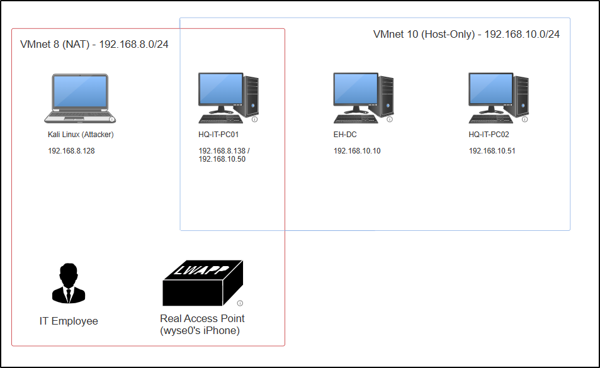

VMnet 8 simulates internet access, and the “Real Access Point” is the one that the IT Employee is connected to in the cafe.

The attacker uses Kali Linux, a distribution of Linux with pentest tools pre-installed. This is also where the Evil Twin Wi-Fi will be set up with the help of a USB adapter.

HQ-IT-PC01 hosts the web application and is also managed by the domain controller, hence it has 2 network interfaces. This will also act as the pivot box for tunnelling.

EH-DC is the domain controller of the active directory, where the DHCP server is set up to give IP address of the internal network in the range 192.168.10.50 - 192.168.10.100.

HQ-IT-PC02 will be the target after the domain controller has been compromised.

Note: Since the DHCP on VMnets are being used, the IP addresses may differ in screenshots for each of the tasks.

## Windows Server 2022 (EH-DC)

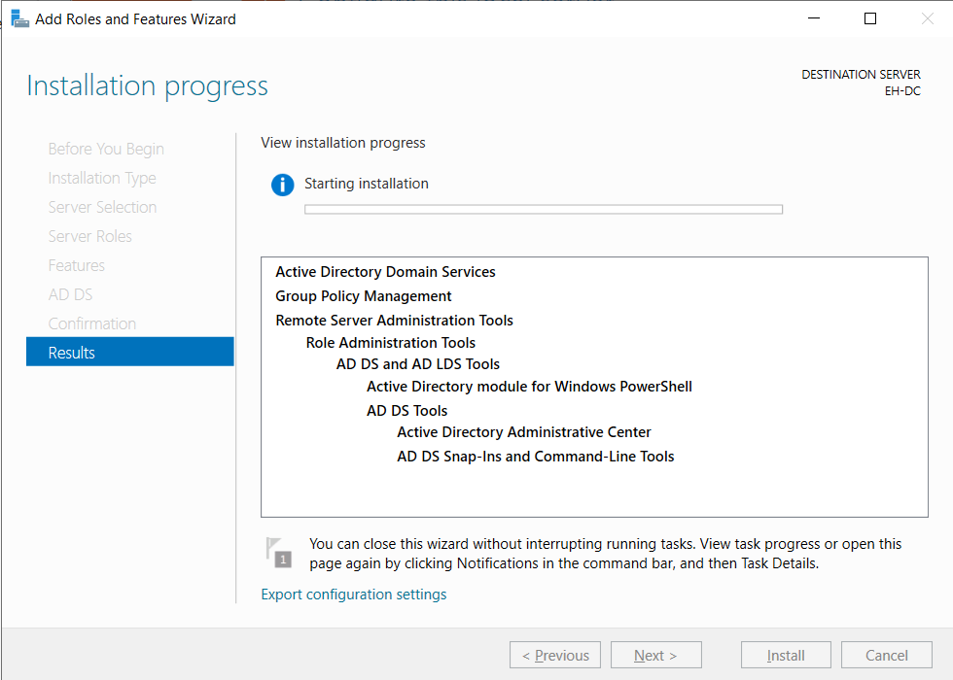

Setting up AD DS

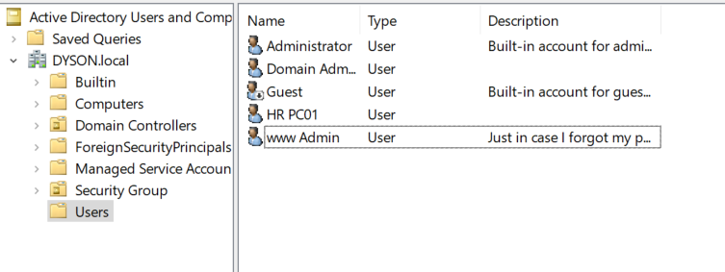

Users on the AD: Administrator, www Admin & Domain Admin (service DC administrator), HR PC01 (Regular user)

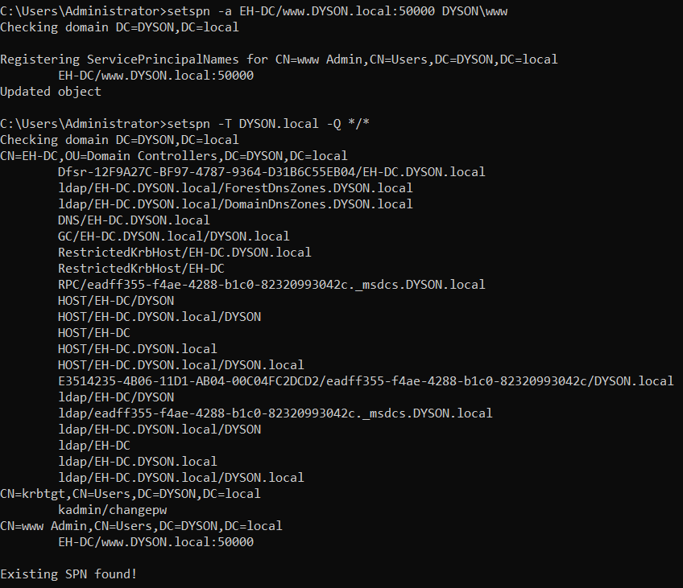

For kerberoasting

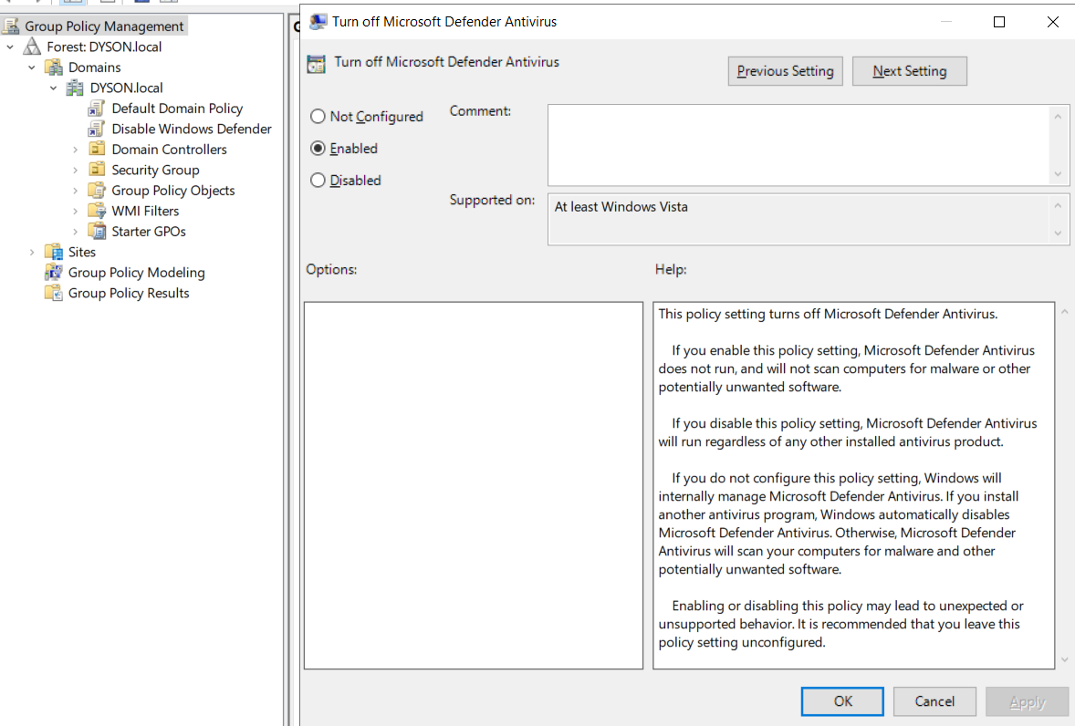

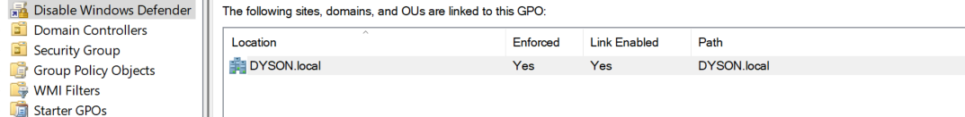

Turning off microsoft defender antivirus for DYSON.local

## Windows 10 Enterprise

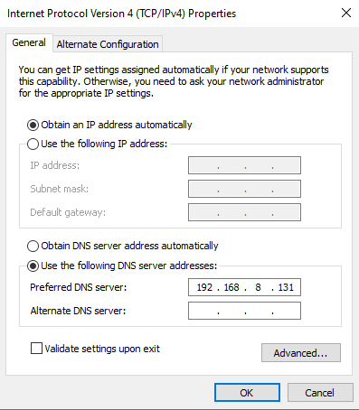

DNS server to the IP address of the domain controller

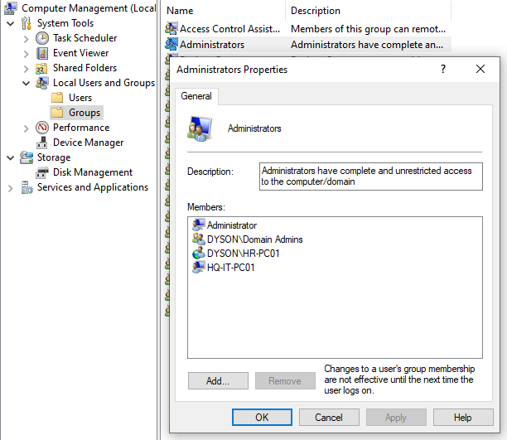

Adding HR-PC01 as local Administrator

## PCs Setup

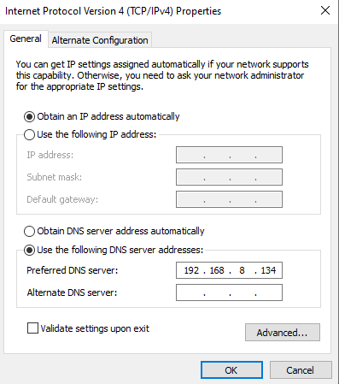

Set DNS to the IP of the Windows server for both HQ-IT-PC01 and HQ-IT-PC02

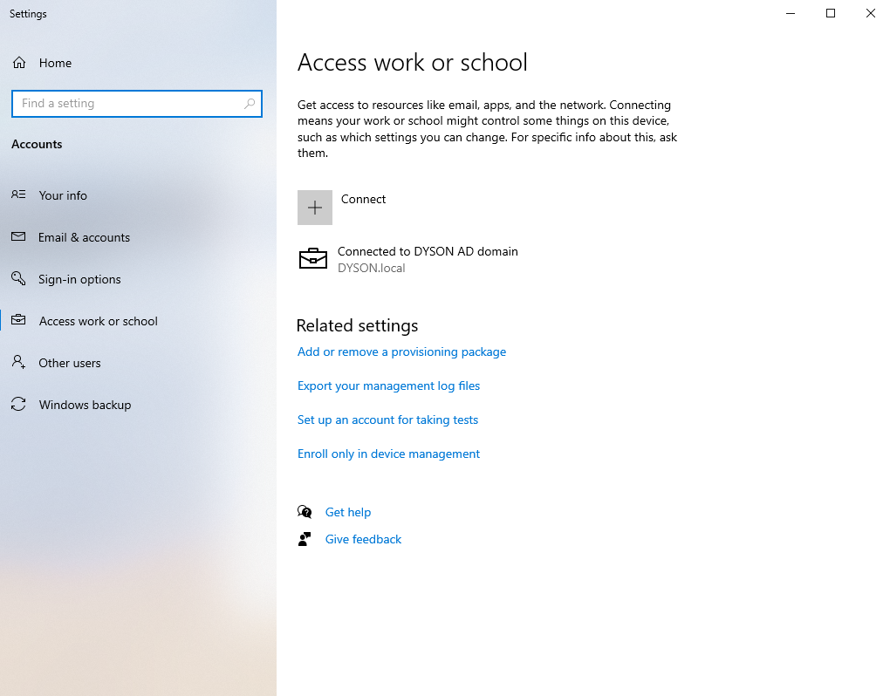

Connect to DYSON.local

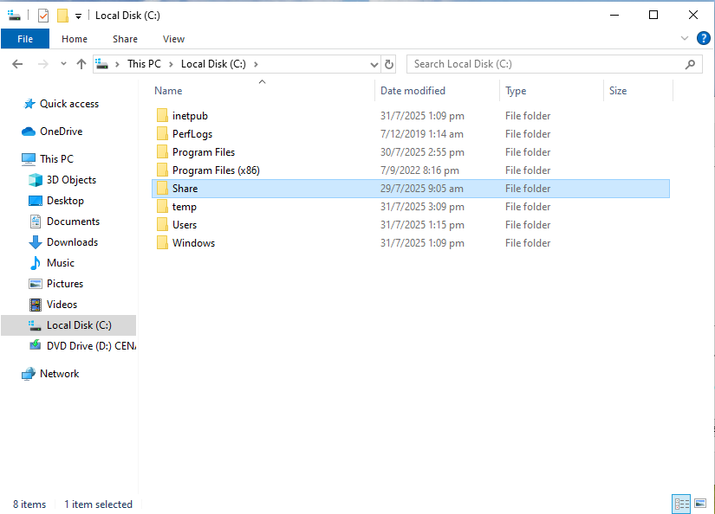

For both PCs create a Share file in C:\

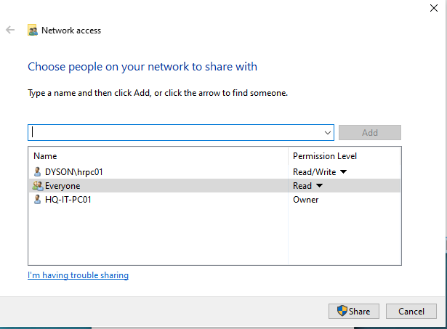

Share the file

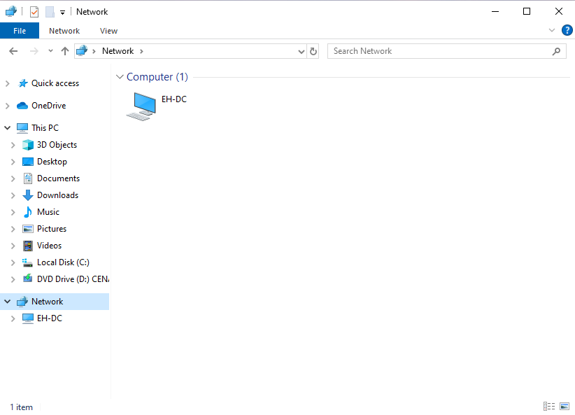

EH-DC should be in the network for both PCs

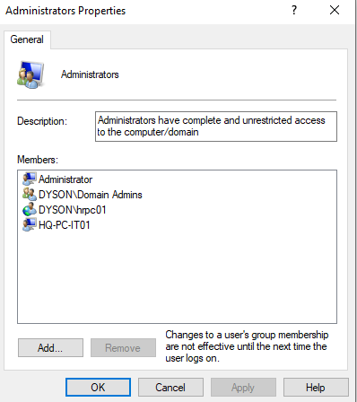

In Computer Management, add DYSON\hrpc01 into Administrator group for HQ-IT-PC01

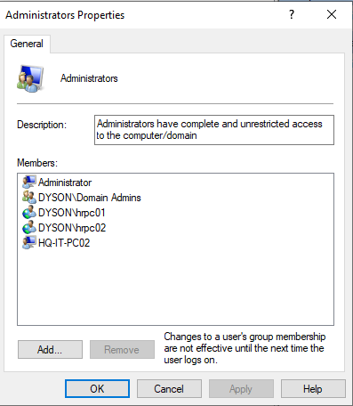

For HQ-IT-PC02, add DYSON\hrpc01 and DYSON\hrpc02 into the Administrator group

# Tasks Outline

Task 1 – Evil Twin Attack (Wyse)

Task 2 – Reconnaissance & Service enumeration (Wyse)

Task 3 – IIS WebDav Exploit (Ian)

Task 4 – Post-Exploitation Local Enumeration (Wyse)

Task 5 – Privilege Escalation through Process Migration (Wyse)

Task 6 – Token Impersonation Privilege Escalation (Ian)

Task 7 – Tunnelling with Ligolo-ng (Wyse)

Task 8 – Active Directory Enumeration (Ian)

Task 9 – Domain enumeration with Bloodhound (Keng Siong)

Task 10 – Kerberoasting (Keng Siong)

Task 11 – Pass-the-Hash (Keng Siong)

Task 12 – Golden Ticket Attack (YuHao)

Task 13 – Persistence with Metasploit & NTFS Stream Manipulation with Scheduled Task (Wyse)

Task 14 – Clear logs (YuHao)

## Task 1 – Evil Twin Attack

### What is Evil Twin?

Evil Twin is a wireless access point (AP) that pretends to be a legitimate AP by having the same network name as the other.

A USB adapter is required to set up the Evil Twin. Once the USB adapter is installed and set up on kali, the following steps show how the Evil Twin is set up to successfully gain the password of the victim.

### Setting up Evil Twin

1. Once the USB adapter is plugged in, use the command “airmon-ng check kill” in order to stop the network manager. This is used to stop processes that might interfere with the WLAN interface in monitor mode. The “airmon-ng” command shows what interfaces are available for use. This is to identify the WLAN interface that will be started in monitor mode. Finally, start the interface identified in monitor mode with the command “airmon-ng start wlan0”.

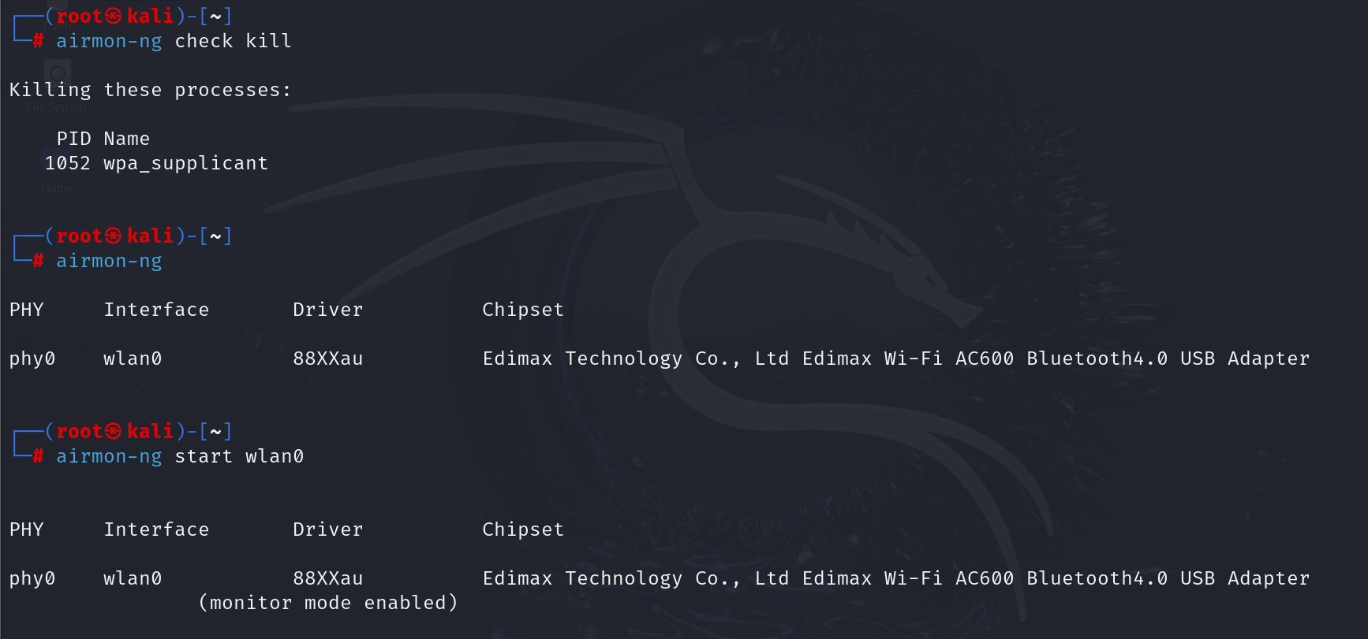

1. With the “airodump-ng –band abg wlan0” command, it starts running continuously to discover any networks possible. Once the target has been found, stop the running process and note down the BSSID and channel number of the network. In our case, we will be using “wyse0’s iPhone”.

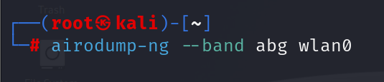

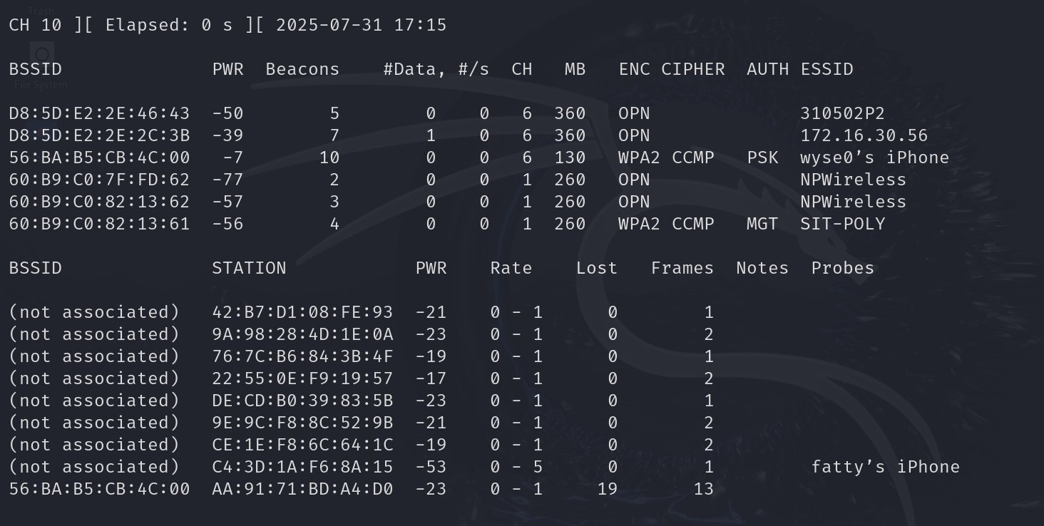

1. With the BSSID and channel number found, we can capture a handshake with the “airodump-ng –bssid <BSSID> --channel <CHANNEL-NUMBER> -w <FILENAME> <WLAN-INTERFACE>”. The filename would determine where the handshake file would be written to and the WLAN interface would just be wlan0.



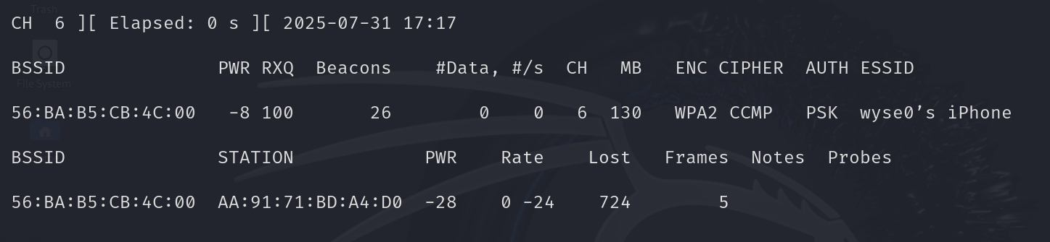

1. The Evil Twin would be set up with “airgeddon”. It will check whether the kali system has the required tools installed.

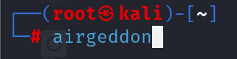

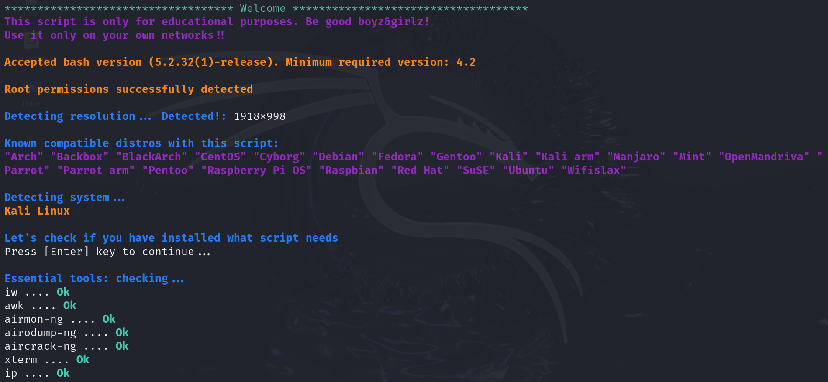

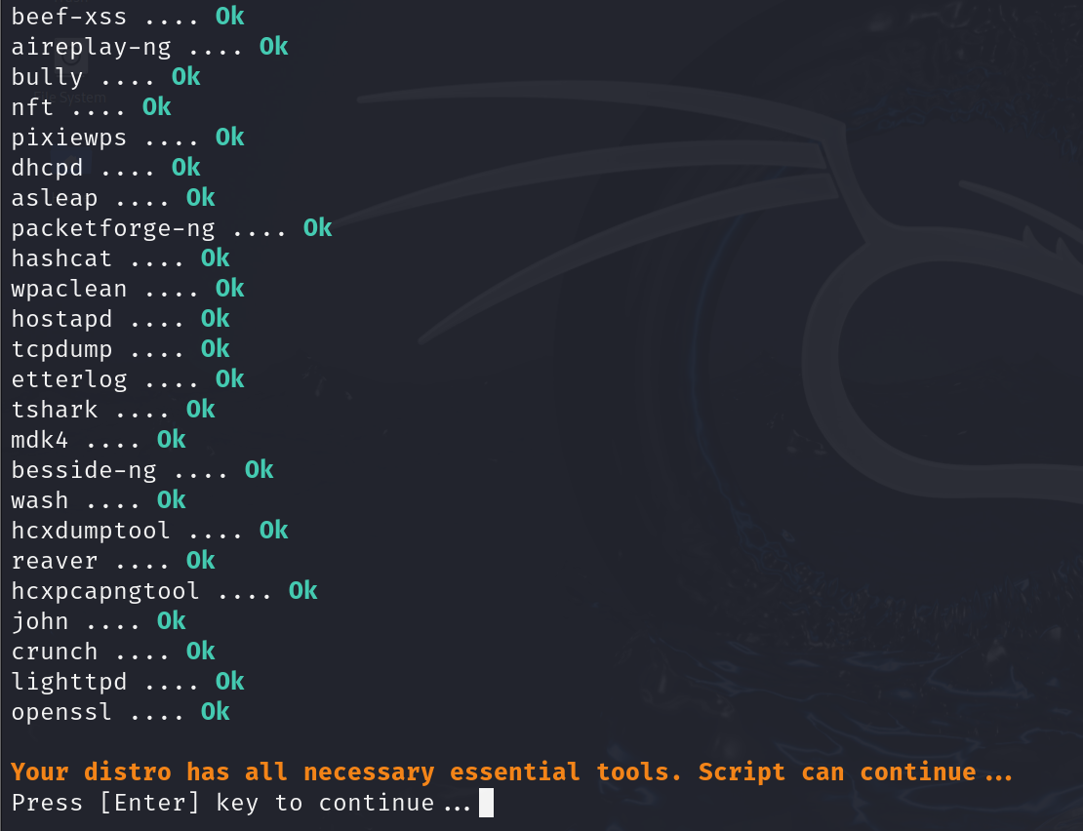

1. Select the wlan0 interface.

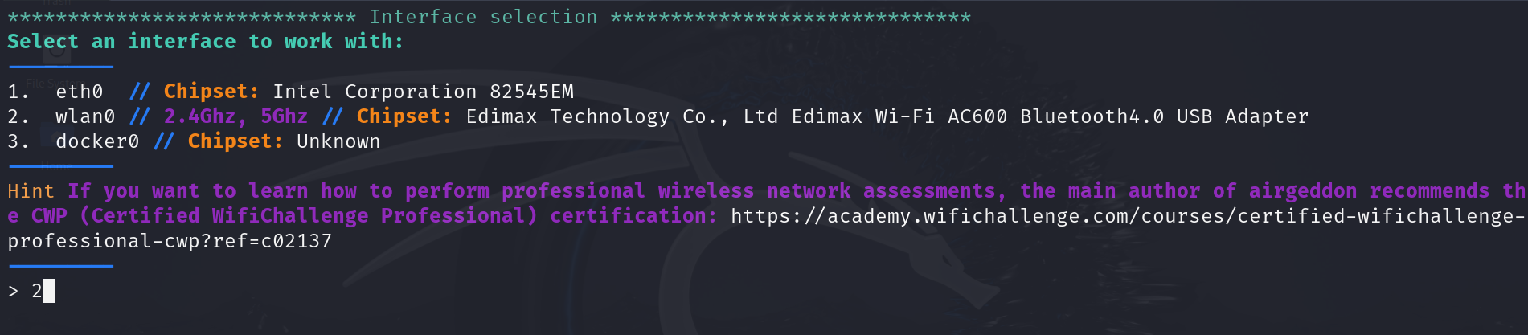

1. Here is where the attack is chosen. Select option 7 as Evil Twin is what the attacker will be using.

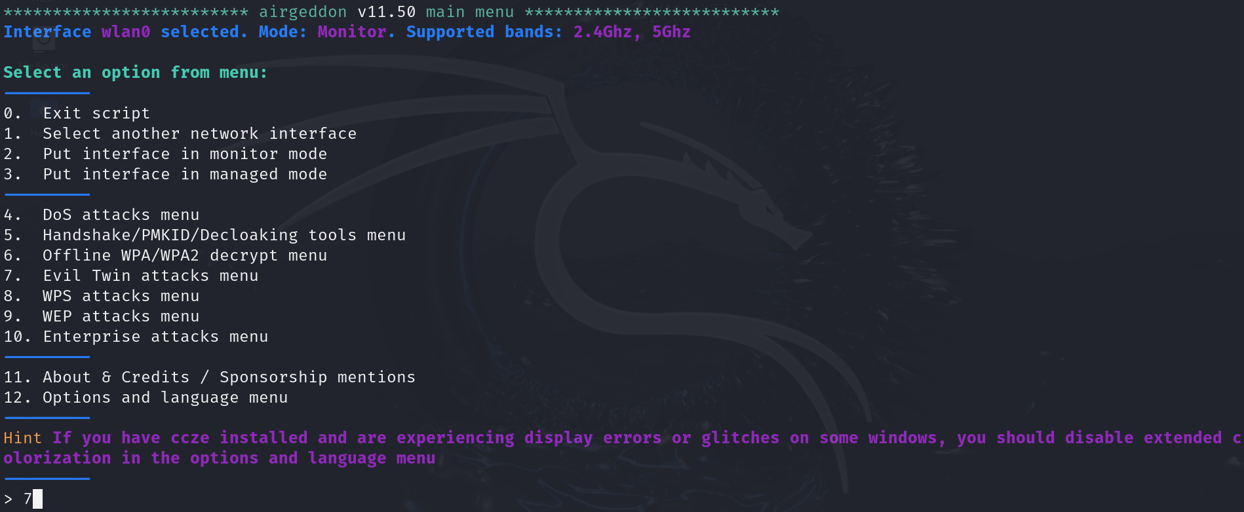

1. Select option 9 to set up the Evil Twin attack with a captive portal.

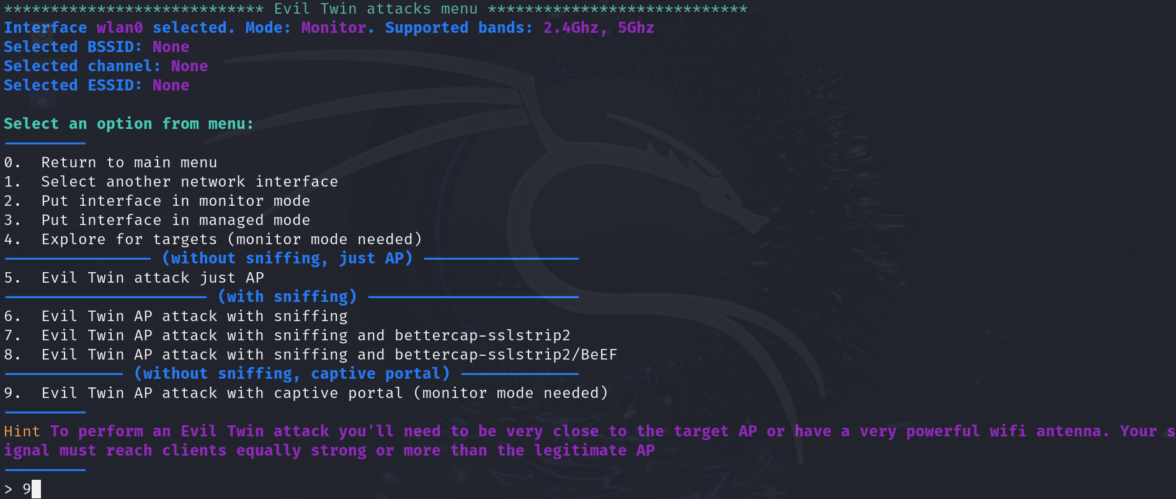

1. The next step is choosing the target. It will first discover the different networks similar to what was done in step 2.

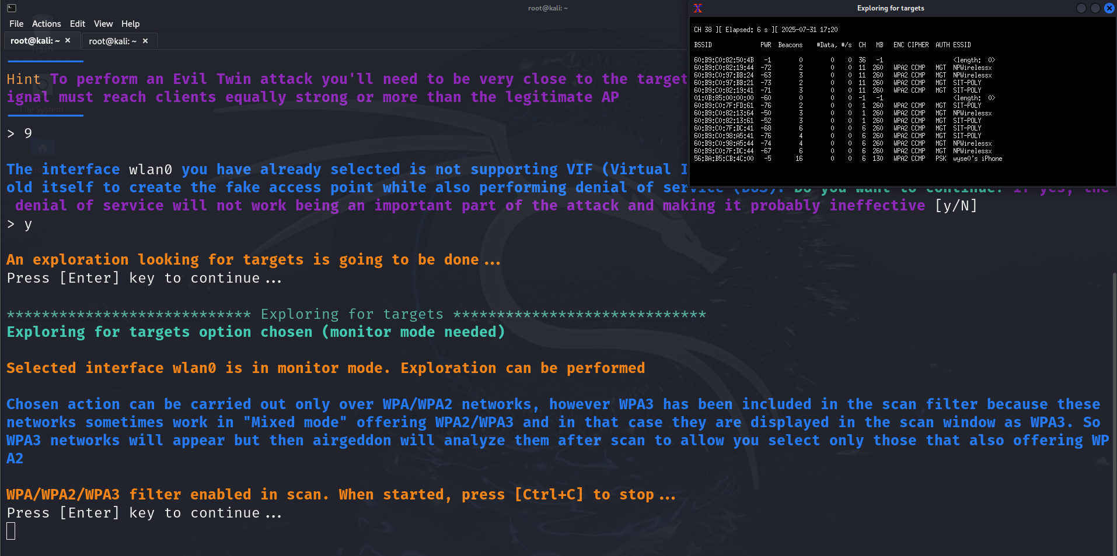

1. Once the discovery is completed, we would select the option where the target network is which would be “wyse0’s iPhone”.

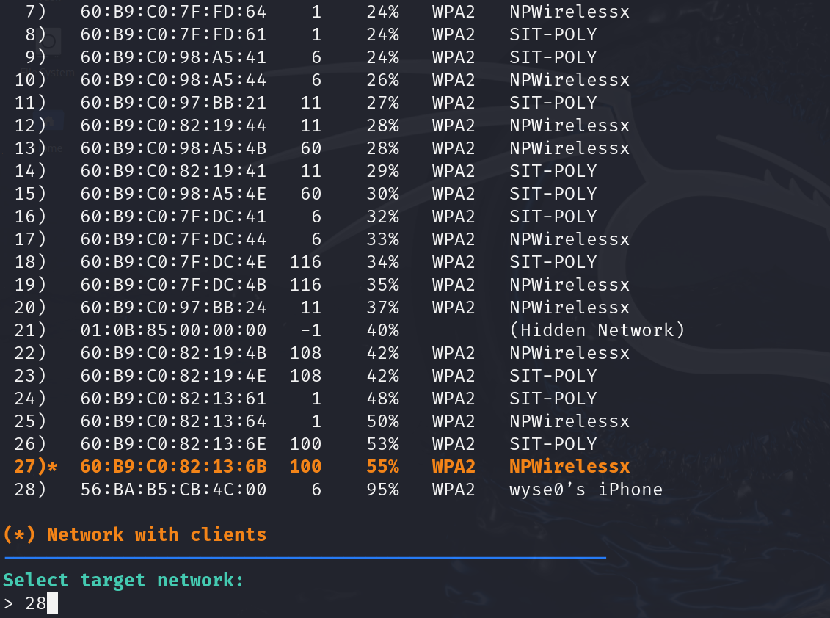

1. Select option 1 which would deauth the user from the network followed by starting the Evil Twin. The user would find that their internet connection is gone and connect to the Evil Twin without realising.

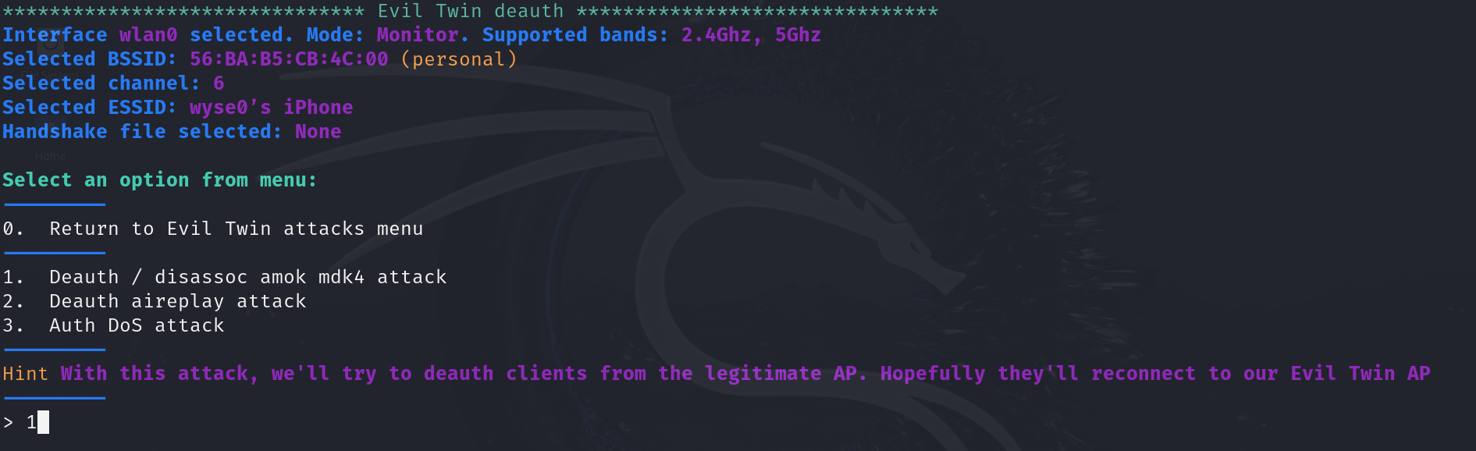

1. To keep things simple, we are setting up the attack without DoS pursuit mode and MAC spoofing. Now, we can enter in the handshake file captured earlier. If the handshake file has not been created, airgeddon has an option to capture the handshake file and also create a text file where the password would be stored in as shown below.

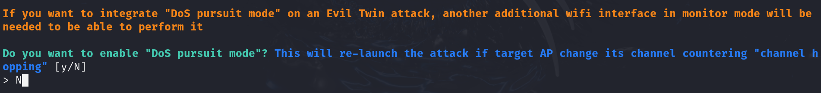

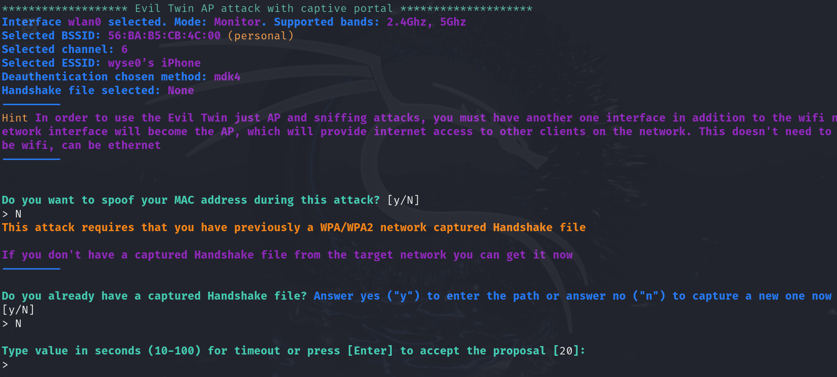

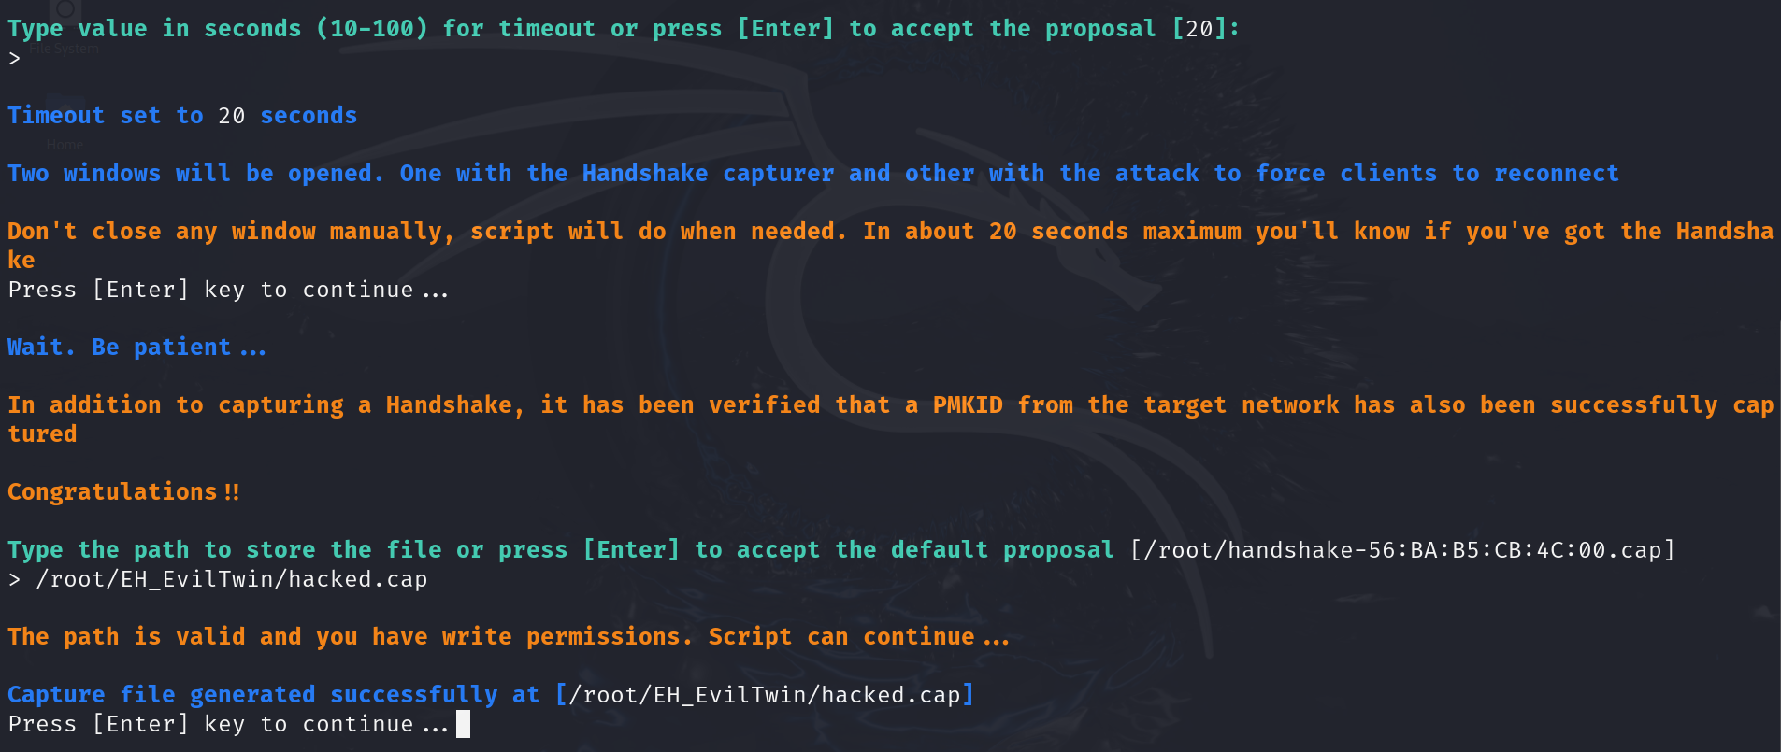

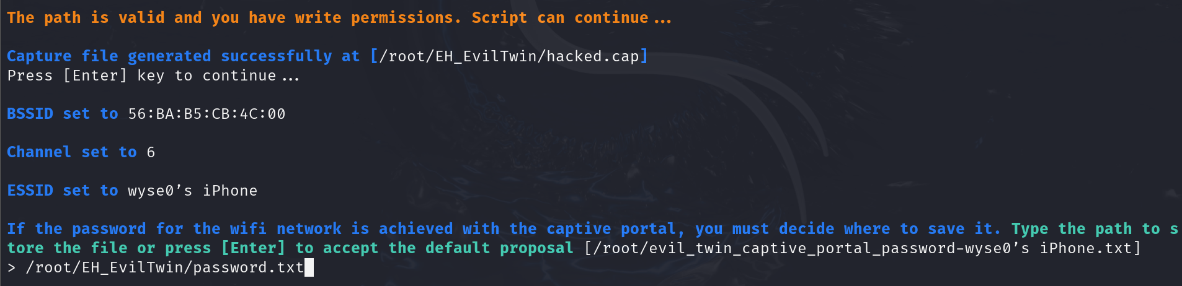

1. Configure the captive portal to be in English, then set up a simple captive portal by entering “N” when asked if an advanced captive portal is to be used instead.

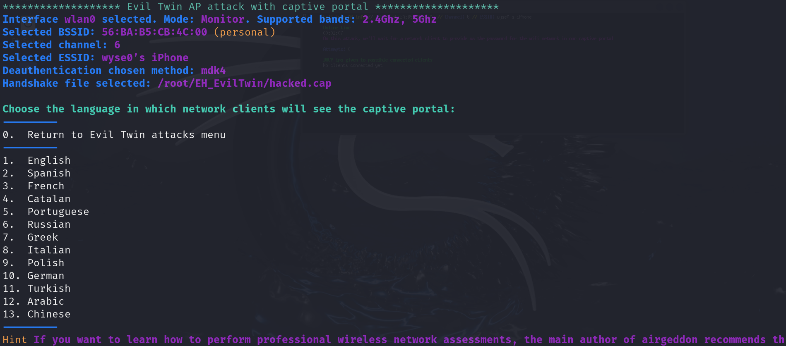

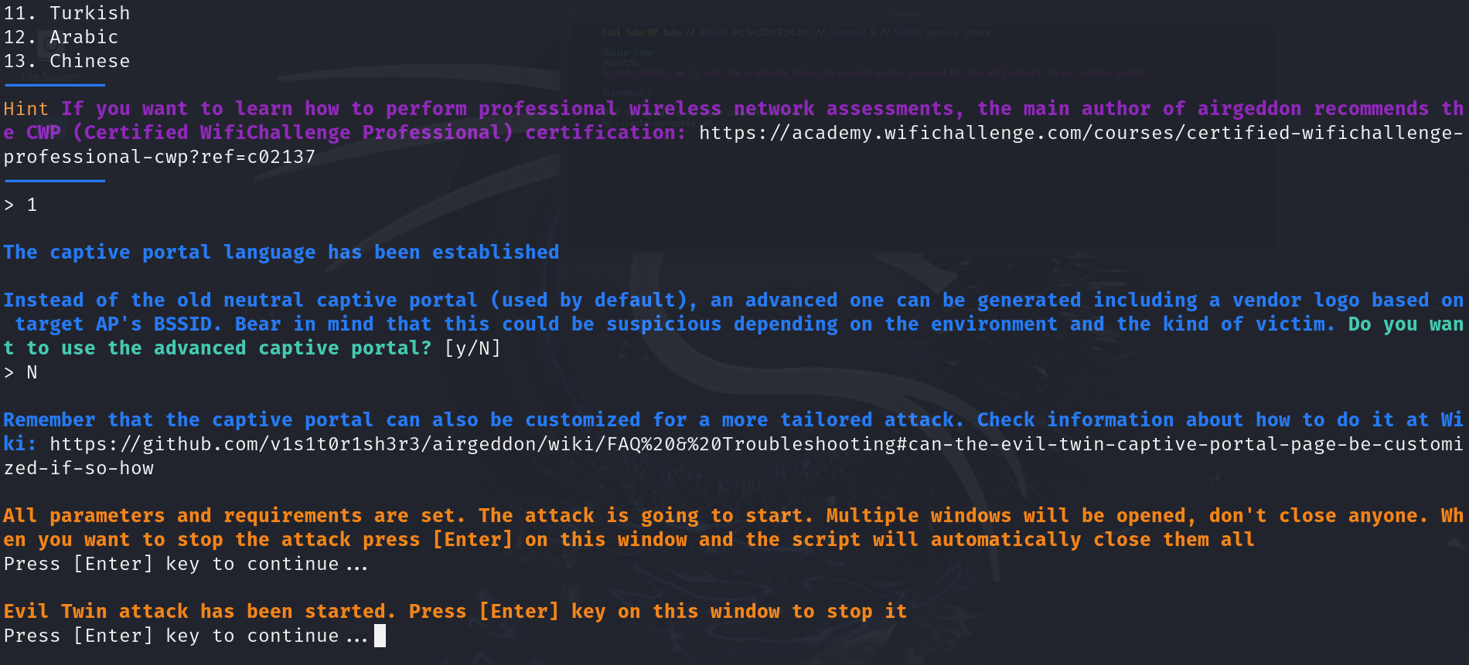

1. The Evil Twin network has started. Now it’s just a matter of time before the victim connects to the fake network.

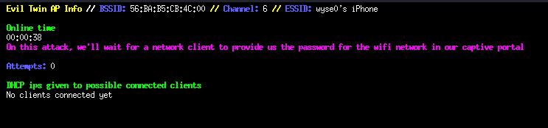

Once the victim has connected to the Evil Twin and entered the password, it would be logged on the kali machine. The attack is successful and the password obtained is “p@ssw0rd”.

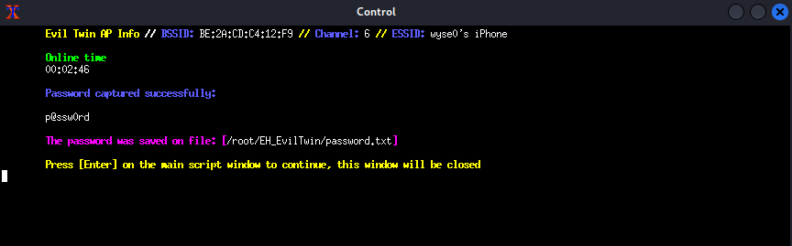

## Task 2 – Reconnaissance & Service enumeration

Currently, the only information that the attacker has is an IP address through footprinting and a password from the previous attack. More information is required for a successful hack into the system. Therefore, this task allows the attacker to gain enough knowledge to be able to find a weakness that can be exploited for the initial foothold.

### Scanning for open ports with Nmap

Firstly, an Nmap scan reveals the open ports on the target machine. From the scan below, it can be seen that there are a total of 14 open ports:

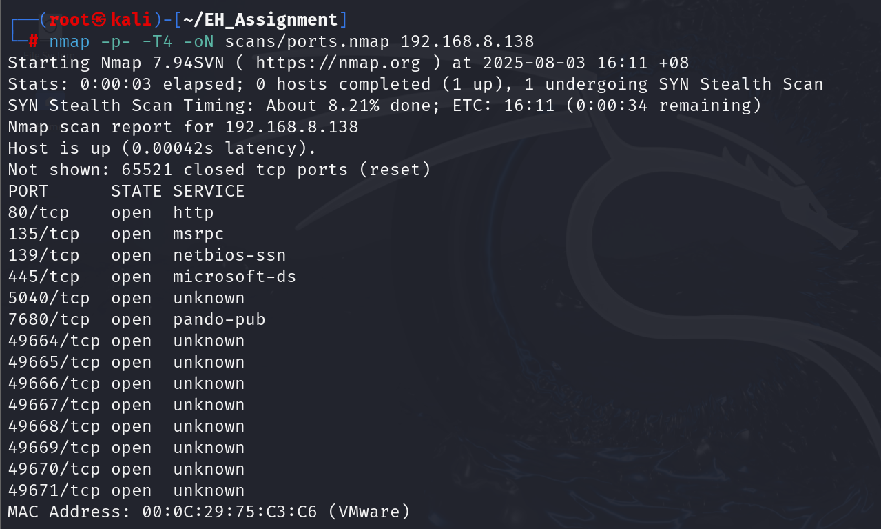

Other than that, however, not much information about each port is shown.

### Identifying services running on each of the open ports

To gain more knowledge on what each port is running specifically, I ran another Nmap scan on the open ports with an additional -A flag. With this aggressive scan that finds out about the service running on each port, what operating system the target is most likely running on, as well as default Nmap scripts ran on the target, the result is as shown below:

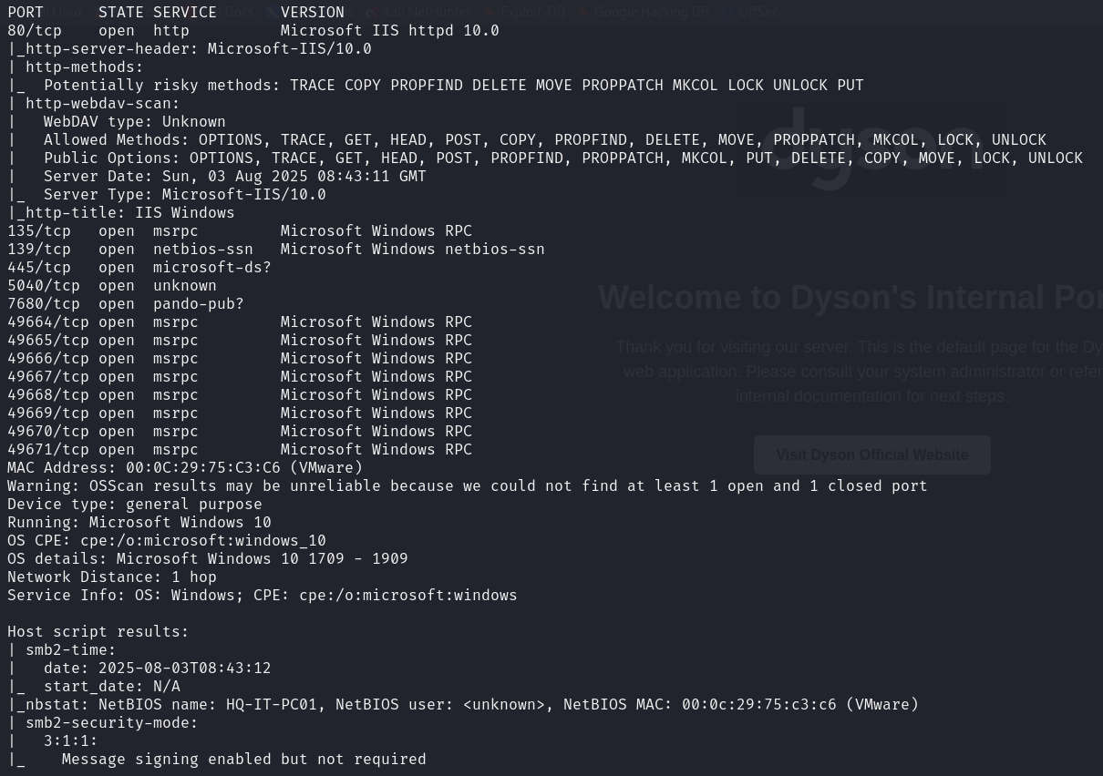

To summarise the important findings of the scan:

* Microsoft IIS 10 with WebDav enabled web server is running on port 80
* Server Message Block (SMB) with NetBIOS running on ports 139/445
* NetBIOS name: HQ-IT-PC01

With the information that the attacker now has, there are 2 possible ways to gain initial access – Web server through port 80 or access to shares through SMB.

### Service enumeration – Port 80 (HTTP)

Upon visiting the web server, a default page for Dyson can be seen. Since there is nothing interesting or exploitable on the web page, the attacker tries to dig deeper into the web service.

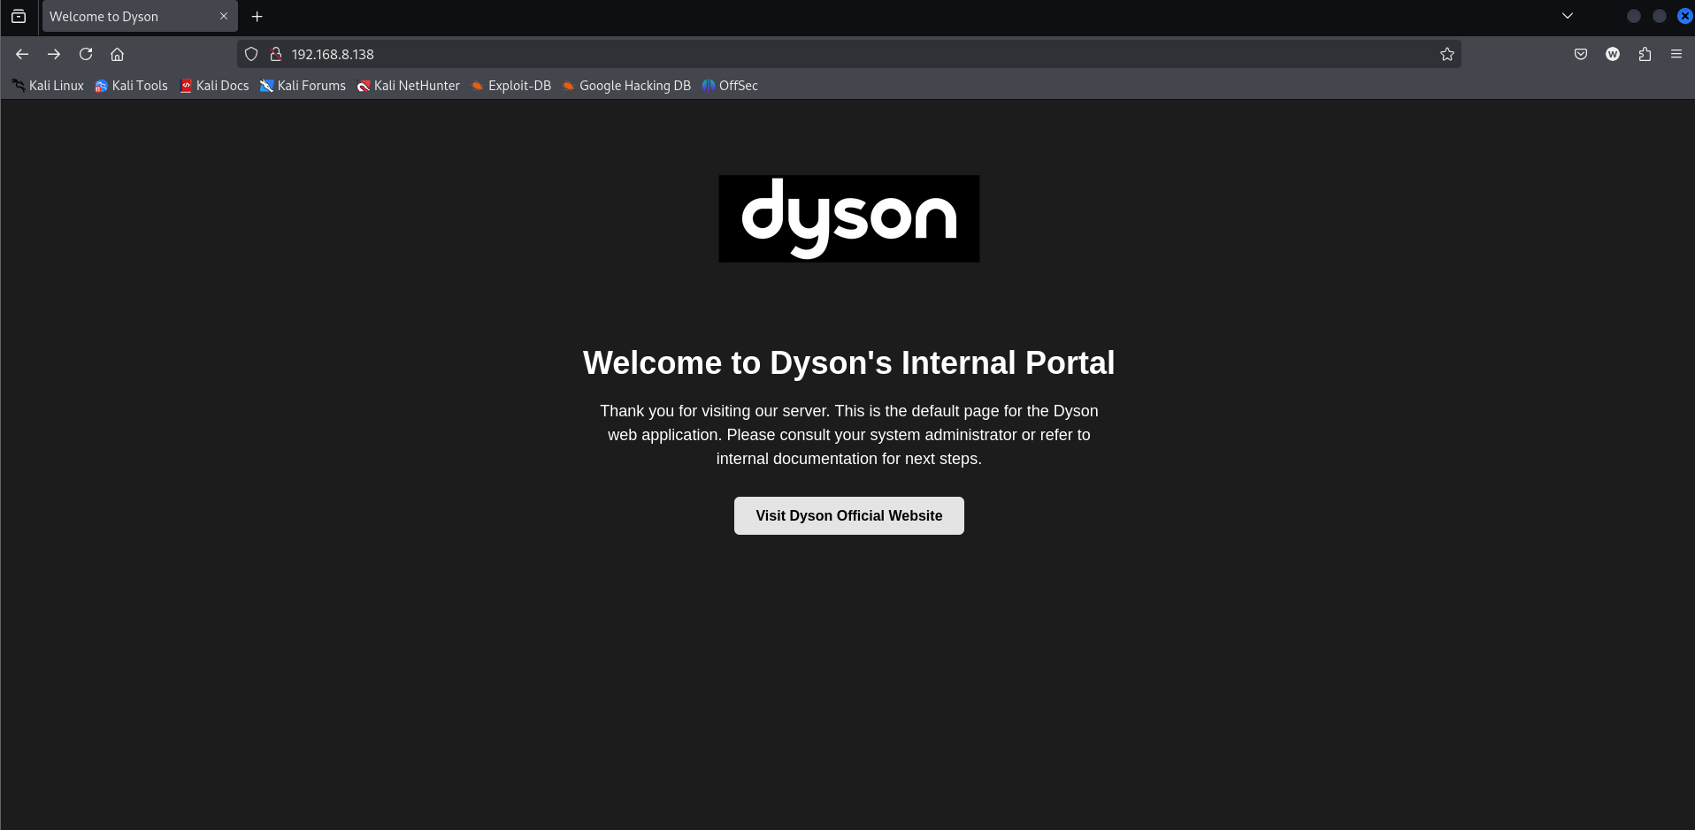

To enumerate the web server even further, the attacker can use an Nmap script “http-enum” to find out even more information about the web server. The results gave an interesting directory “/webdav/” that requires authorization as seen from the login below:

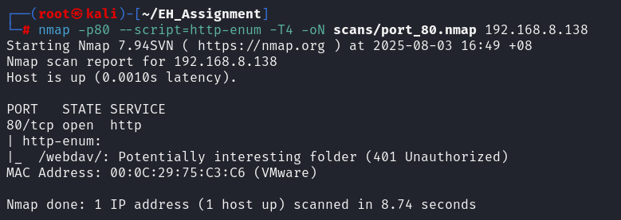

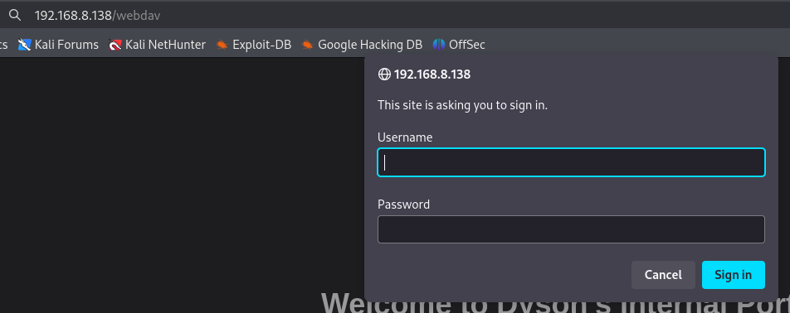

For the web server, since a set of credentials is required, we can assume the NetBIOS name as the username used together with the password obtained in the Evil Twin Attack (HQ-IT-PC01:p@ssw0rd).

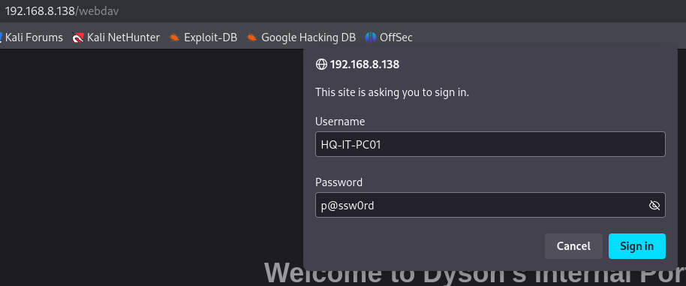

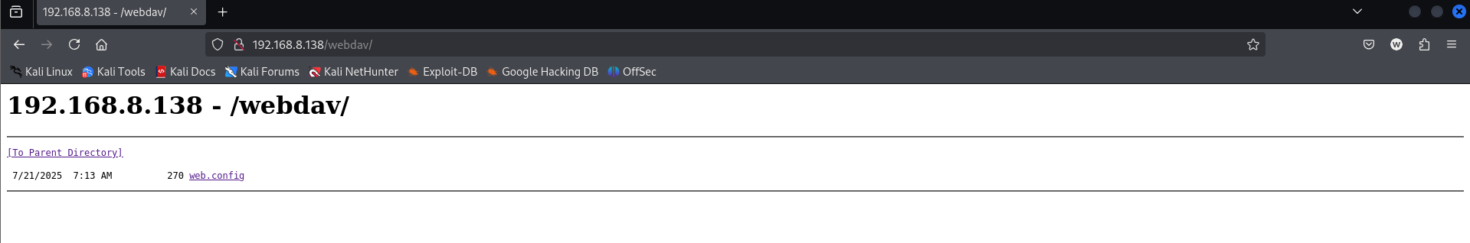

The credentials worked and the attacker is successfully signed into the IIS web server. The initial exploitation of the system with this information will be showcased in the next task.

### Service enumeration – Port 139/445 (SMB / NetBIOS)

Before moving on, there is still the SMB service that seemed interesting. The attacker uses a tool called smbclient to try accessing shares.

Testing to see if anonymous login is enabled, I tried listing shares with an empty password field to no avail.

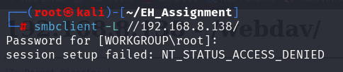

Testing the previous credentials obtained, I successfully retrieved the share names.

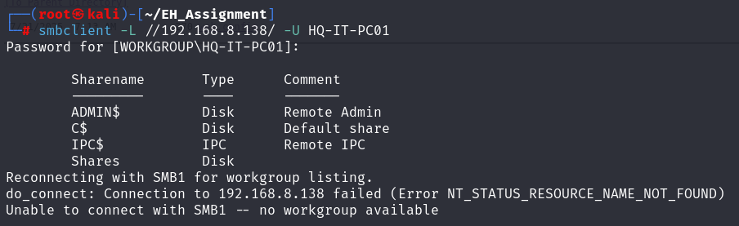

I then logged into the SMB service share called “Shares”. It was found to be empty. The ADMIN$ share seemed interesting, but was not accessible due to permissions.

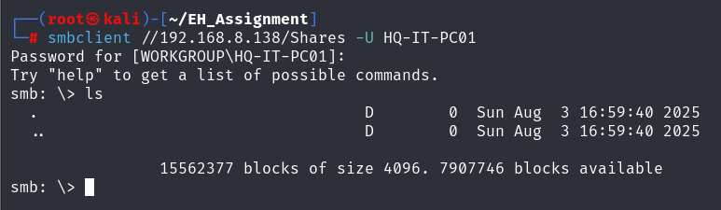

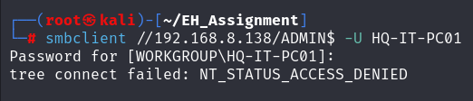

I attempted to use Impacket PsExec tool to try and gain a remote code shell. However, this failed and could not establish a connection.

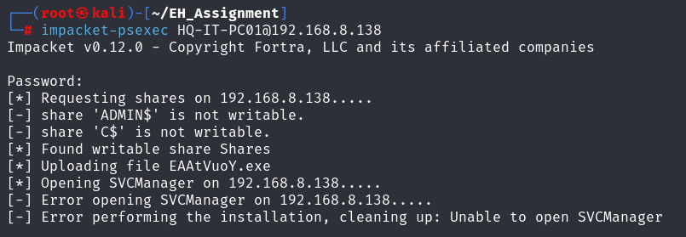

## Task 3 – IIS WebDav Exploit

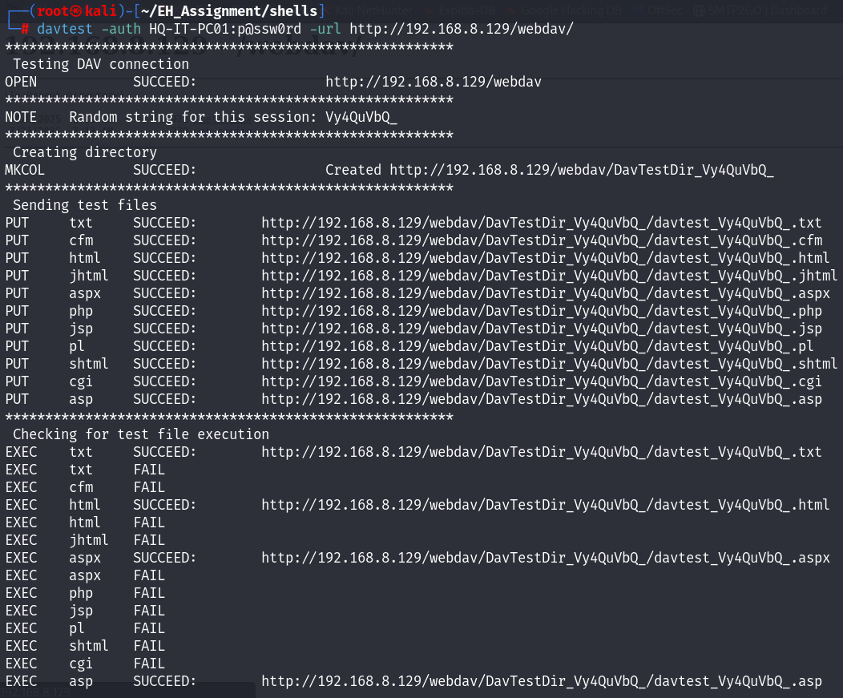The tool davtest is used to assess the capabilities of a WebDAV-enabled server specifically, which file types can be uploaded and executed. In this screenshot, the attacker authenticates to the target WebDAV share (http://192.168.8.136/webdav/) using valid credentials. The screenshot shows that the execution of .aspx file has succeeded which implies that a malicious .aspx web shell can uploaded and executed to gain remote code execution (RCE) on the target system.

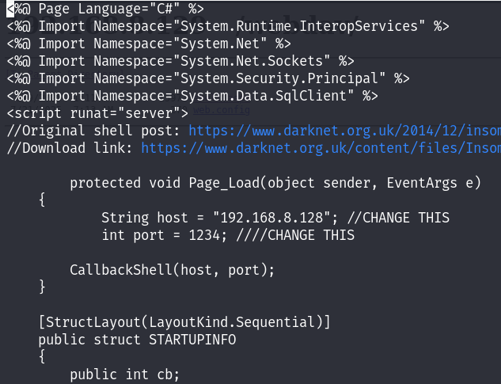

Downloaded a .aspx reverse shell code from github (link in citations), shell.aspx . Change the payload, set the host to the Attacker’s machine IP address (192.168.8.138) and port number to 1234

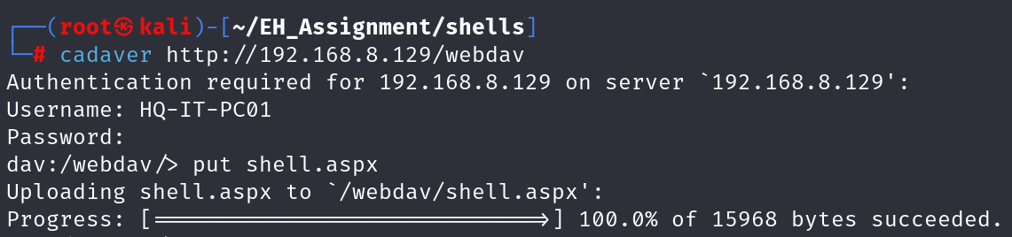Cadaver, a command-line WebDAV client, is used to connect to the web server hosted on the IP address 192.168.8.136 using the /webdav directory. Once connected, upload shell.aspx to the /webdav directory.

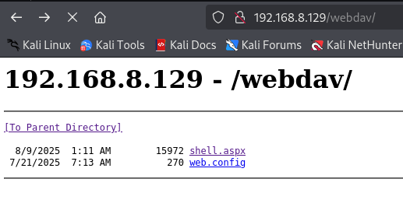

The uploaded shell.aspx is now visible in the /webdav directory on the target server, ready for exploitation.

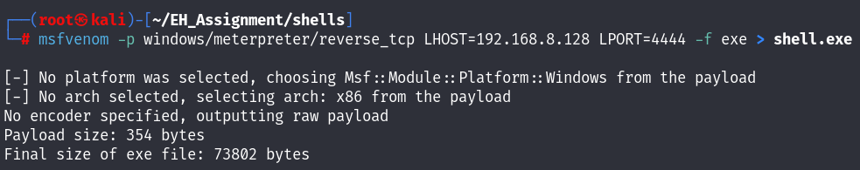On the Attacker’s machine, use msfvenom to generate a reverse shell executable (shell.exe) in /home/kali. The LHOST is set to the Attacker’s machine IP address and LPORT is set to 4444. The reverse shell is configured with LHOST to 192.168.8.138 (Attacker’s IP) and LPORT set to 4444. This will create a Meterpreter reverse shell that attempts to connect back to the attacker’s machine when executed on the victim’s machine.

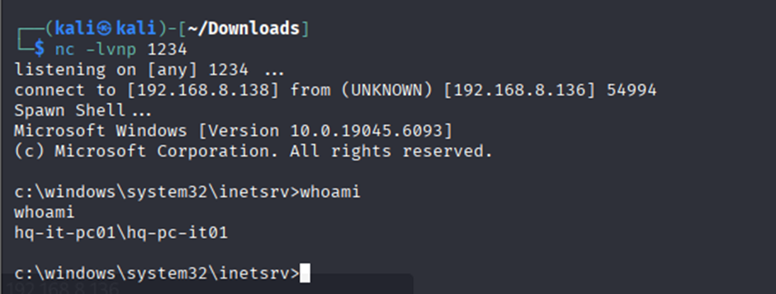A Netcat listener is set up on the Attacker’s machine which listens on port 1234 which is the port number in the reverse shell payload. Then, click on shell.aspx on the web server, the payload will be executed, causing the target machine (192.168.8.136) to initiate a connection back to the attacker's Netcat listener. As shown, a reverse shell is successfully established, providing us with command-line access to the Windows target. The whoami command confirms the session is running under the context of the user hq-it-pc01\hq-pc-it01.

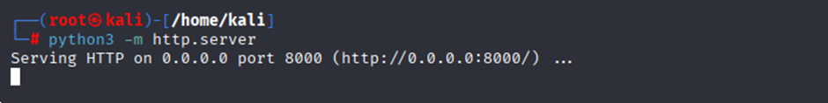Setting up Python HTTP server on the attacker’s machine so that on the victim’s machine, certutil can be used to fetch shell.exe from the Python HTTP server that is running on the attacker’s IP.

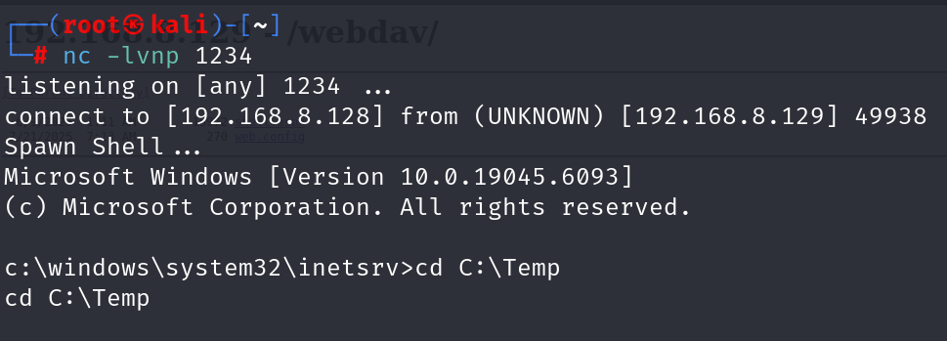Now that the connection is established, navigate to C:\ directory and create a temp directory where certutil is used to download shell.exe from the attacker’s machine at 192.168.8.138:8000/shell.exe and naming it shell.exe to be stored in the victim’s machine in C:\temp.

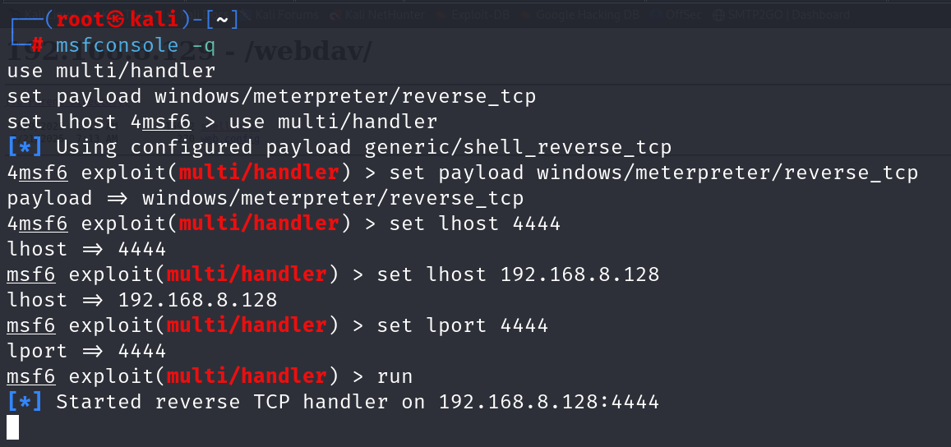

On the attacker’s machine, msfconsole is used to start metasploit and the multi/handler module is used to listen for incoming connections from the victim machine. This is essential for handling the reverse shell once the payload is executed on the victim’s machine. The LHOST is set to the attacker's machine IP address (192.168.8.138). This is the address the victim's payload will connect to once executed. The LPORT is set to 4444. run to start the listener.

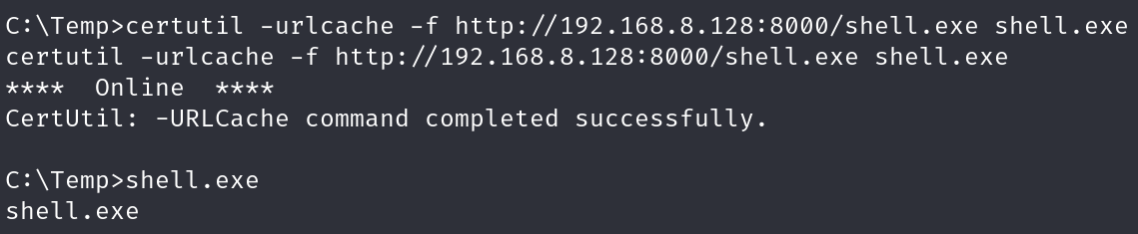After shell.exe is downloaded, dir to verify that shell.exe is in C:\temp. Then execute shell.exe.

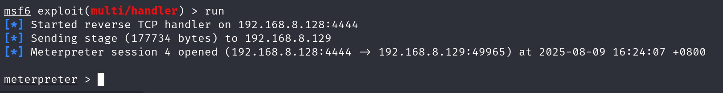After executing shell.exe, the reverse shell is successfully triggered, establishing a command-line connection back to our machine, and allowing us to control the victim machine remotely.

## Task 4 – Post-exploitation local enumeration

After gaining the initial foothold on the target machine, the attacker now requires more information in order to find a path to escalate privileges and gain access to the internal network.

### Categories of information gathered

* System information
* Users, groups & privileges
* Network information
* Processes & Services

For each category, all information retrieved is stated at the top. Screenshots of commands ran to obtain the information is shown after.

### System Information

* Hostname (HQ-IT-PC01)
* OS Name (Microsoft Windows 10 Enterprise Evaluation)
* OS Build (10.0.19045 N/A Build 19045)
* OS Architecture (x64)
* Installed updates / Hotfixes (6 Update and 4 Security Update)
* Domain name (DYSON)

The systeminfo command displays information about the system of the machine. This is where the information about the system’s hostname, OS name, OS build and OS Architecture is found.

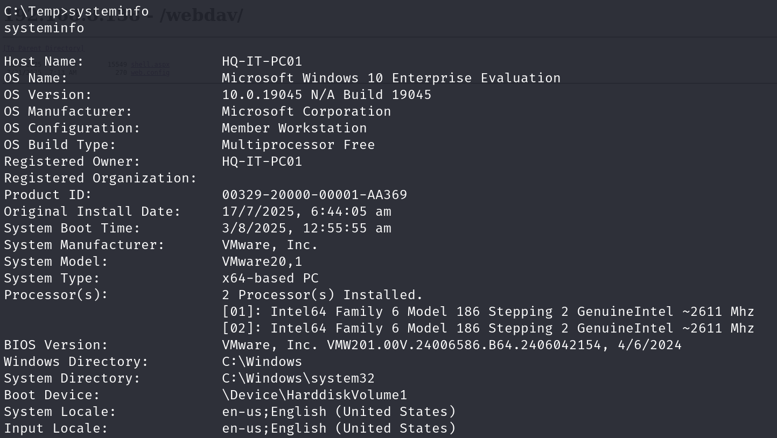

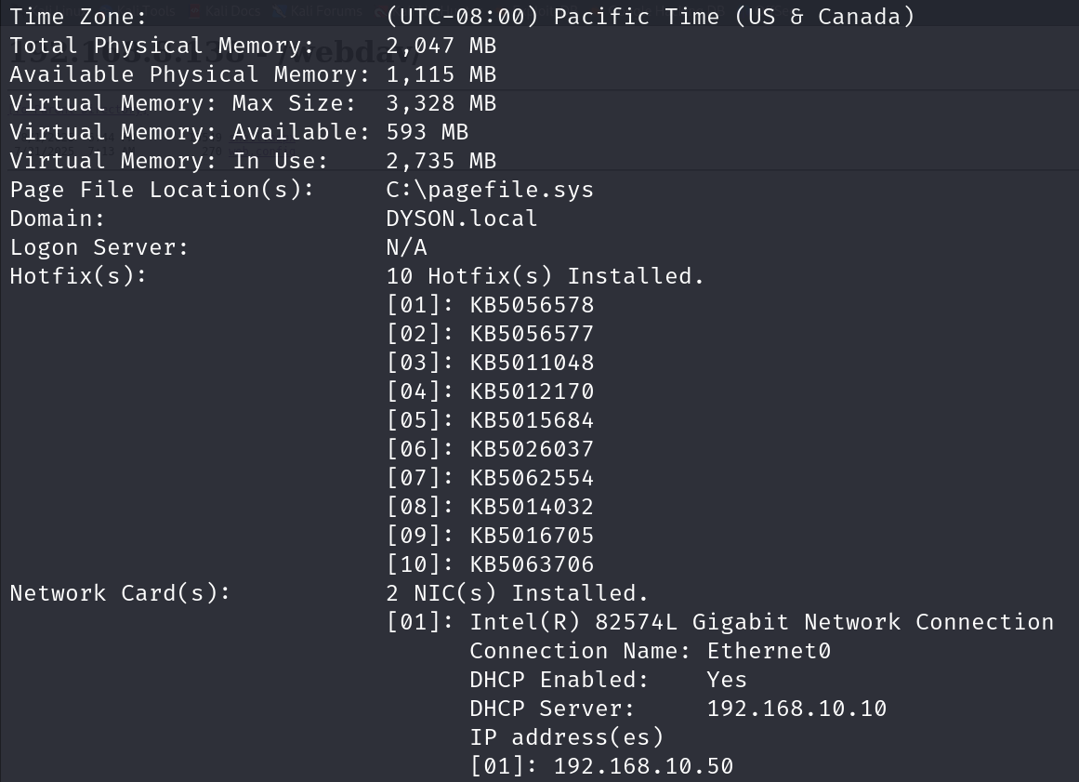

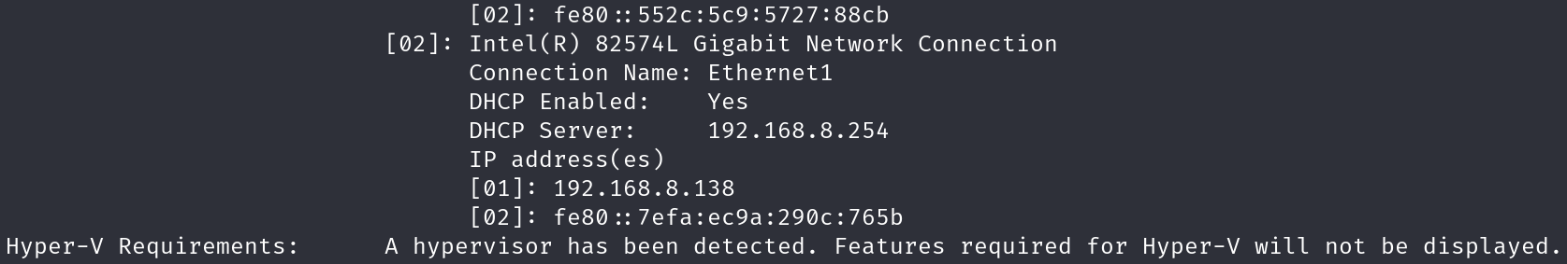

The command below lists all hotfixes installed on the machine. This is useful as those with the description ”Security Update” can tell us what exploits have already been patched or what exploits work against the target.

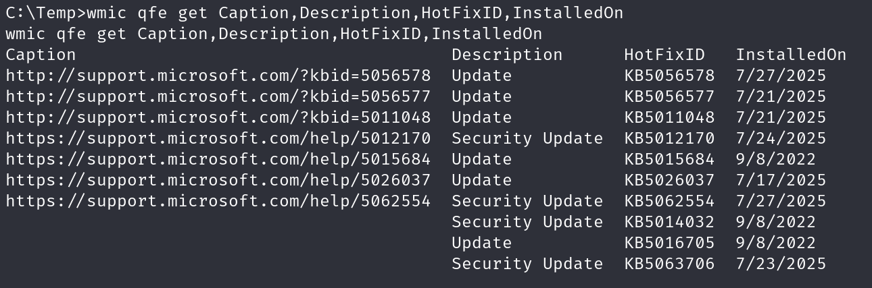

The sysinfo command from the meterpreter shell gives the name of the domain the target machine is in. This indicates that an active directory network named “DYSON” is present and this machine is part of it.

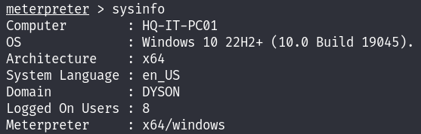

### Users & Groups

* Current user (HQ-IT-PC01\ HQ-IT-PC01)
* Privileges
  + SeChangeNotifyPrivilege
  + SeImpersonatePrivilege
  + SeCreateGlobalPrivilege
* Additional user information
* Other users on the system
  + Administrator
  + DefaultAccount
  + Guest
  + HQ-IT-PC01
  + WDAGUtilityAccount
* Groups
  + Access Control Assistance Operators
  + Administrators
  + Backup Operators
  + Cryptographic Operators
  + Device Owners
  + Distributed COM Users
  + Event Log Readers
  + Guests
  + Hyper-V Administrators
  + IIS_IUSRS
  + Network Configuration Operators
  + Performance Log Users
  + Performance Monitor Users
  + Power Users
  + Remote Desktop Users
  + Remote Management Users
  + Replicator
  + System Managed Accounts Group
  + Users
* Members of the built-in administrator group
  + Administrator
  + DYSON\Domain Admins
  + DYSON\IT-PC01
  + HQ-IT-PC01

The whoami command shows the user that we are logged into.

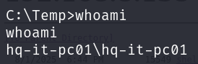

The whoami /priv shows the enabled/disabled privileges that the current user has.

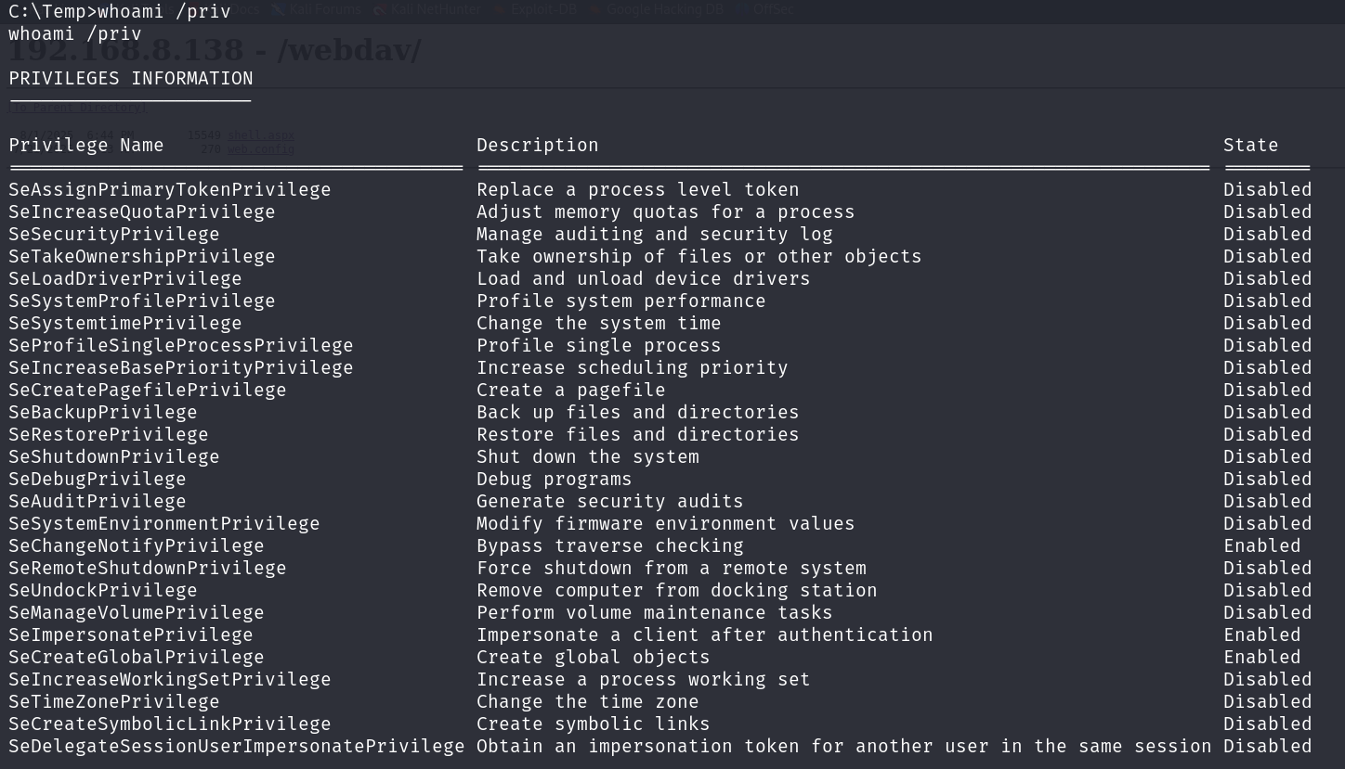

The net users command lists all user accounts on the machine.

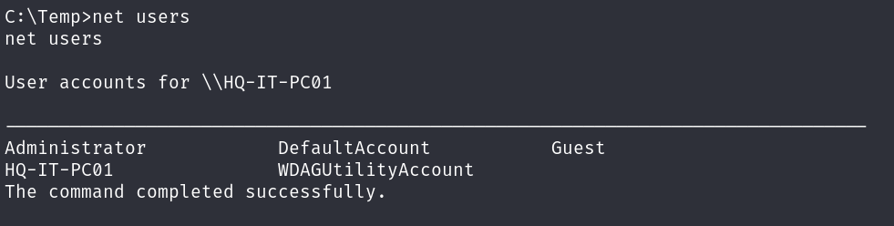

The “net user HQ-IT-PC01” command shows additional information about the “HQ-IT-PC01\HQ-IT-PC01” user.

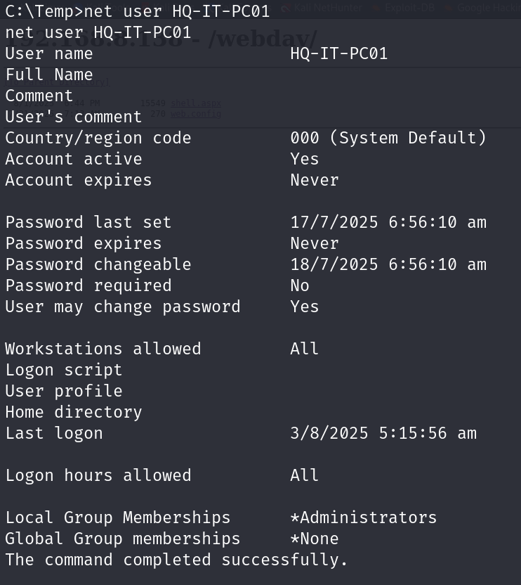

The net localgroup command lists out all the groups that exists on the machine. This is useful if the attacker wants to check what group which users are in to know what permissions each user account has.

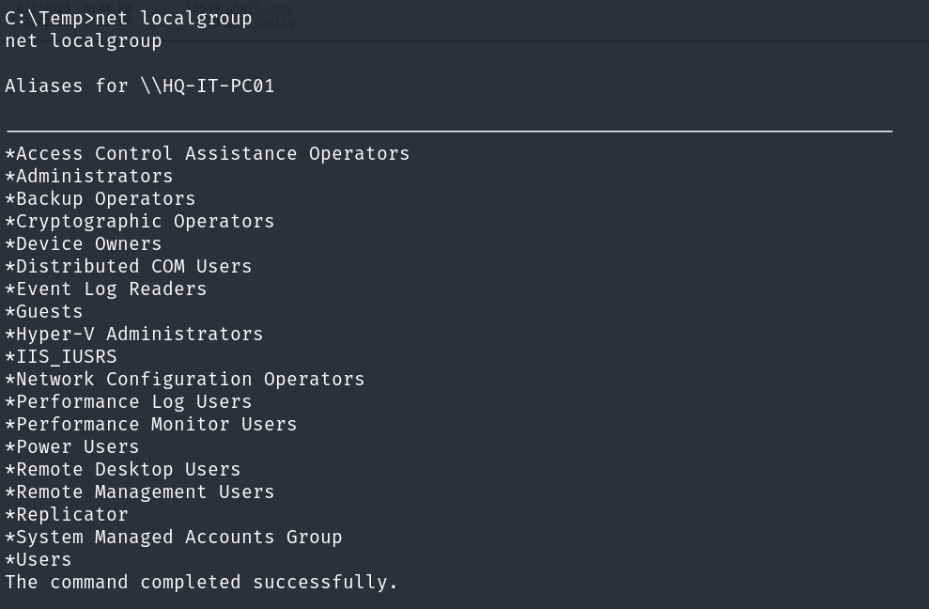

To see who is in the localgroup “Administrators”, the attacker uses the command “net localgroup Administrators”.

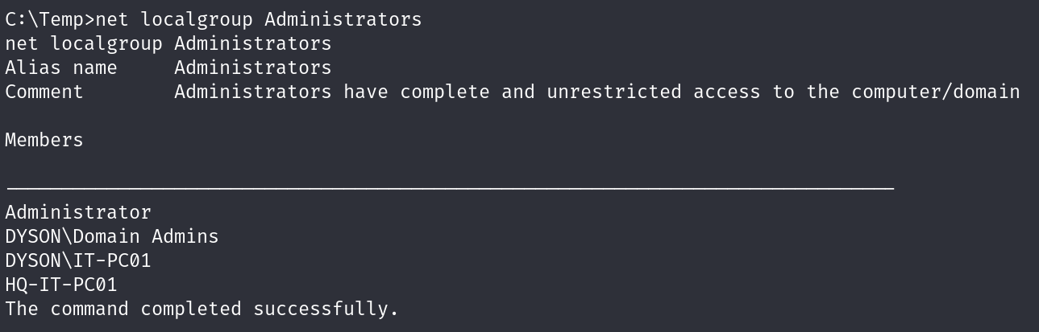

### Network Information

* Current IP address (192.168.10.50 & 192.168.8.138)
* Network adapter (Ethernet0 & Ethernet1)
* Active Directory DNS (DYSON.local)
* Internal networks (192.168.10.0/24)
* Other hosts on the network (192.168.10.10)
* Routing table
* Windows Firewall state (Off)

This shows the active directory domain DNS “DYSON.local”, 2 ethernet adapters with 2 different IP addresses in 2 different subnets. The IP address 192.168.8.138 is the internet-facing one while 192.168.10.50 is used for the internal network. The internal network is found to be 192.168.10.0/24.

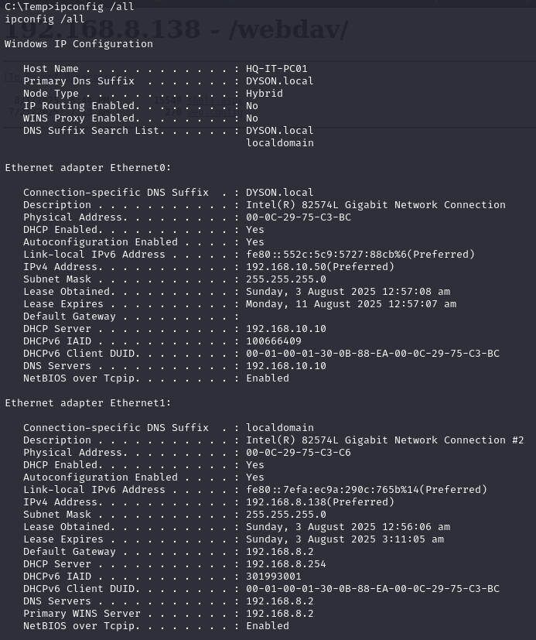

This shows the routing table of the machine.

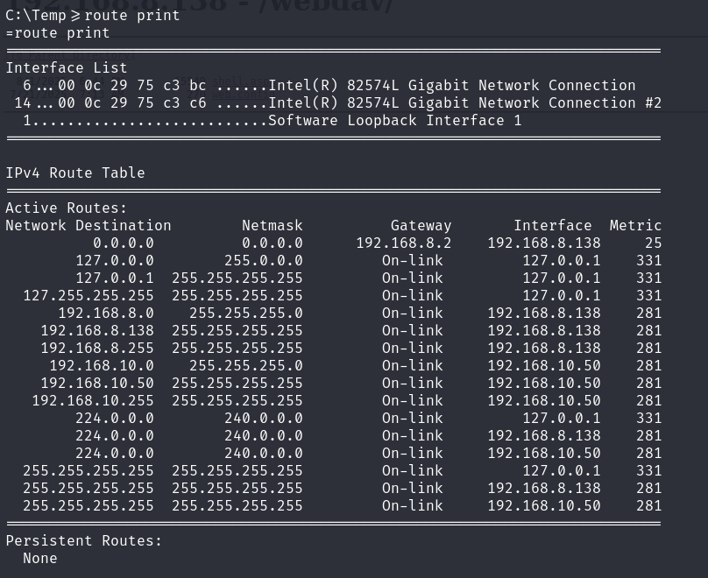

The arp -a command is able to identify another device in the internal network with an IP address 192.168.10.10. This is likely to be the domain controller but is not confirmed with the current information we have so far.

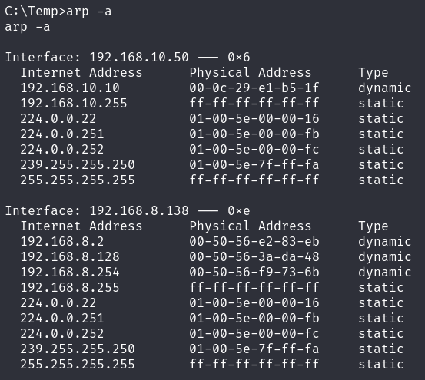

This shows the status of the host-based firewall. All the firewalls have been turned off.

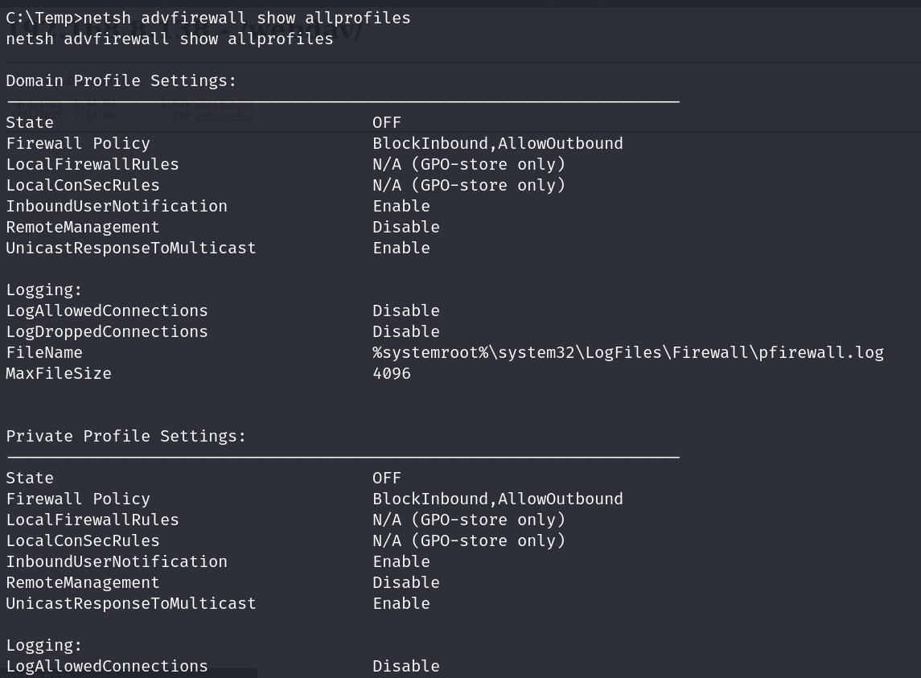

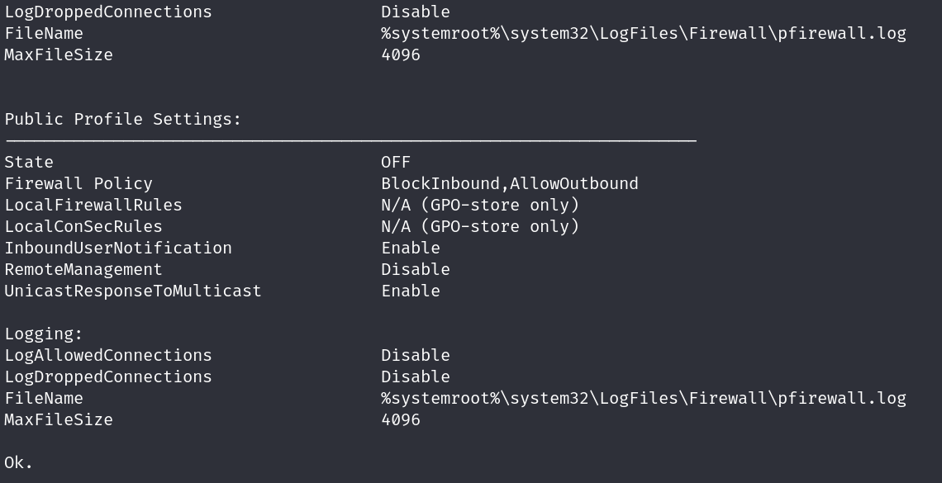

### Processes & Services

* Running processes & services
* Schedules tasks

#### Processes vs Services

Process is defined as an instance of a running executable or program. An example of a process would be Google Chrome. On the other hand, service is defined as a process which runs in the background and does not interact with the desktop.

The ps command shows the running processes on the machine. This information is used in a later task to perform privilege escalation to the DYSON\Administrator account.

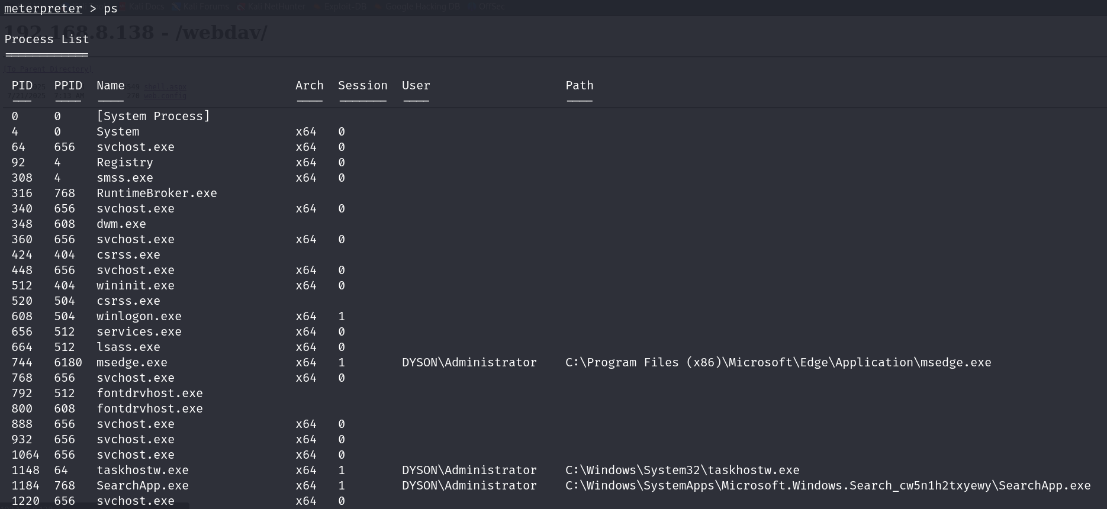

The tasklist /SVC command lists processes and services running under each process.

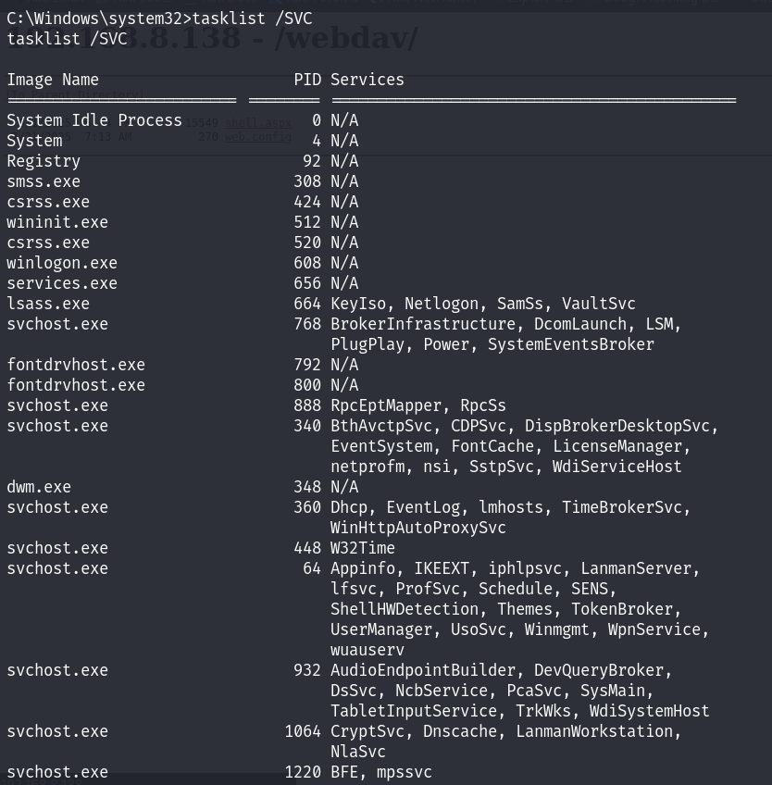

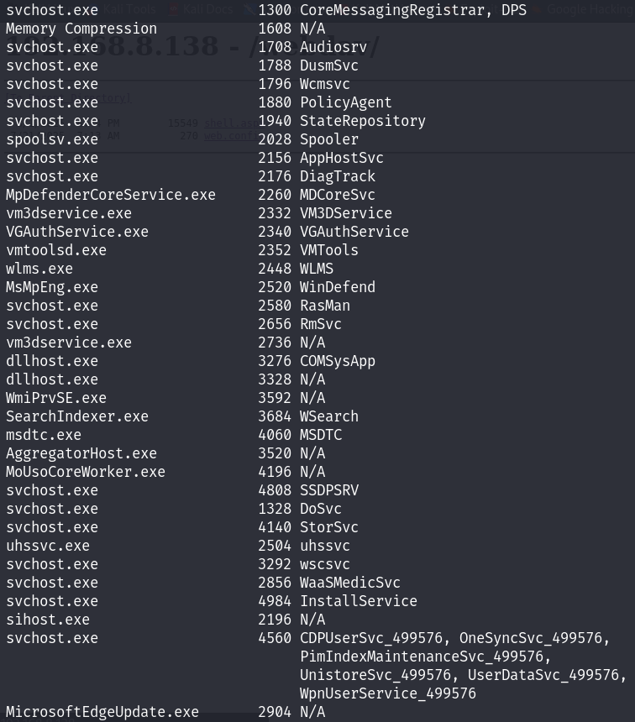

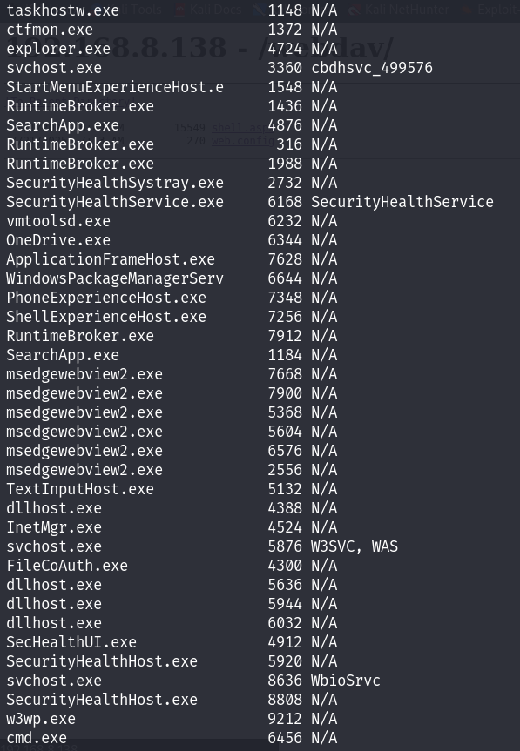

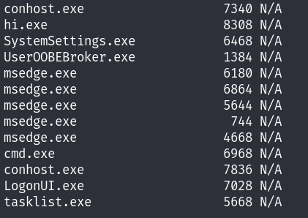

## Task 5 - Privilege Escalation through Process Migration

After local enumeration, many processes are found to be running on the system. The attacker can take advantage of these processes, especially those ran by users with higher privileges.

In this task, the attacker would first find a suitable and stable process. A good example of one would be explorer.exe.



In this case, the explorer.exe process is ran by DYSON\Administrator. This meets the requirements for the privilege escalation technique to be successful.

With the meterpreter shell, a powerful command “migrate” can be used to change from running in one process to another. Since the attacker already have the PID of explorer.exe which is 4724 from enumerating the system, the attacker can run “migrate 4724” and this would change to explorer.exe process. To verify that this privilege escalation technique worked, we run a simple “getuid” command to retrieve the user that the attacker is running as. Sure enough, we are now DYSON\Administrator.

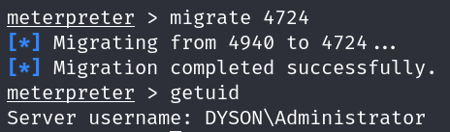

## Task 6 – Token Impersonation Privilege Escalation

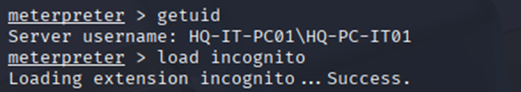

Use getuid to retrieve the user id of the current user. Load incognito is used to help impersonate users or elevate privileges on a Windows domain by manipulating Kerberos tickets.

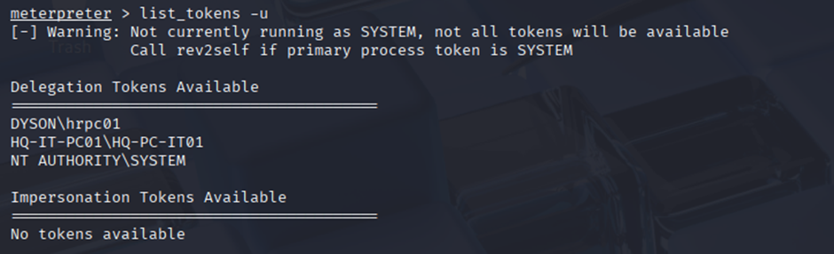

Using the list_tokens -u command, lists the available user tokens on the victim's machine. The NT AUTHORITY\SYSTEM token, which holds the highest privileges, is available for impersonation.

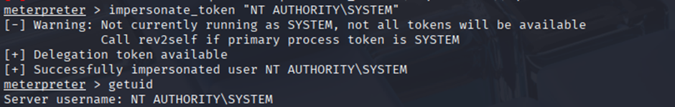

Impersonate the NT AUTHORITY\SYSTEM token, thereby elevating our privileges to SYSTEM level, which grants full administrative control over the machine. After impersonating the SYSTEM token, getuid again, confirming that user context is now NT AUTHORITY\SYSTEM which means privilege escalation is successful.

## Task 7 – Tunnelling with Ligolo-ng

### Reason for tunnelling

Without setting up a tunnel from the attack machine to the exploited target machine, it is not possible for the attacker to reach the internal network of the target.

To proof this, since we already know that there is an internal host running with the IP address 192.168.10.10, we can try to ping it on the attacker’s kali machine:

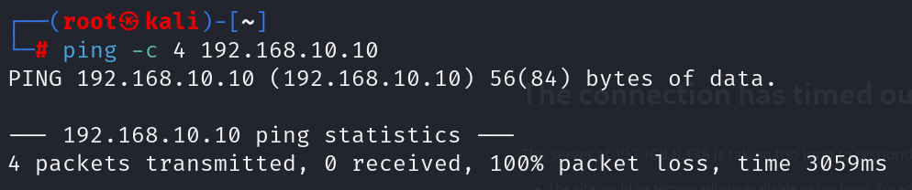

No matter how powerful the tools used by the attacker, if an exploit only works remotely, they would be useless without the ability to communicate with the internal network devices. This is where Ligolo-ng comes into play.

### What is Ligolo-ng?

According to the Kali Linux documentations, Ligolo-ng is a simple, lightweight and fast tool that allows pentesters to establish tunnels from a reverse TCP/TLS connection using a tun interface (without the need of SOCKS).

### Setting up Ligolo-ng

1. Download both the agent and proxy from github (link to the download page can be found in the citations section)



1. Extract both the files downloaded.

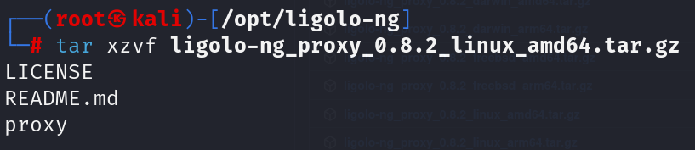

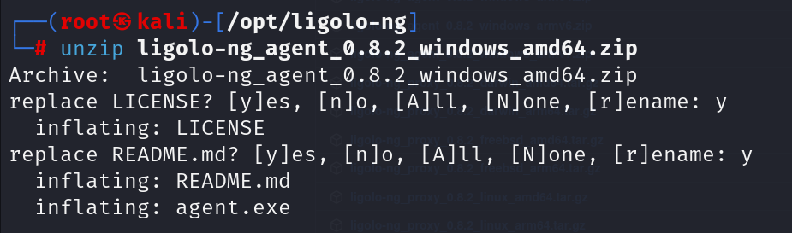

1. Set up a tunnel interface on kali. It will be called “ligolo”.

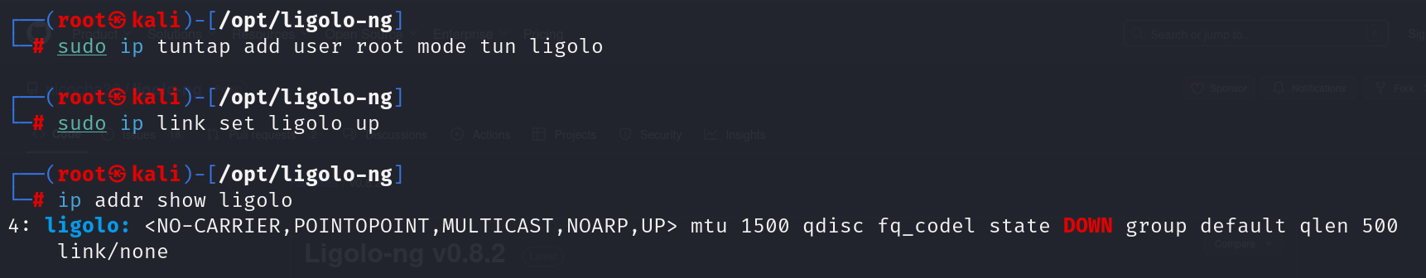

1. Start Ligolo-ng using the proxy executable downloaded earlier. It is now listening on port 11601 for connections made back to the kali machine.

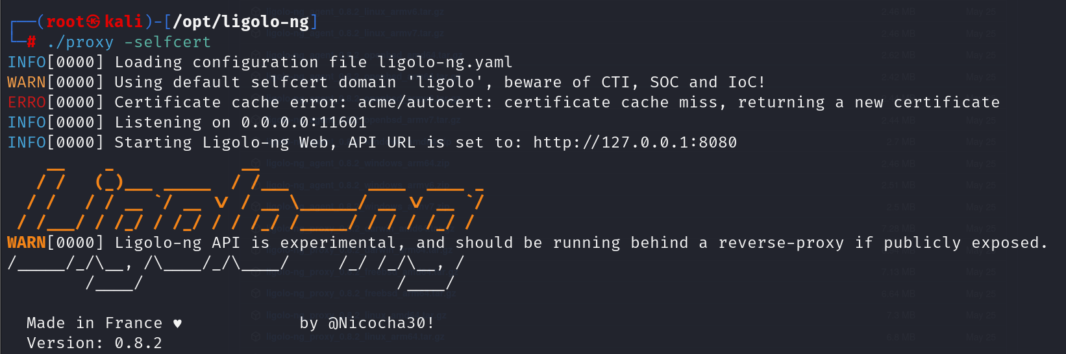

1. Transfer the agent executable file to HQ-IT-PC01.

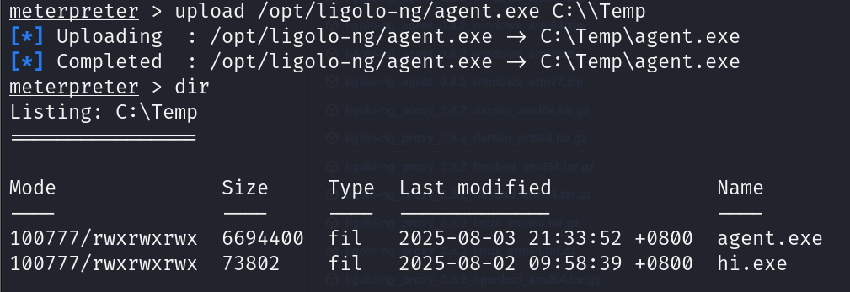

1. Run the agent executable that connects back to the Ligolo-ng listener running on the kali machine. We can verify the connection on kali.

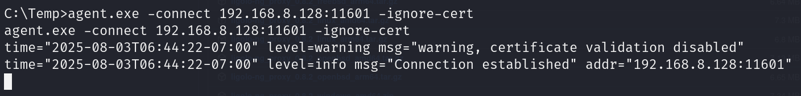



1. Select the session with the agent that joined (HQ-IT-PC01)



1. Running ifconfig displays the network interfaces of the HQ-IT-PC01 machine.

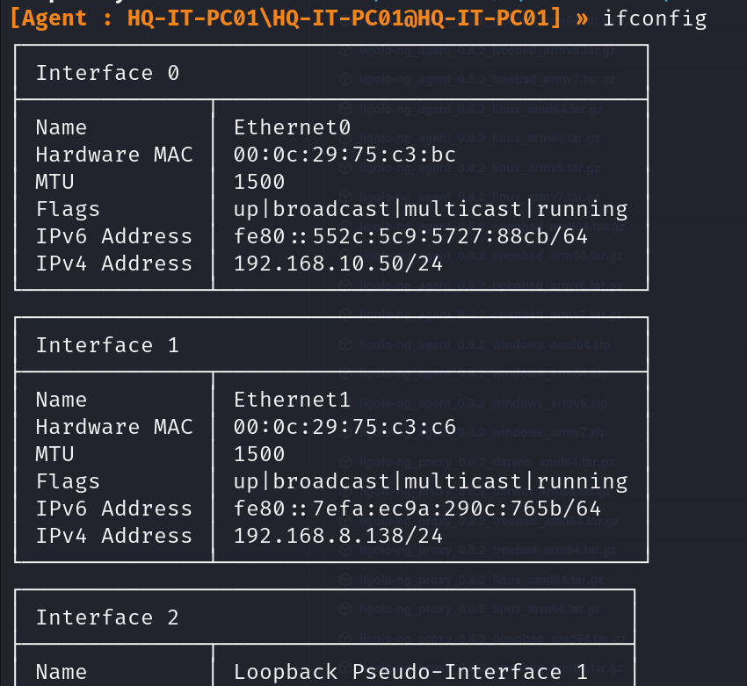

1. Add a networking route to the internal network on the “ligolo” interface

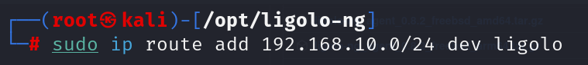

1. Start the tunnel to the pivot machine



1. Verifying that the tunnel has been established. One way to do this is by pinging the device with the IP address 192.168.10.10 which is in the internal network:

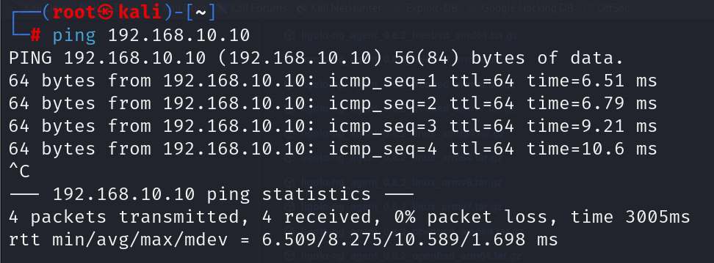

## Task 8 – Active Directory Enumeration

Active Directory enumeration is a critical part of a penetration test. It's a reconnaissance technique that allows an attacker to gather a wealth of information about a domain from an authenticated user's perspective, without generating noisy network traffic that might be detected by security tools. PowerView is a PowerShell module that automates the process of querying Active Directory for users, groups, computers, security policies, and other objects. This helps us to identify potential weak points, such as misconfigured permissions, high-value targets , and possible attack paths. The information gathered with PowerView is essential for planning subsequent phases of an attack, such as privilege escalation, lateral movement, and ultimately, gaining full control over the domain.

### PowerView Setup

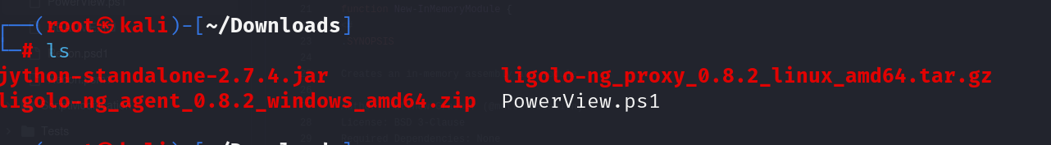

Download Powerview.ps1 from github (link in citations)

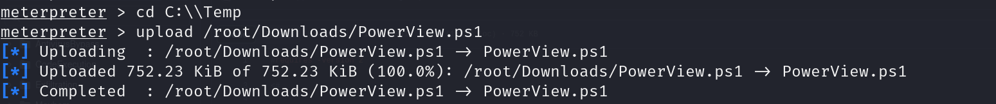

From meterpreter, get a shell and upload PowerView.ps1 into C:\Temp

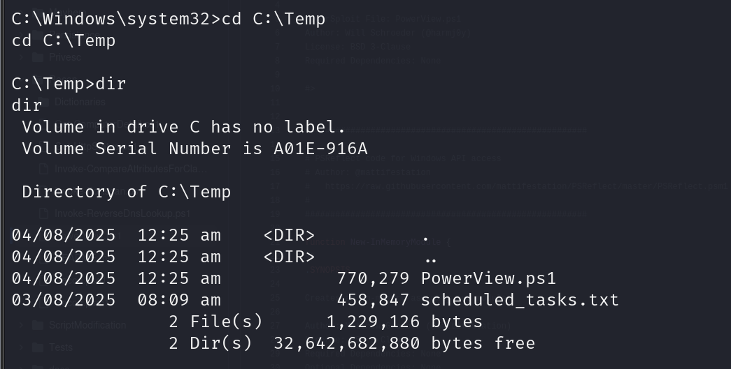

Verify that Powerview.ps1 is inside C:\Temp

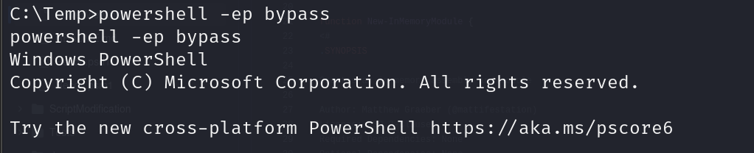

Bypass execution policy to allow the PowerView script to be executed without getting blocked

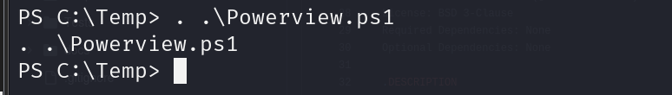

Run PowerView.ps1

### Domain Information

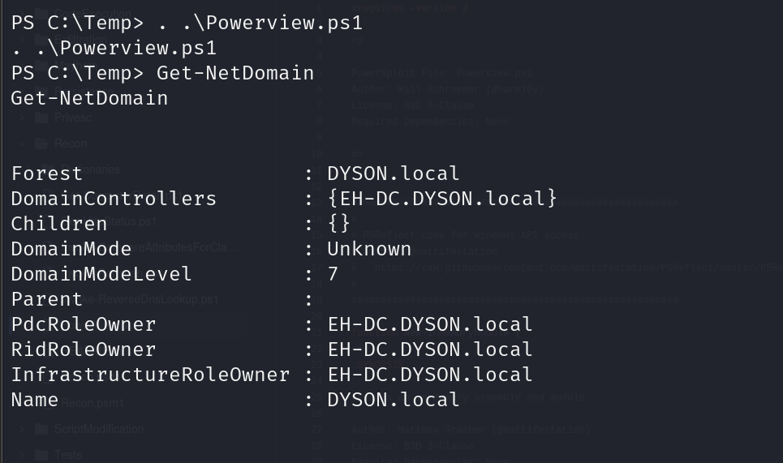

Get-NetDomain to retrieve info about the domain.

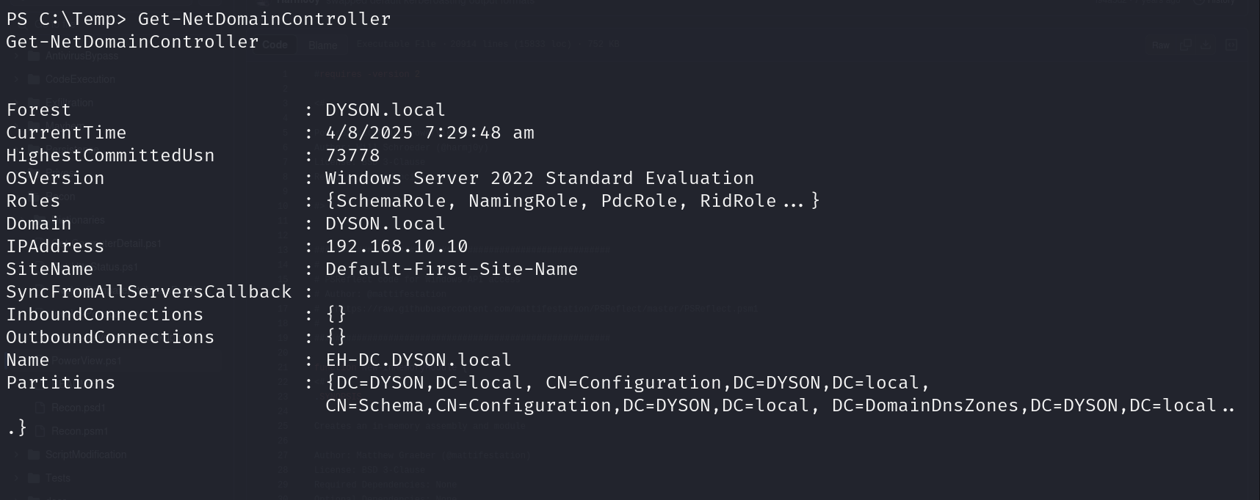

Get-NetDomainController to retrieve information about the domain controller

### Domain Policies

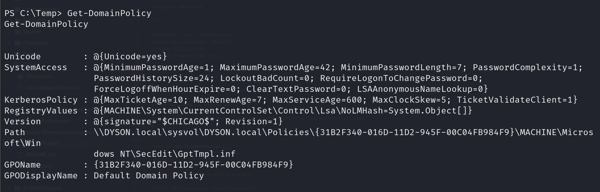

Retrieve the information about the domain policies

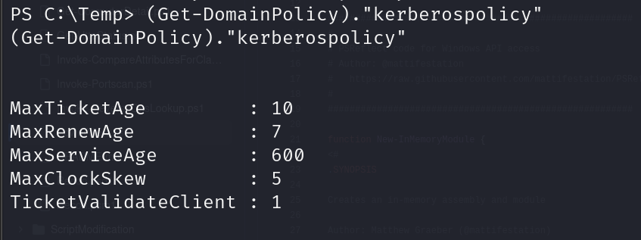

Retrieve kerberos policy so that we have more information for kerberoasting

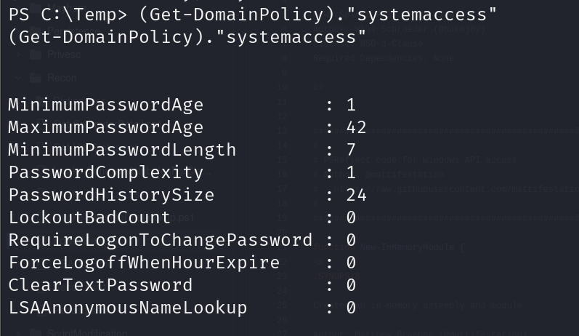

Get information on the system access which tells us that the minimum password length is 7 and can be used to brute force the password

### User Information

Get-NetUser to retrieve all the information of all the users in the domain

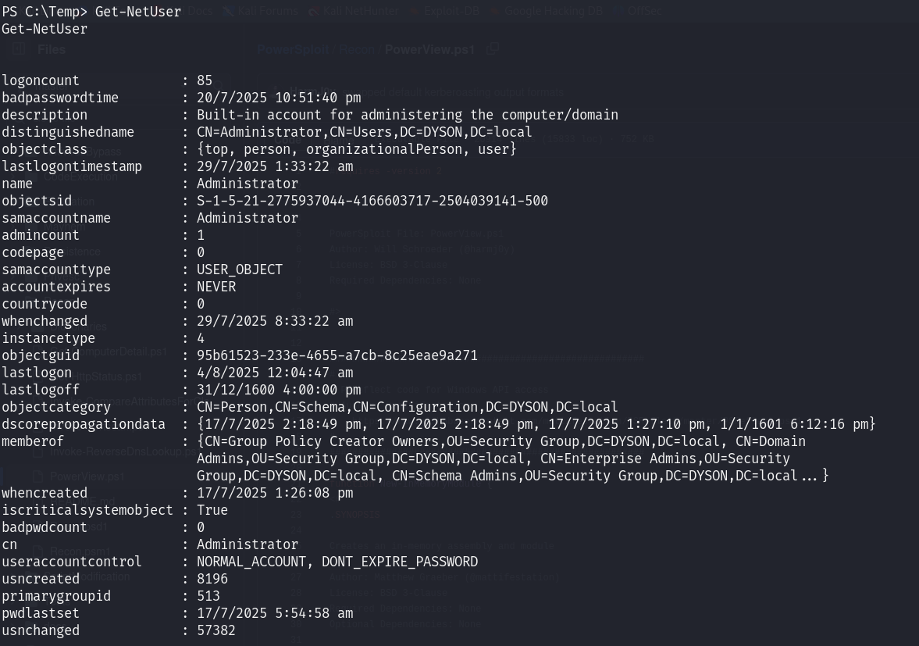

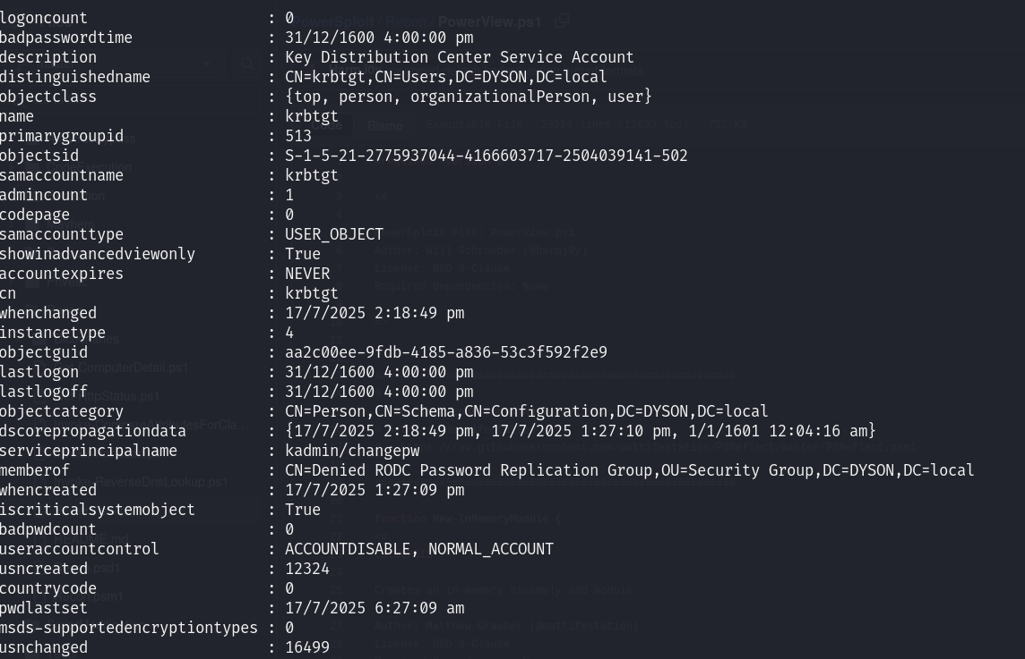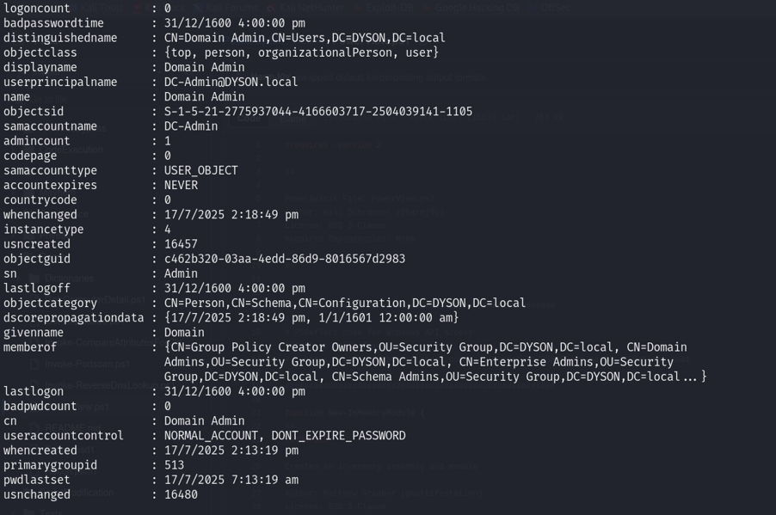

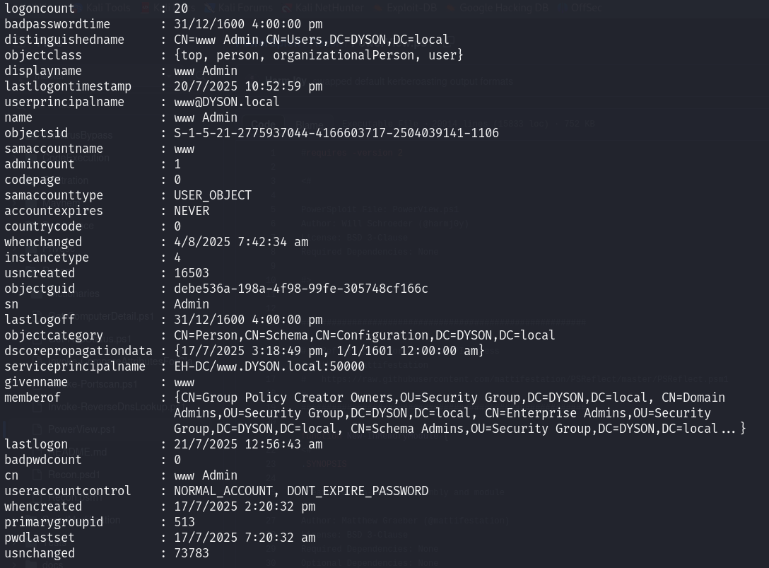

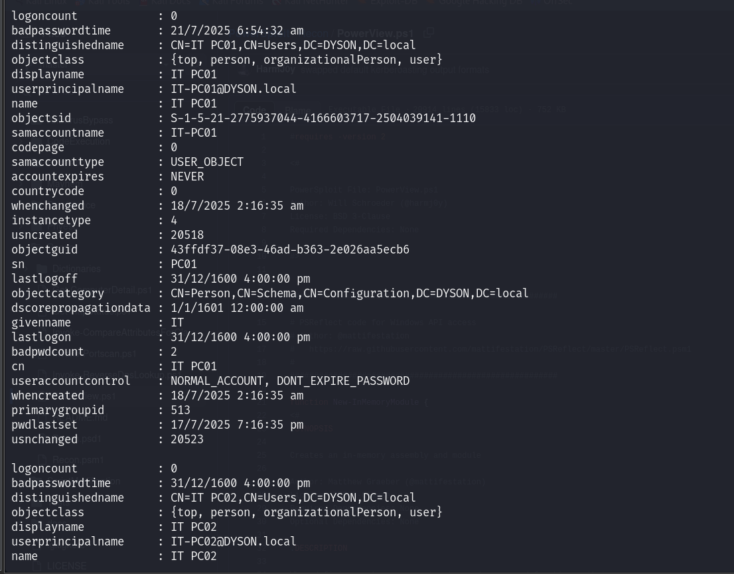

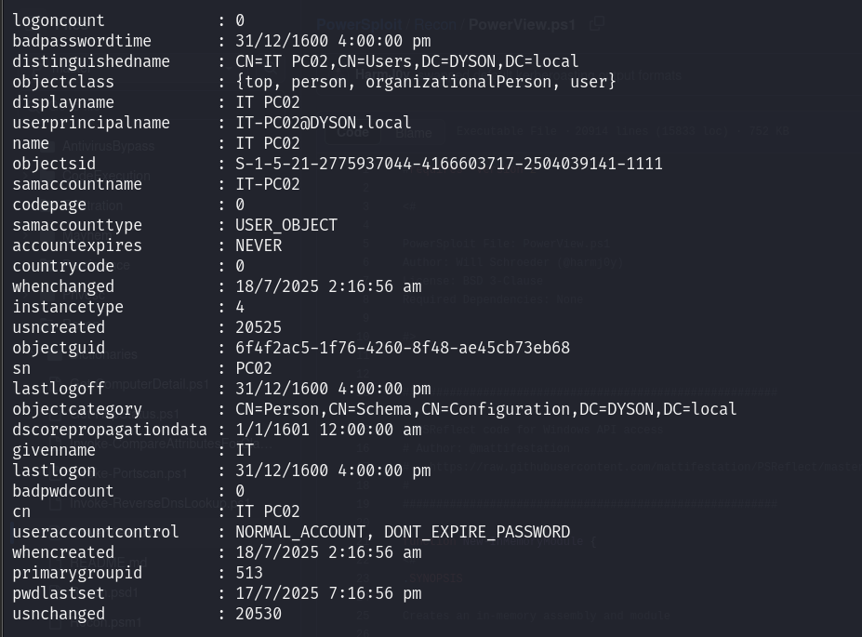

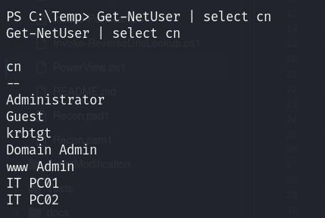

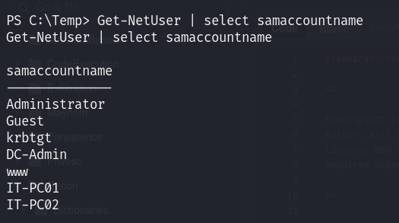

This shows the sam account name of the users where 2 of them are admins which means they have higher privileges. This information can be used to target these 2 users to escalate privileges.

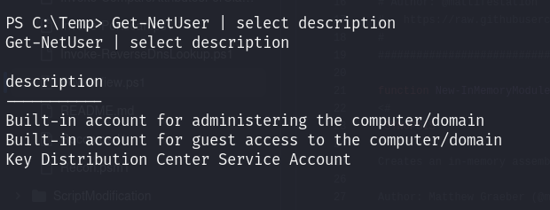

### Computer Information

Get-NetComputer retrieves the information of all the computers that are in the domain which include Service Principal Name (SPN) which is needed for kerberoasting later.

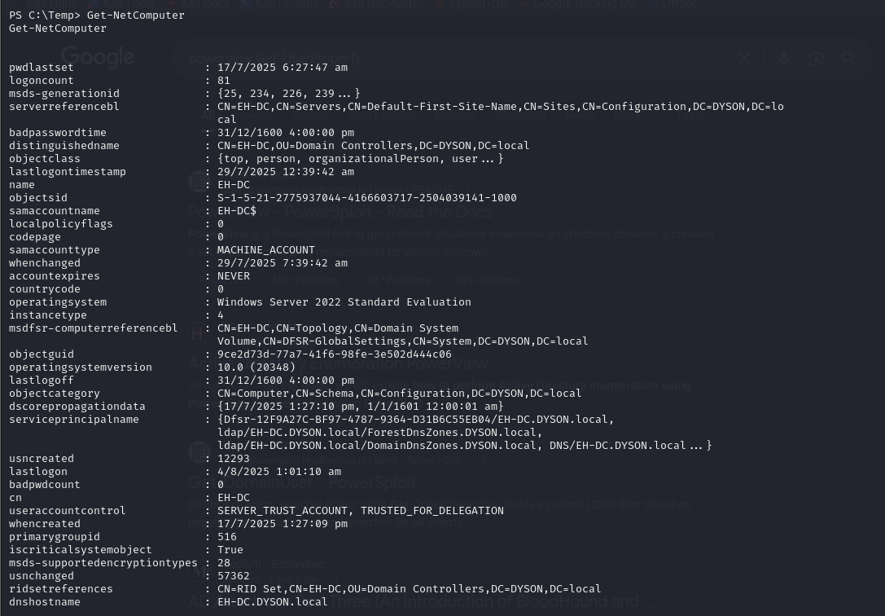

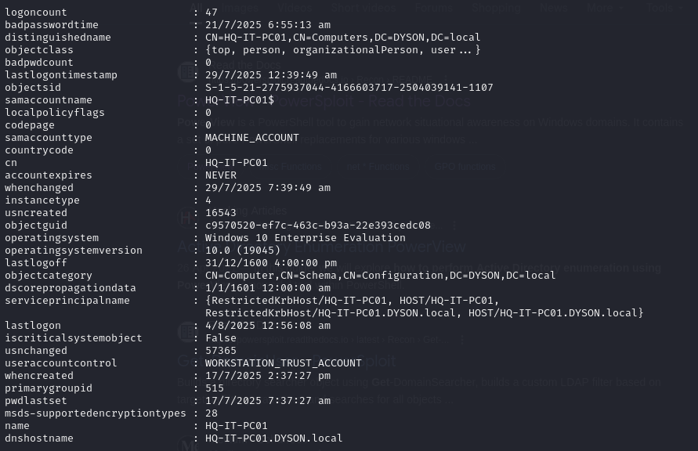

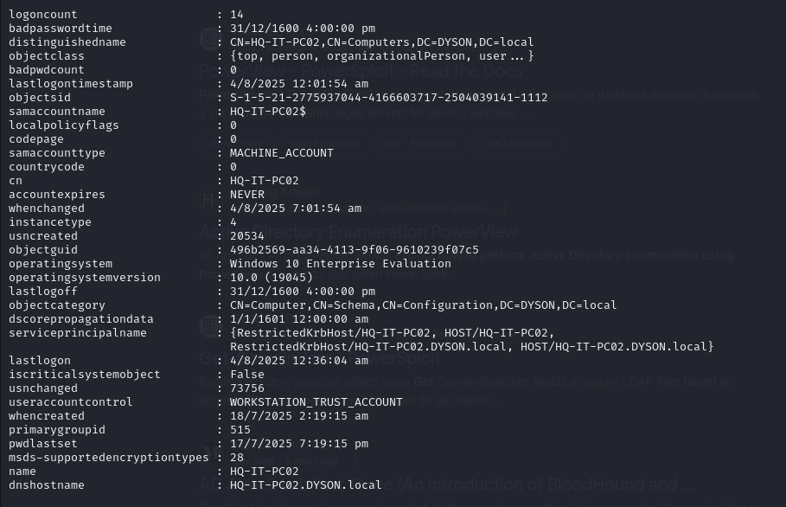

### Group Information

List out all the groups that are in the domain

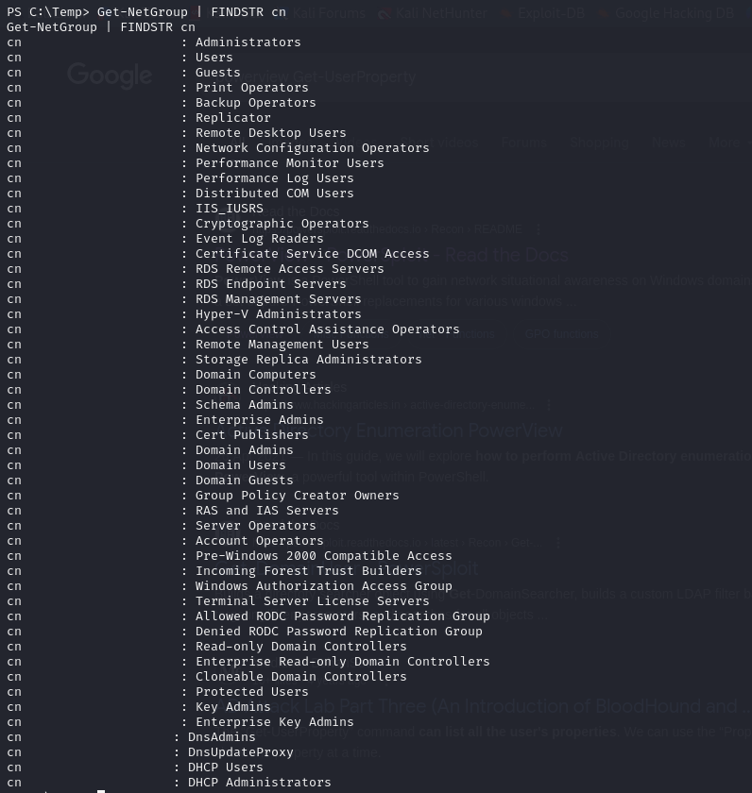

### GPO Information

Retrieve information about the different group policy objects

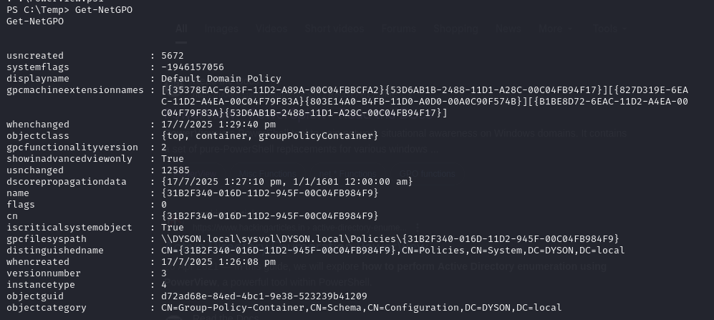

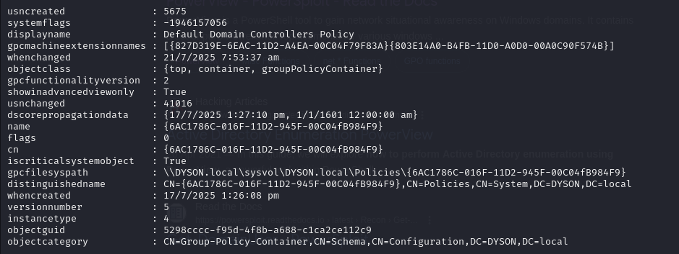

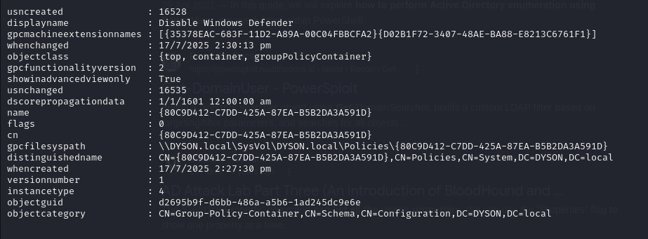

This image shows that there is a GPO called Disable Windows Defender. Vulnerabilities on systems that would normally be patched or mitigated by Windows Defender can now be exploited with much higher success. We could target known exploits for unpatched vulnerabilities without triggering alerts.

## Task 9 - Domain enumeration with Bloodhound

Introduction:

Domain enumeration is a critical phase which involves gathering information about the target domain, including user and group accounts, service accounts, permissions, and the relationships between them. Enumerating the domain is essential for understanding the attack surface and identifying **privilege escalation** opportunities

Bloodhound is a powerful tool used for domain enumeration and Active Directory (AD) enumeration. Bloodhound leverages the graph theory model to visualise attack paths within an Active Directory Infrastructure, making it a critical tool for us to identify attack vectors and potential privilege escalation paths.

* Privilege Escalation: By identifying relationships and permissions between users, groups, and services, Bloodhound helps locate potential privilege escalation paths within a network. Attackers can exploit these paths to gain higher levels of access, including domain administrator rights.
* Attack Path Visualization: Bloodhound generates a graphical representation of a domain's trust relationships and attack paths, making it easier to understand the structure and identify potential vulnerabilities.
* Identify Misconfigurations: It helps identify misconfigurations in AD, such as users with excessive privileges or improper group memberships, which are common entry points for attackers.

Bloodhound operates in two parts:

1. Bloodhound interface (GUI): A web-based interface that allows us to analyse the attack paths and the overall structure of the domain using their graphical function. It helps visualise how an attacker could escalate privileges and move through the network.
2. Bloodhound Tools that collect information about the domain: Sharphound (Bloodhound’s enumeration tool that runs on windows to collect data on groups, users, trusts, and permissions).
3. Run neo4j console

Bloodhound runs on a tool called neo4j console (a graph database platform) to store and query Active Directory enumeration data. When setting up Bloodhound, the default password for the Neo4j console is typically set to neo4j, which is a weak password. For security purposes, it is critical to change this default password to a strong, unique one to prevent unauthorized access to the database and ensure the integrity of your environment.

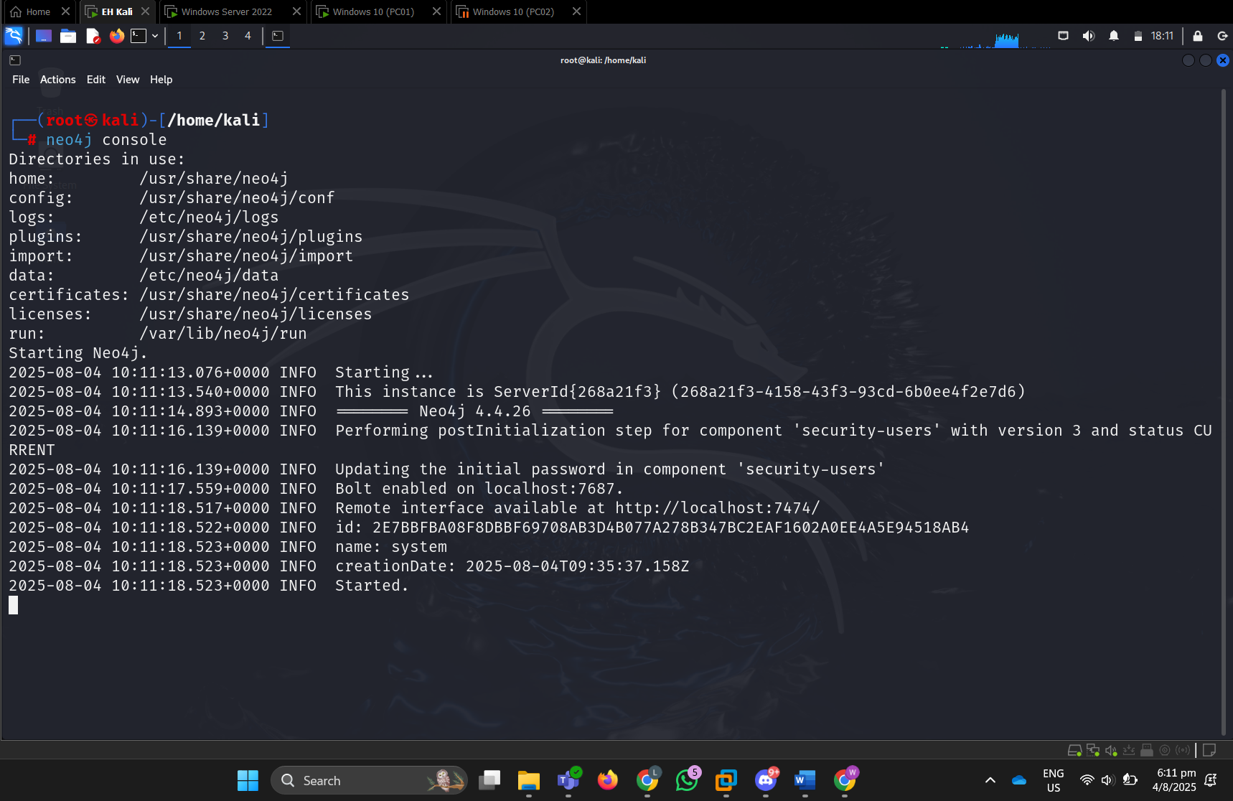

It is important to run bloodhound-setup to set up the bloodhound database if this is the first time running bloodhound.

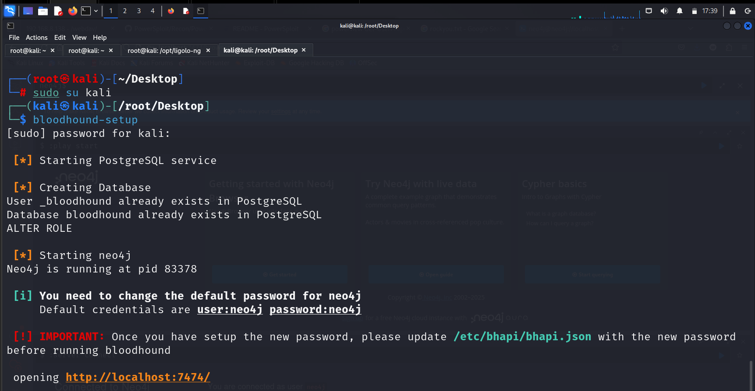

1. Head over to /etc/bhapi/bhapi.json to change the neo4j console password to the desired password.

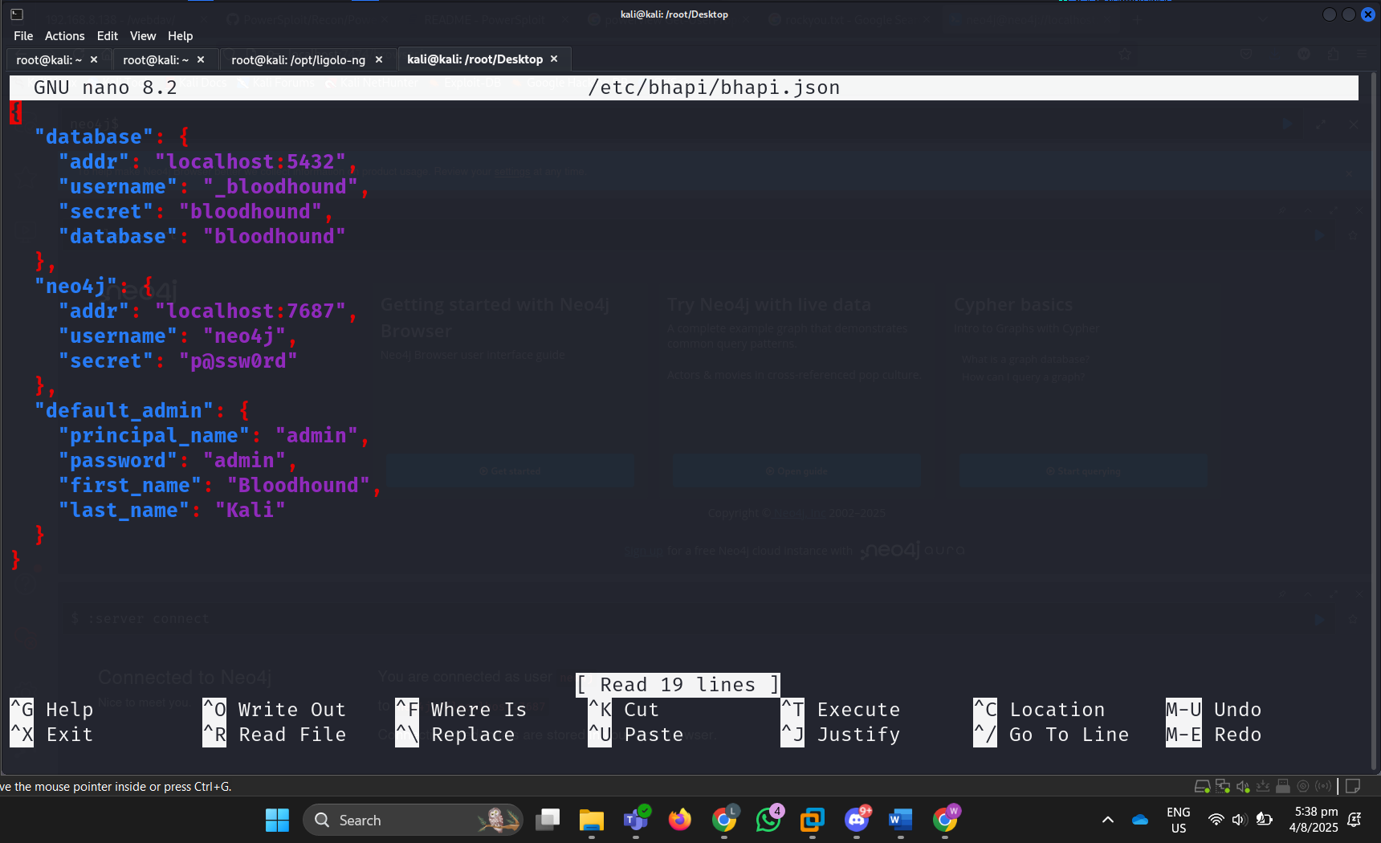

1. Using the meterpreter, I can run the upload command to transfer the SharpHound.exe file to PC01. This step is crucial because I must run SharpHound.exe on the domain user device so that it can enumerate domain users and devices in DYSON.local.

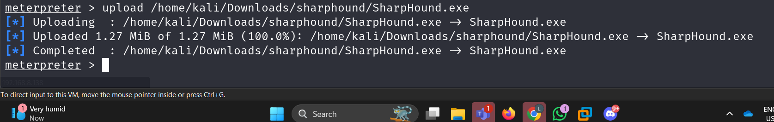

1. Since I have successfully transferred the sharphound.exe file from our kali attacker machine to PC01 via the upload function in meterpreter, I ran SharpHound.exe -c ALL in PC01 remote command prompt environment to initiate the enumeration of the Active Directory environment. The –c ALL command instructs Sharphound to perform a comprehensive query, gathering all available data related to domain trusts, group memberships, effective admin rights, and other relationships within the domain. This includes identifying service principal names (SPNs), group memberships, and potential privilege escalation paths.

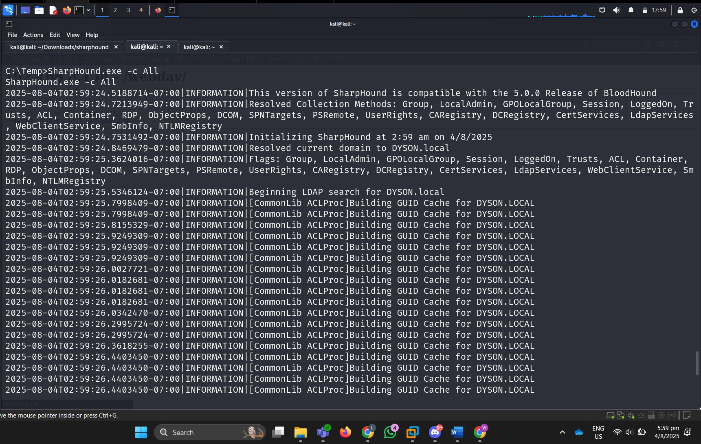

1. A Bloodhound.zip file was then generated which includes all the JSON files of the domain information. I renamed the file to bh.zip so that it would be easier to access the file. When I ran ‘dir’ the zip file can be seen.

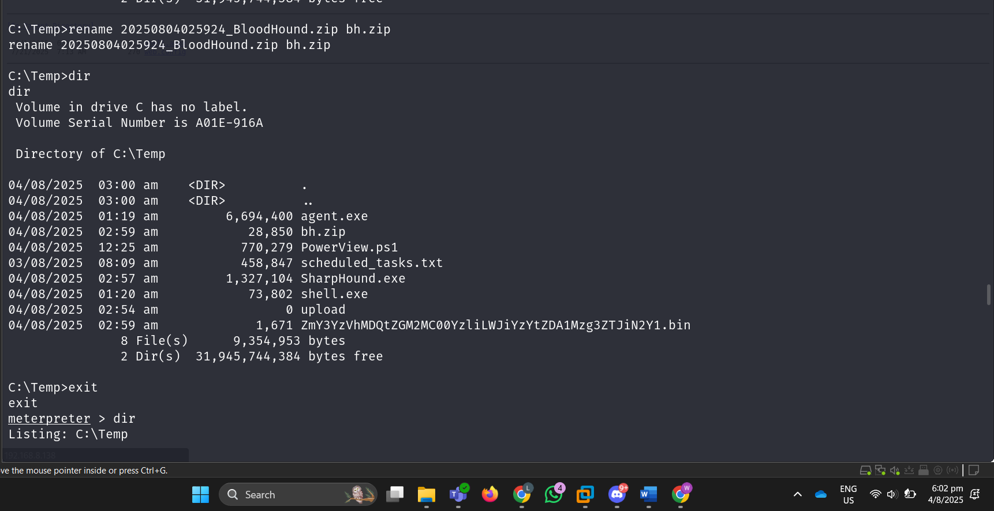

1. Using meterpreter’s Download function, I transferred the bh.zip file from PC01 Temp directory to my Kali machine so that I can use this bh.zip file for bloodhound graphing.

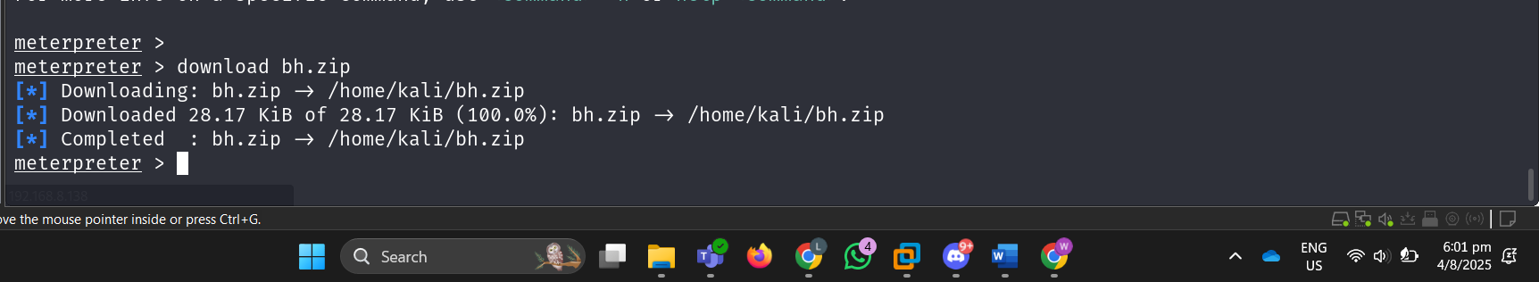

1. Back to the neo4j console, I can now select to import the bh.zip file which contains all the enumeration data collected from the DYSON.local’s AD environment, such as user account, group memberships, domain trusts, and session information. This would initiate the graphing engine of bloodhound, providing us with insightful information about the complex relationships within DYSON.local. This includes how users and computers are linked, which users have privileged access, and potential attack paths an adversary could exploit to escalate privileges. This step is crucial for post-exploitation analysis and identifying misconfigurations in AD environments.

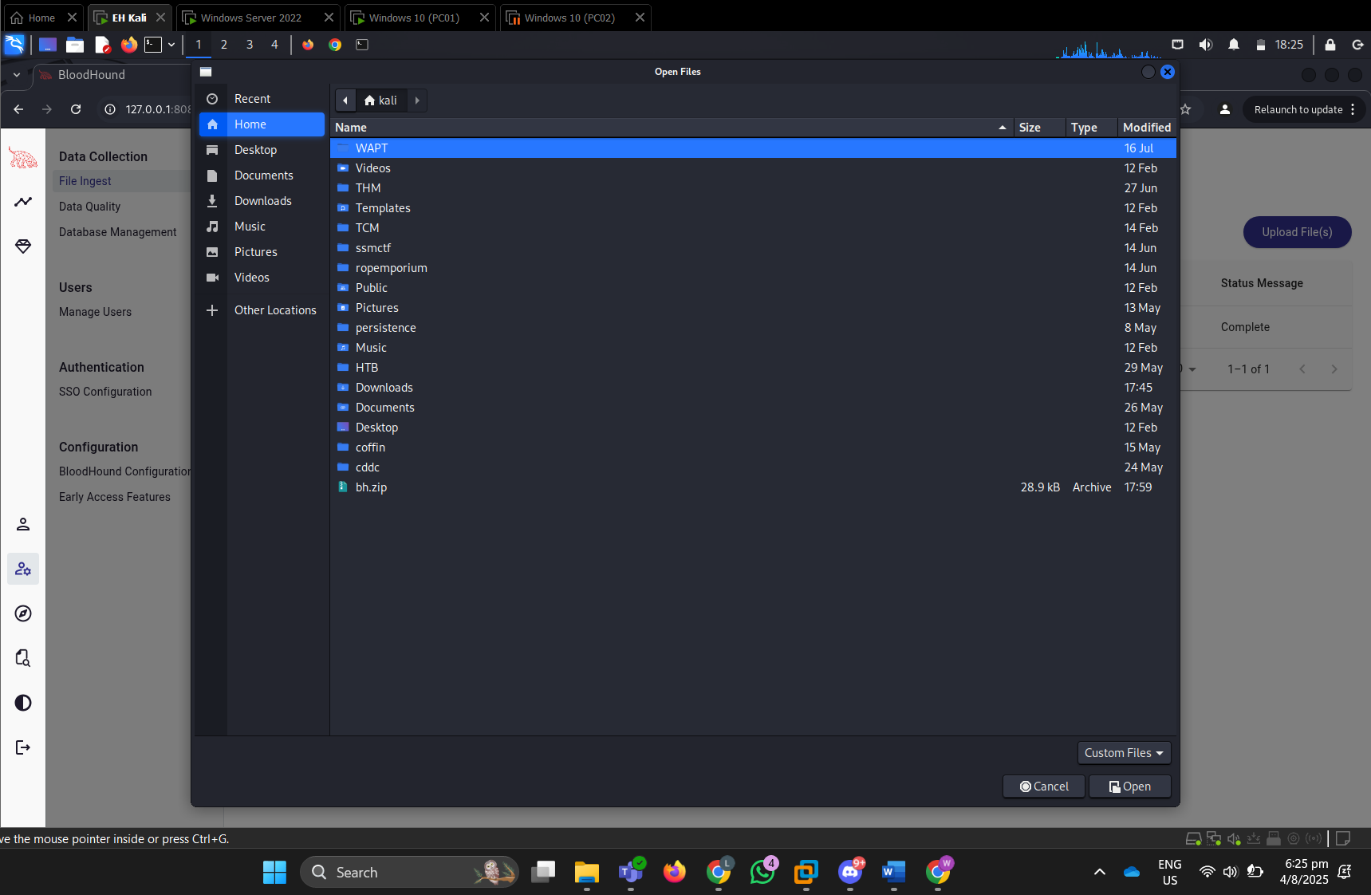

1. By using BloodHound’s inbuilt queries, I can find service accounts that are vulnerable to Kerberoasting attacks with administrator pivilleges.

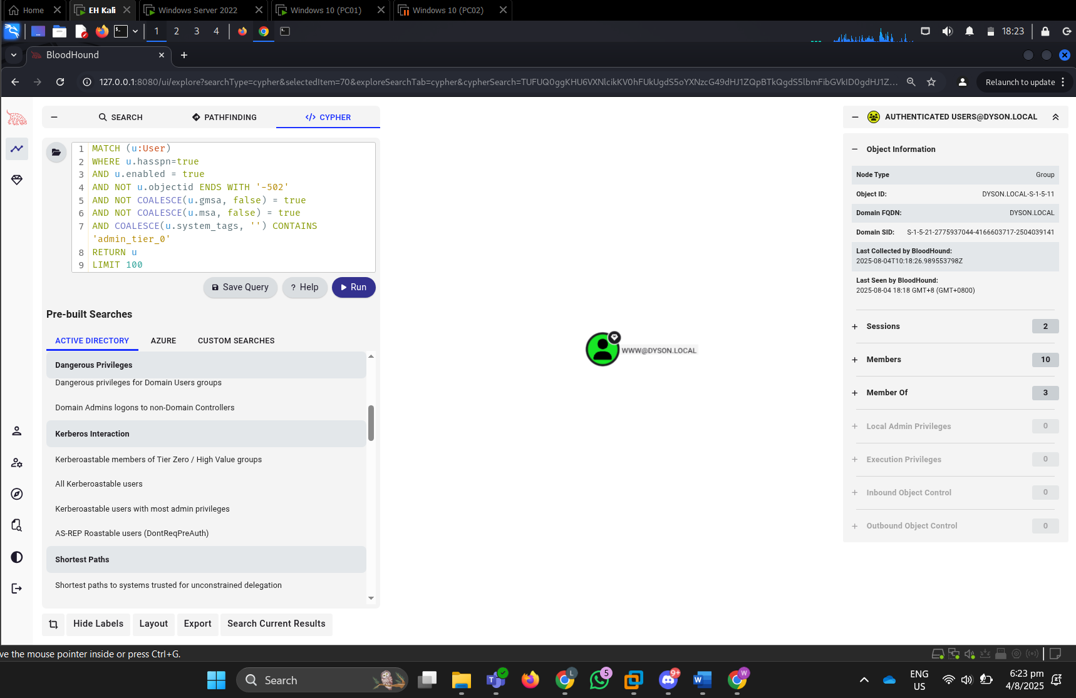

This screenshot shows a query executed in BloodHound that identifies the members of the Domain Admins group within the DYSON.local Active Directory environment. The yellow node represents the high privileged group, and it is connected to 3 green nodes which represents the accounts with full administrative privileges over the domain. With this visual representation, it clearly shows which user account an attacker could target for privilege escalation or lateral movement, especially since compromising one of these accounts would grant full control over the entire AD. In this case, the [www@DYSON.LOCAL](mailto:www@DYSON.LOCAL) account can be kerberoasted and has administrator capability which is ideal for us.

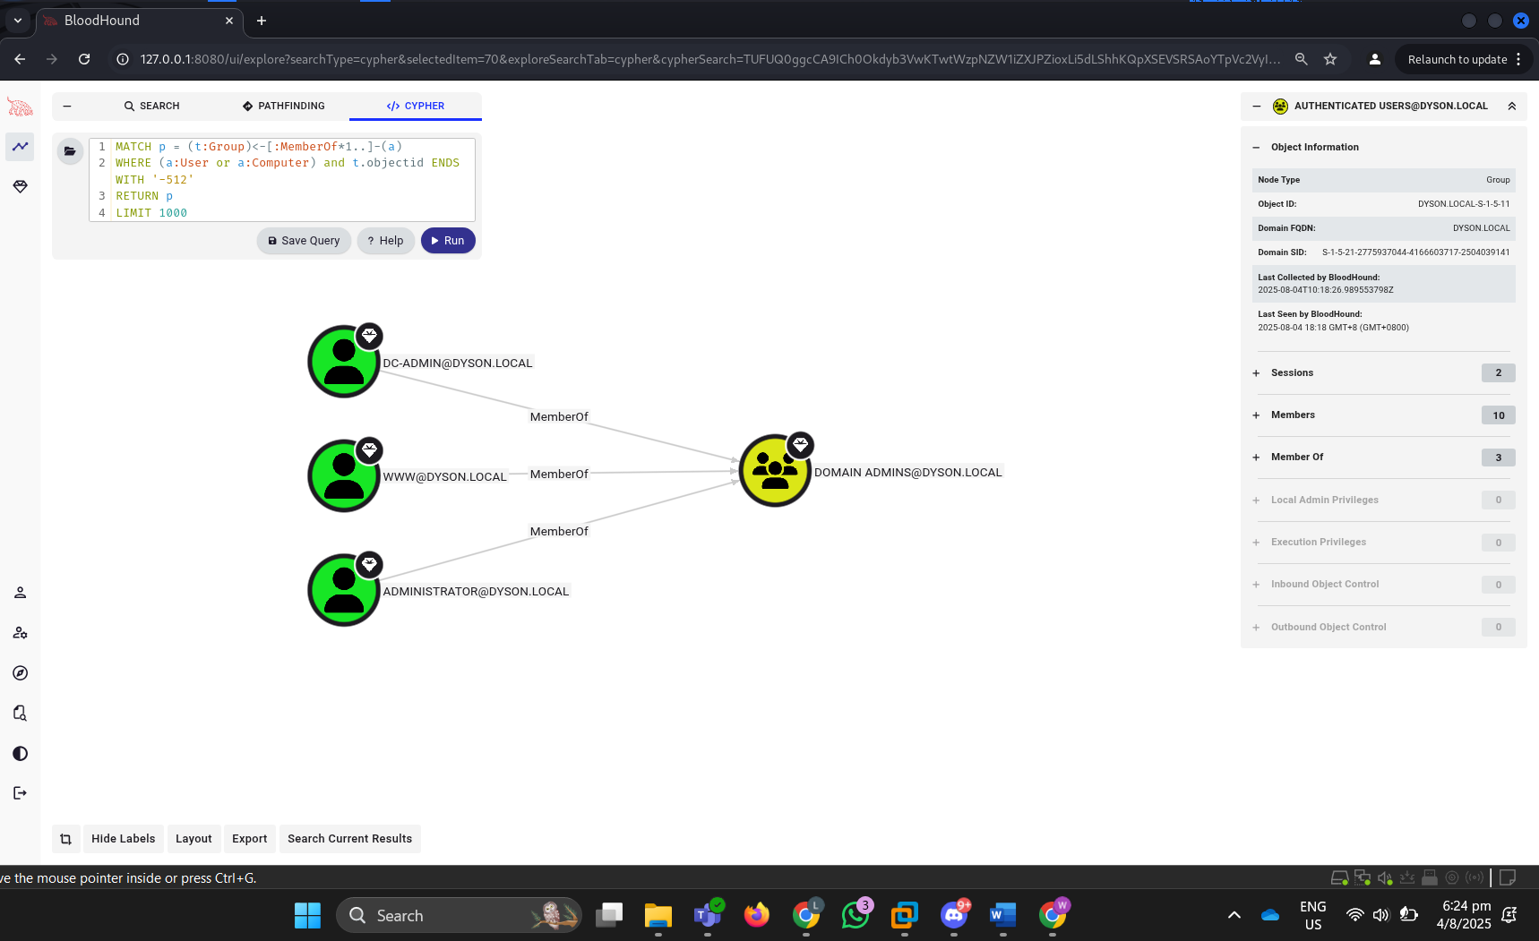

This BloodHound screenshot shows the structural overview of the DYSON.local AD, focusing on group memberships and organizational hierarchy.

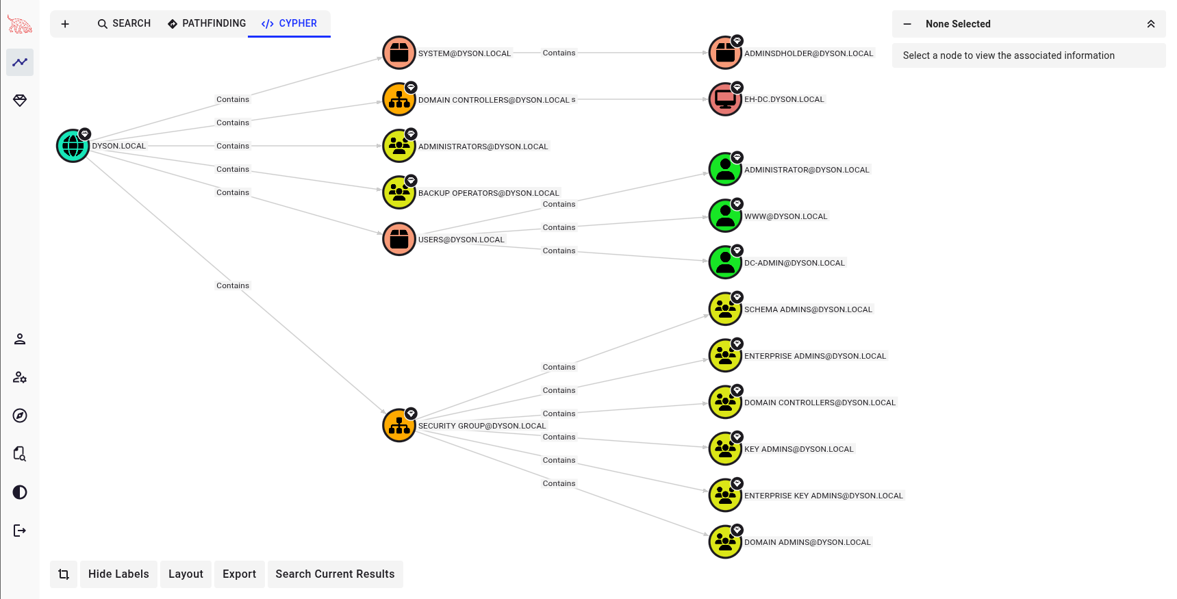

In this screenshot, it shows that the HQ-IT-PC01.DYSON.LOCAL device is vulnerable to NTLM relay attacks, meaning that it does not have SMB signing enabled, and attacker can intercept authentication requests and relay them to gain unauthorized access.

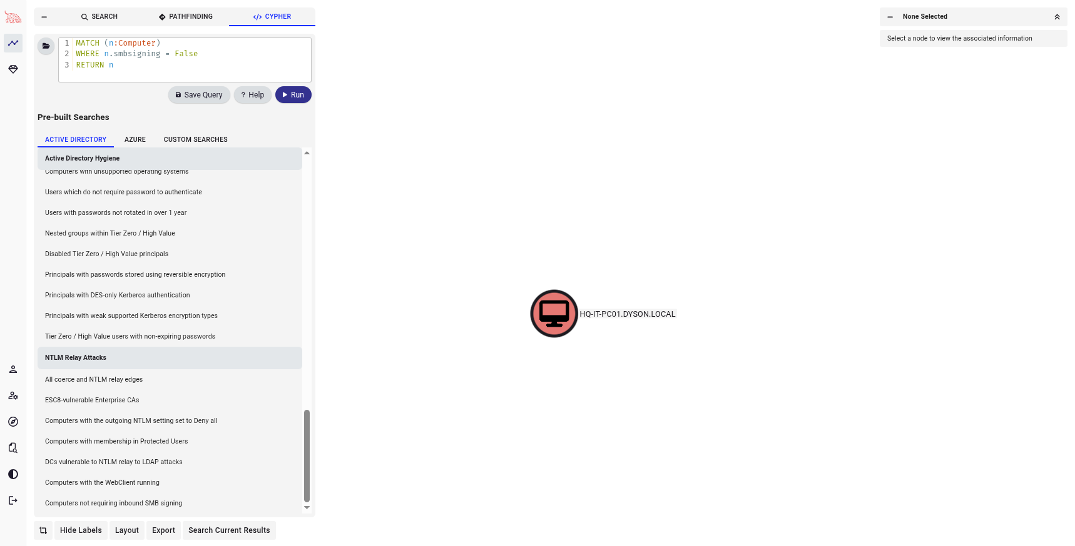

## Task 10 – Kerberoasting

**Objective:**

To obtain a Kerberos Ticket Granting Service (TGS) hash for a service account within an Active Directory environment and attempt to crack the hash offline to extract the service account’s password.

**What is Kerberoasting?**

Kerberoasting is a post-exploitation attack technique that allows an authenticated domain user to request service tickets (TGS) for accounts with Service Prinicpal Names (SPNs). These tickets are encrypted using the service account’s NTLM hash, which can be cracked offline to recover the plaintext password.

This is effective because many service accounts in Active Directory (like SQL services or web apps) have:

* weak or non-expiring passwords
* high privileges (even domain administrator powers)

One good thing is that Kerberoasting does not require elevated permissions, any domain user can request these tickets. Since we have exploited HQ-IT-PC01 from the previous attacks, we now have the credentials and permissions of a low privilege domain user and can safely request for a service ticket.

Step1: Identify SPNs and Request TGS Tickets

1. Run impacket-GetUserSPNs DYSON.local/IT-PC01:’p@ssw0rd’ -dc-ip 192.168.10.10 -request

This command basically makes a Kerberos TGS request to the Domain [Controller @192.168.10.10](mailto:Controller@192.168.10.10) for service accounts associated with SPNs under the DYSON.local domain. Since we already have a compromised low-privilleged domain user account (IT-PC01) username and password, we can use the credentials to request these TGS tickets. After requesting for TGS, we can see that there is a service account ‘www.DYSON.local’, and it’s ticket is given to us. Copy down this ticket value and store it inside a txt file called TGS_hash.txt.

Impacket-GetUserSPNs: a script from the Impacket toolkit, which is used for kerberoasting attacks to help request a SPN ticket from a domain controller.

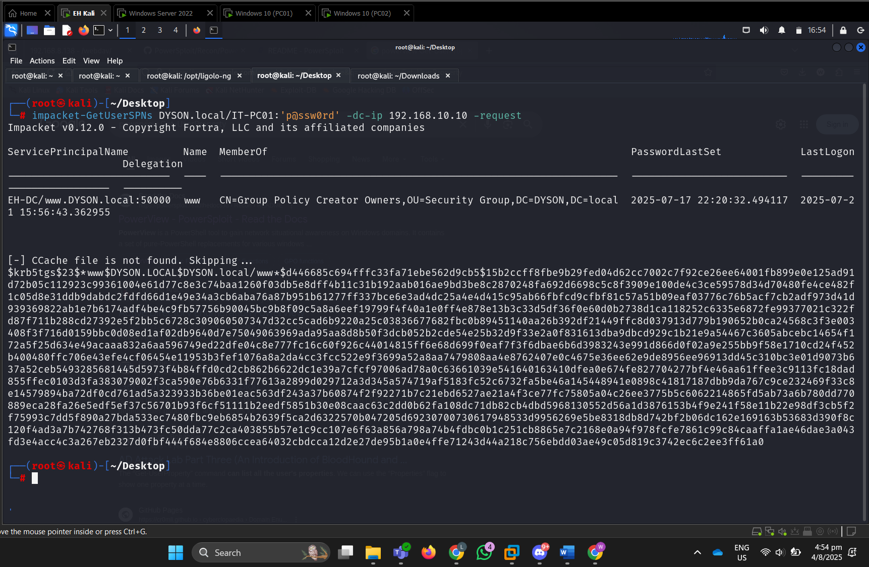

1. Next we run john –format=krb5tgs –wordlist=/usr/share/wordlists/rockyou.txt TGS_hash.txt

Since the TGS ticket is encrypted with the NTLM hash of the service account, for example, TGS is encrypted using the NTLM hash of the [www.DYSON.local](https://www.DYSON.local) service account. I was able to crack the TGS ticket offline to retrieve the password of the service account using john the ripper dictionary-based attack, where a predefined list of likely passwords (such as rockyou.txt) is tested against the encrypted ticket. The passwords in rockyou.txt is hashed and used to decrypt the TGS ticket, if the decryption works, then the password that was previously hashed is the plaintext password for the service account. In this case, the password for www service account was found: iL0veEH123!

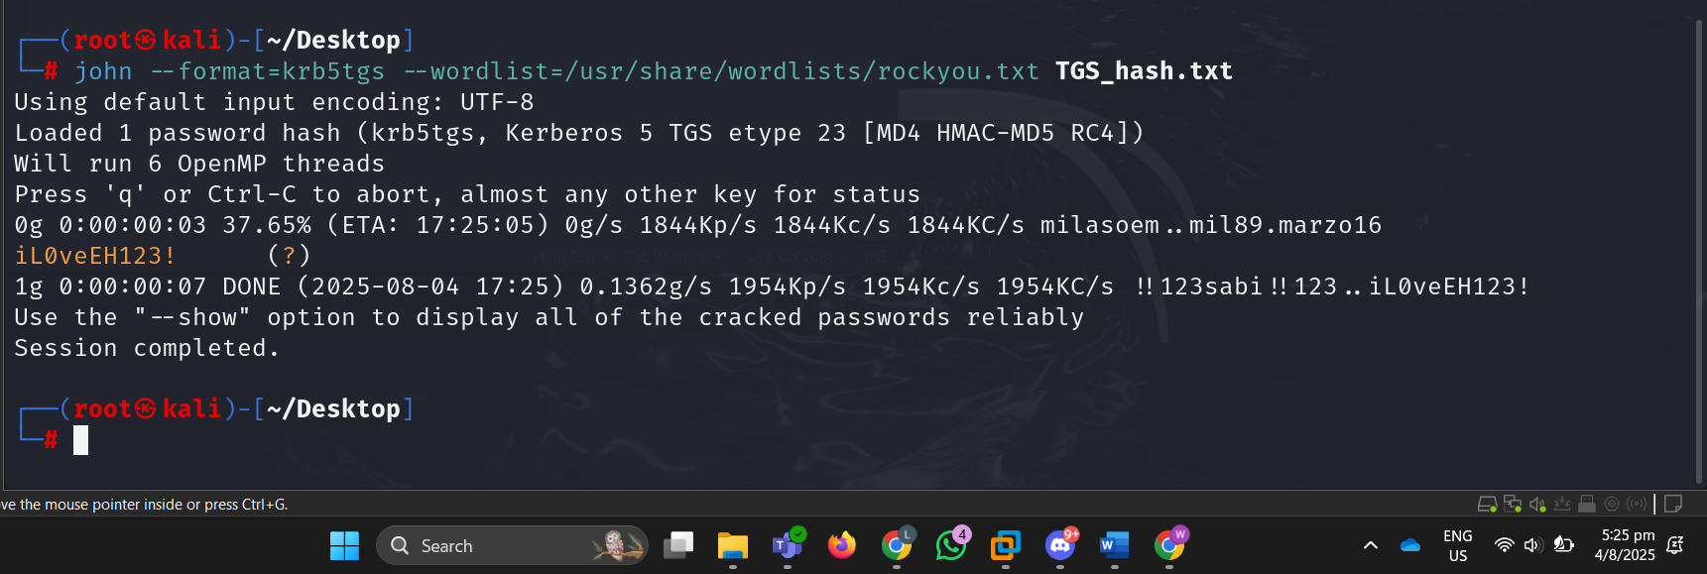

## Credential dumping via secretsdump

1. run [impacket-secretsdump.DYSON.local/www:’iL0veEH123!’@192.168.10.10](mailto:impacket-secretsdump.DYSON.local/www:’iL0veEH123!’@192.168.10.10)

Many companies often give their service accounts administrator access and rights. Hence, I attempted to do a secretsdump credential dumping with www credentials. Turns out, www service account has the same rights as administrator and my secretsdump worked.

From the screenshot, local SAM NTLM hashes were fully dumped out and can be used to perform Pass the Hash (PTH) attacks to gain access to another account.

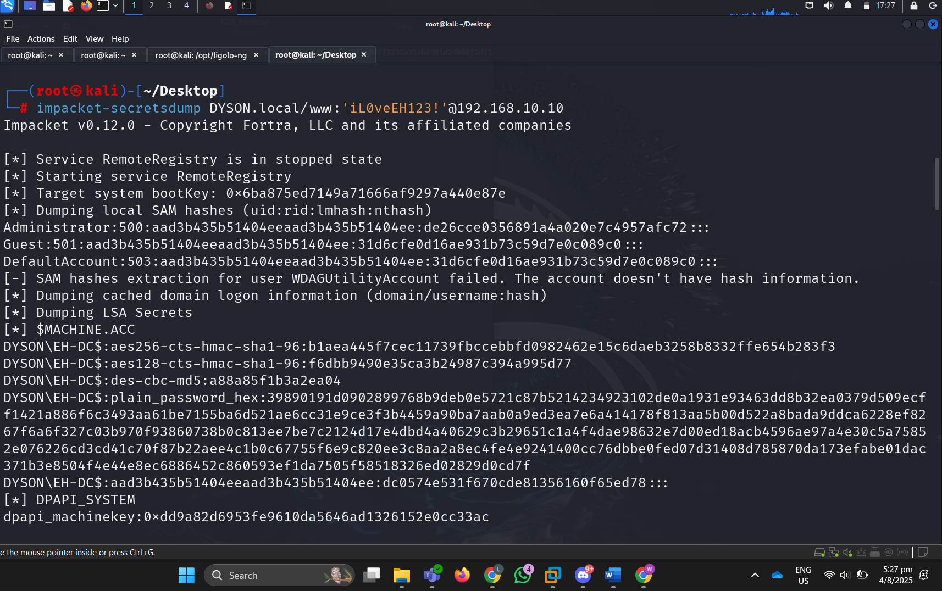

NTDS.dit is the database that stores, all domain users' password hashes, group membership, admin accounts, computer accounts. From the screenshot, we can see that the Domain Credentials in NTDS.dit are being dumped out. This is crucial as these NTLM hashes credentials can be used to authenticate across other machines in the domain (including Administrator account). With these hashes, I can perform Pass the Hash (PTH) next to move laterally within the network, gaining access to additional systems and sensitive resources without needing the actual plaintext passwords.

Additionally, the Kerberos keys are also dumped out, where they can be used for Golden Ticket Attack using krbtgt keys that we have compromised. We can forge our own Kerberos TGT tickets that never expire, impersonate any user, including Administrator.

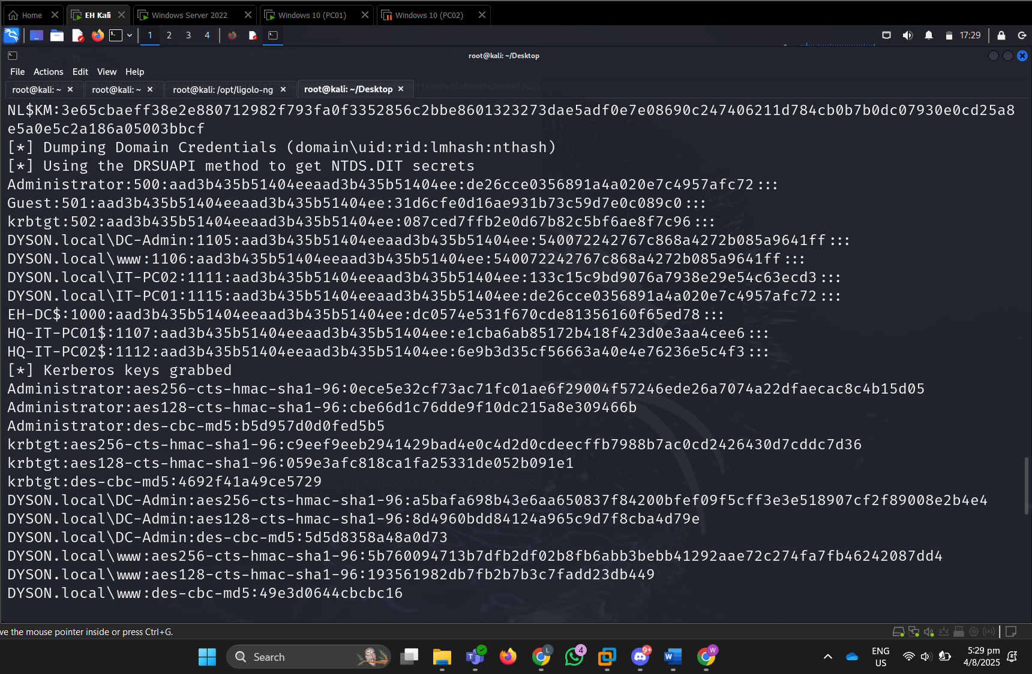

## Task 11 – Pass-the-Hash

What is Pass-the-Hash (PTH):

Pass the Hash is a technique used to laterally move in a network and a post exploitation attack that allows an attacker to authenticate to a remote machine by using the hash of a password instead of the plaintext password. This attack is usually used in a Windows network environment where NTLM authentication is used.

In this attack:

* I am trying to compromise the Domain Controller device by using Administrator’s hash de26cce0356891a4a020e7c4957afc72 to log into the domain controller device.
* Since the Administrator account is most likely a high privileged user account in the domain controller, I can use it to perform PTH.
* I do not need to know the plaintext password. Instead, I used the hash of the password I obtained from credentials dumping via secretsdump.



Run: impacket-psexec [DYSON.local/Administrator@192.168.10.10](mailto:DYSON.local/Administrator@192.168.10.10) -hashes :de26cce0356891a4a020e7c4957afc72 “cmd.exe”

This psexec command uses the administrator’s account hash to authenticate with the domain controller at 192.168.10.10 and opens a remote command prompt of the domain controller. From here, the attacker can interact with the machine, escalate privileges, or move laterally within the network.

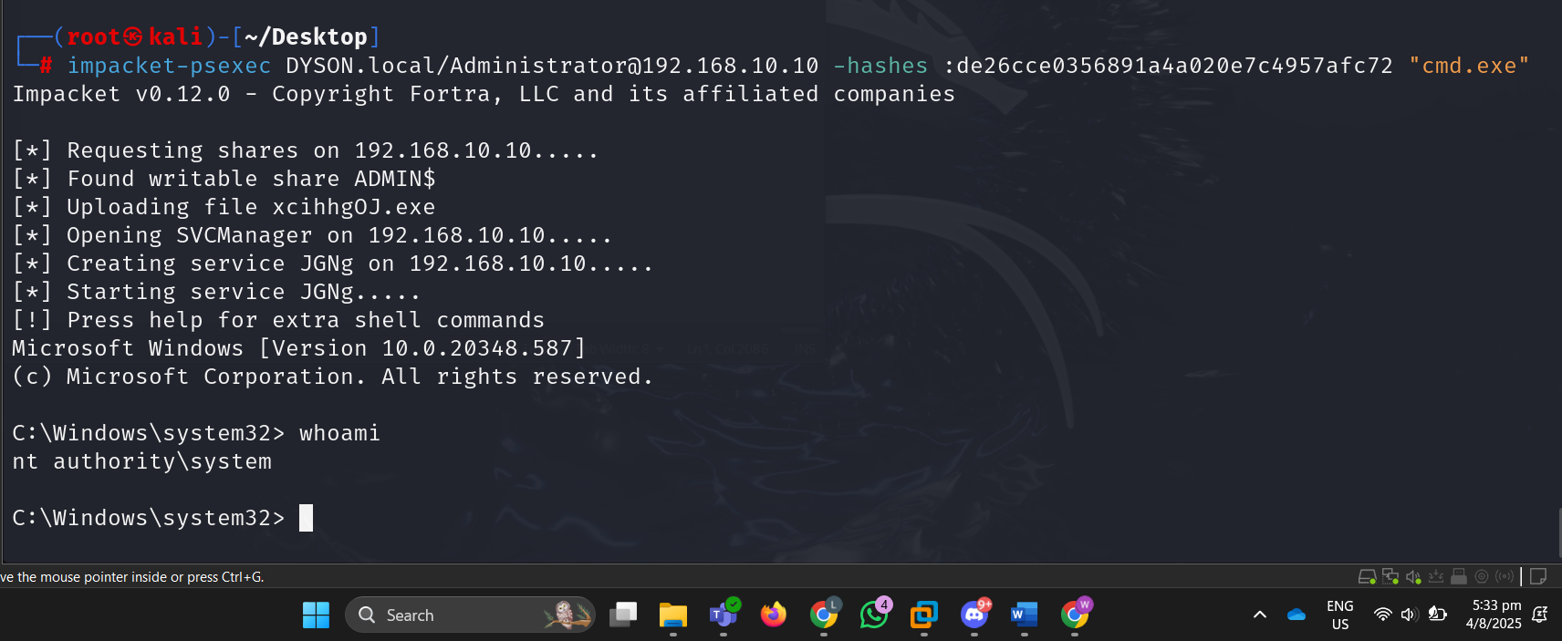

## Task 12 - Golden Ticket Attack

### Mimikatz

1. Run mimikatz tool to extract Kerberos tickets from memory in Windows systems

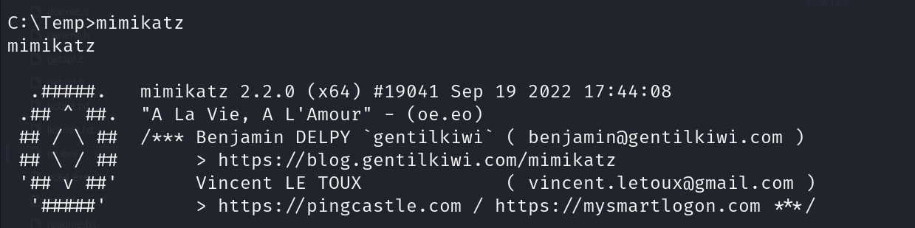

1. privilege::debug command to enable the SeDebugPrivilege on the current process.

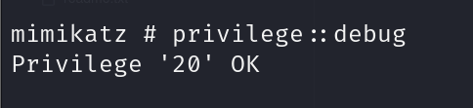

1. extract the NTLM hash of the KRBTGT account using the command lsadump::lsa /inject /name:krbtgt. The output reveals the domain’s Security Identifier (SID). Attacker uses the SID to craft a fake TGT in Mimikatz This forged ticket can then be injected into memory to impersonate a privileged user, allowing the attacker to move laterally and access any resource in the domain undetected.

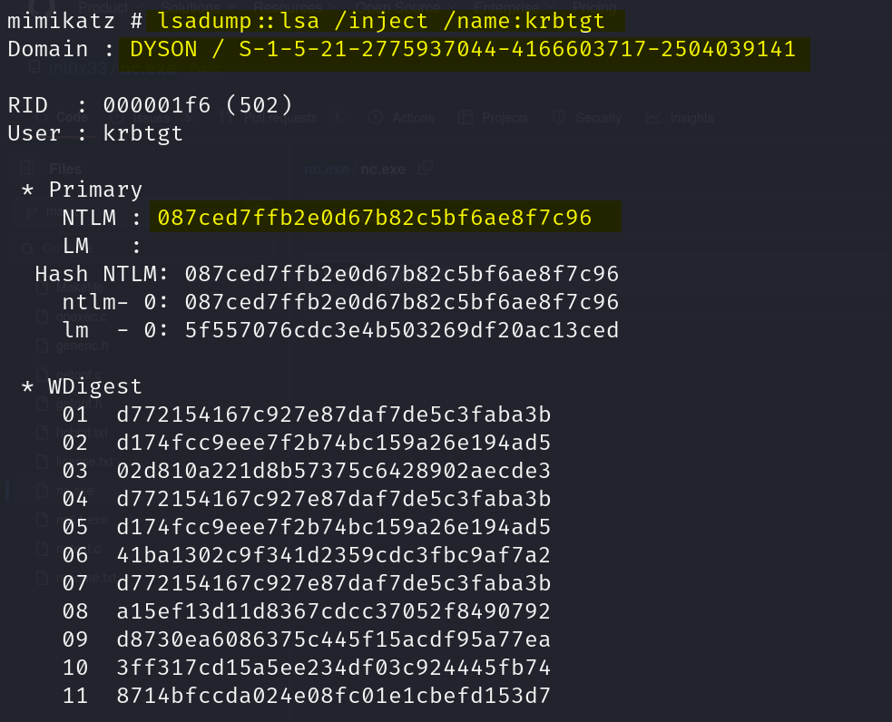

1. kerberos::golden is used with parameters including the fake username, fake domain name, domain SID, user ID and the NTLM hash of the KRBTGT account. /ptt tells Mimikatz toimmediately inject the generated Golden Ticket into the current session's memory. Once executed, Mimikatz successfully generates and injects a Golden Ticket, allowing the attacker to impersonate the domain administrator and gain unrestricted access across the entire domain

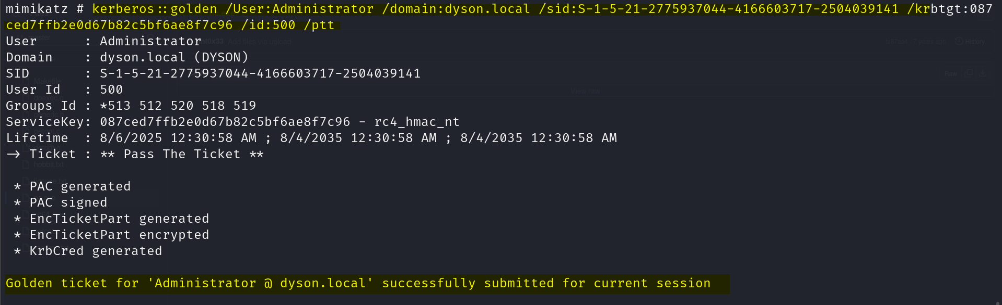

1. After that, I used Impacket’s psexec to access the domain controller and perform actions on PC02.

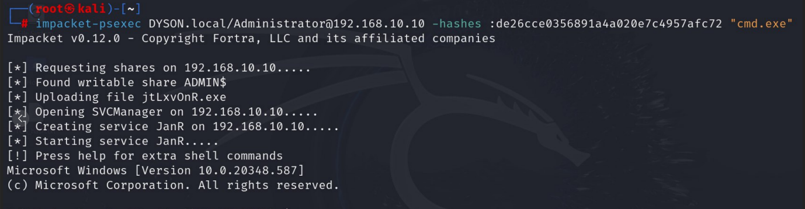

1. On PC02, I was able to use the command dir \c$ to list all the directories on the device’s C drive, allowing me to systematically enumerate folders in search of valuable data. During this exploration, I discovered a data.txt file located on the Desktop. This file contained sensitive and important information, including employee IDs, job roles, and access levels of Dyson employees, which could be exploited for further lateral movement or privilege escalation within the network.

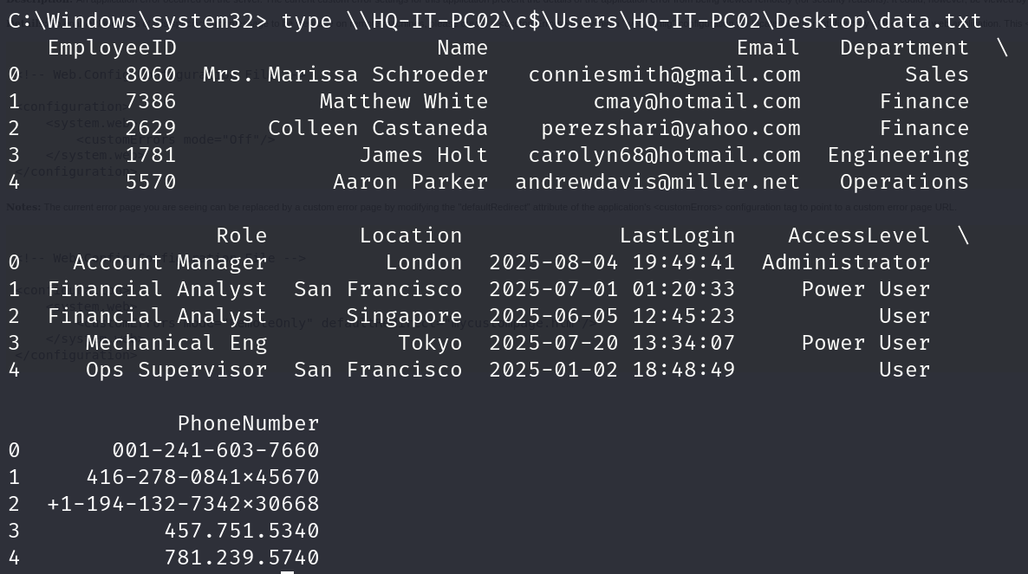

A Golden Ticket attack allows an attacker to create a forged Kerberos Ticket Granting Tickets (TGTs) that grant unrestricted access within a Windows domain, giving them persistent and undetectable control over the network. Because the attacker has compromised the domain’s KRBTGT account hash they can generate valid tickets and even if the attacker closes the Domain Controller’s command prompt, they can still retain the ability to access resources such as administrative shares using dir \\hq-pc-it02\c$ without needing to re-authenticate or re-configuring golden ticket.

Additionally, normal users cannot change or invalidate the forged KRBTGT tickets easily, making this attack particularly dangerous and persistent until the KRBTGT password is reset twice to invalidate previously forged tickets.

## Task 13 – Persistence

### Metasploit

1. Background the current meterpreter session and obtain the session number.

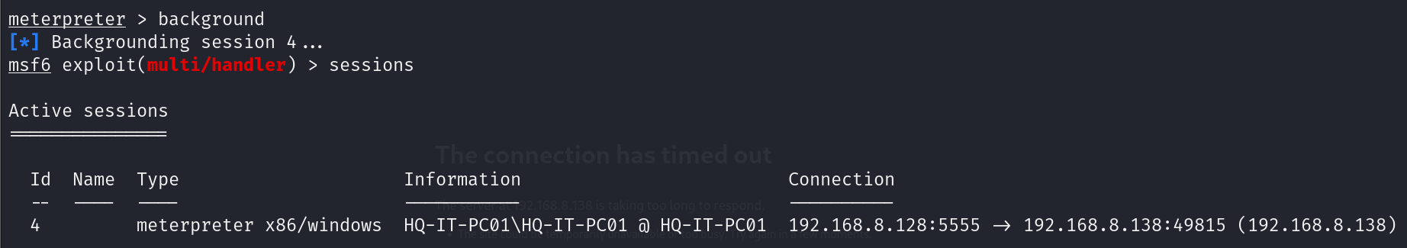

1. Use the persistence service Metasploit module which creates a connection to the attacker every few seconds.

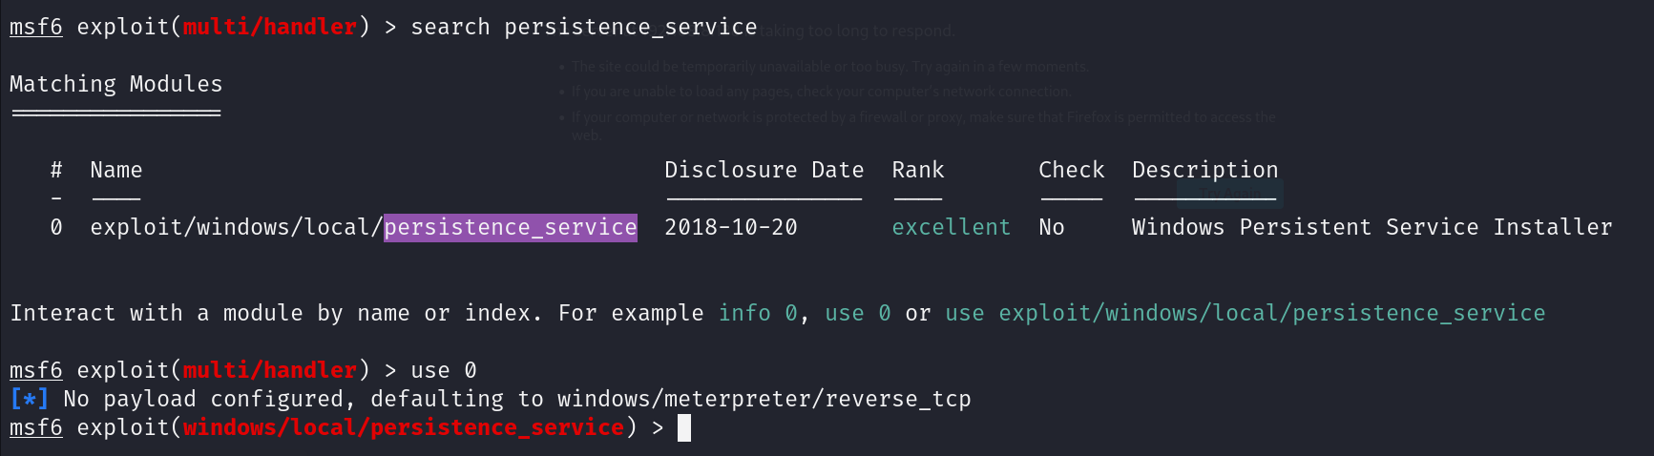

1. Set the LPORT which is the port that the persistent service will connect back to and the session number (4455 and 4 respectively in my case). Running the module will automatically create the executable file ran persistently in the C:\Windows\Temp directory and also gain a meterpreter shell on the system.

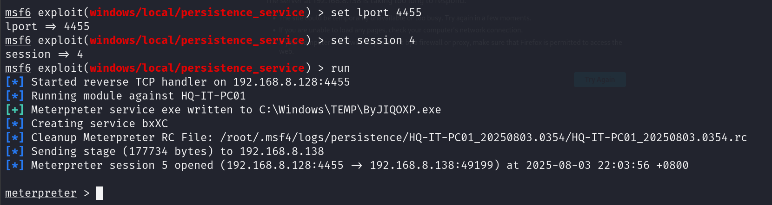

1. To confirm the persistence of the meterpreter shell, I ran another multi/handler listener on LPORT 4455. After waiting a few seconds, I got a meterpreter shell.

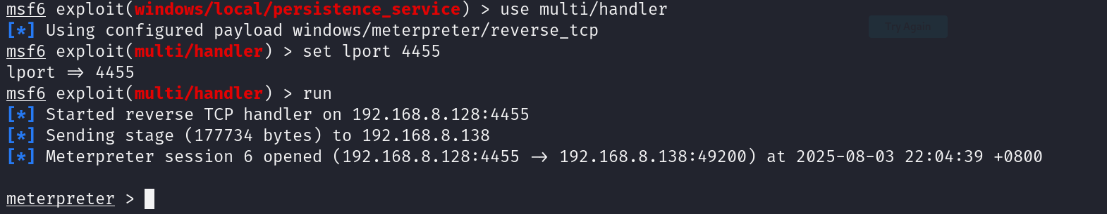

1. I ran a whoami command to see what user account I am logged into. The result is that I am now NT AUTHORITY\SYSTEM, which has the highest privilege on the system.

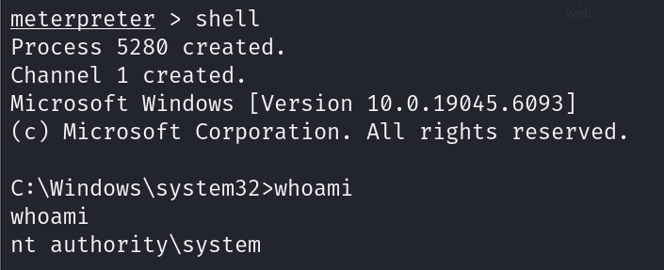

### NTFS Stream Manipulation + Scheduled Task

1. Checking the directory in which the file was created with Metasploit to ensure that it still exists.

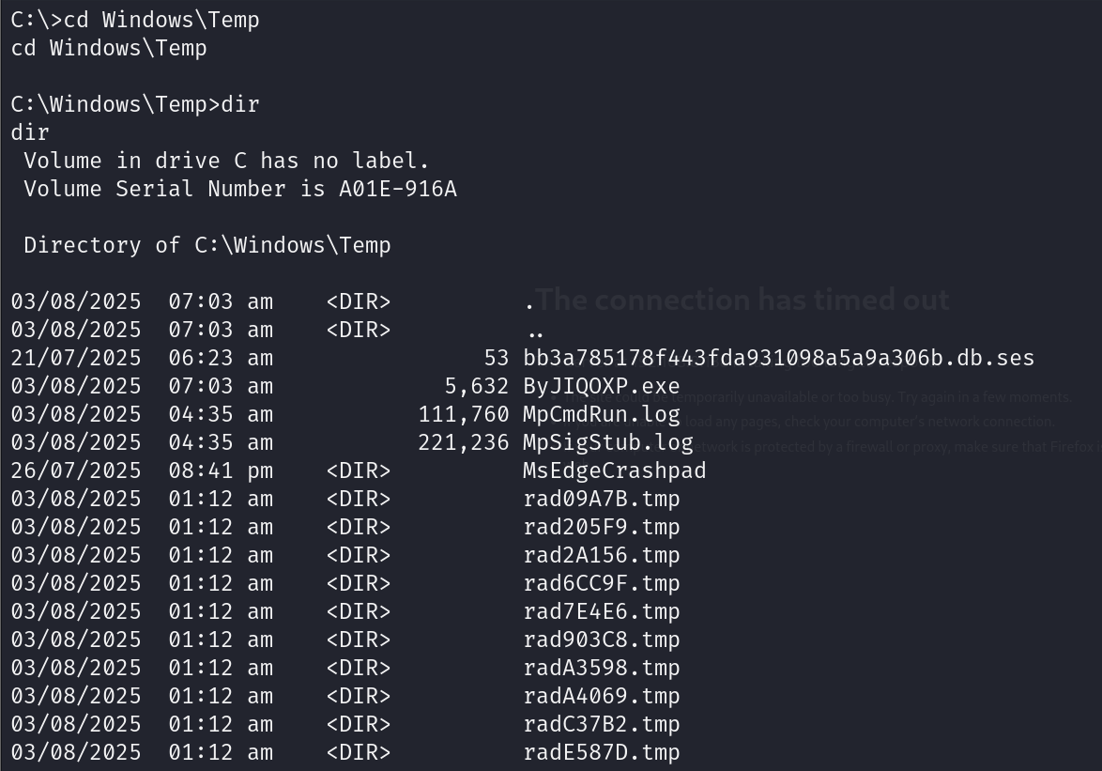

1. The iisstart.htm file in C:\inetpub\wwwroot will be used to hide the malicious executable file.

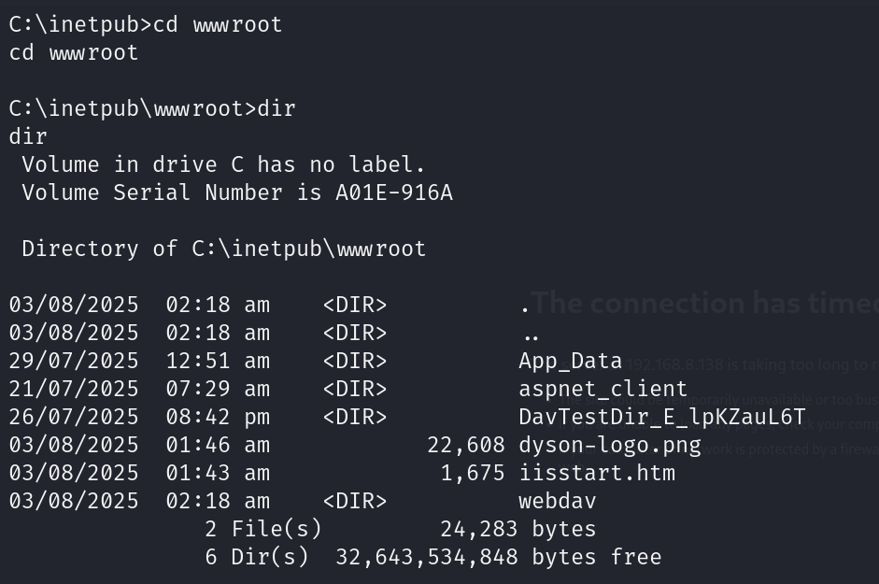

1. I copied the contents over to the iisstart.htm:svchost.exe file so that when it is ran, it would seem like a normal Windows process. The command dir /r confirms that the file has been made.

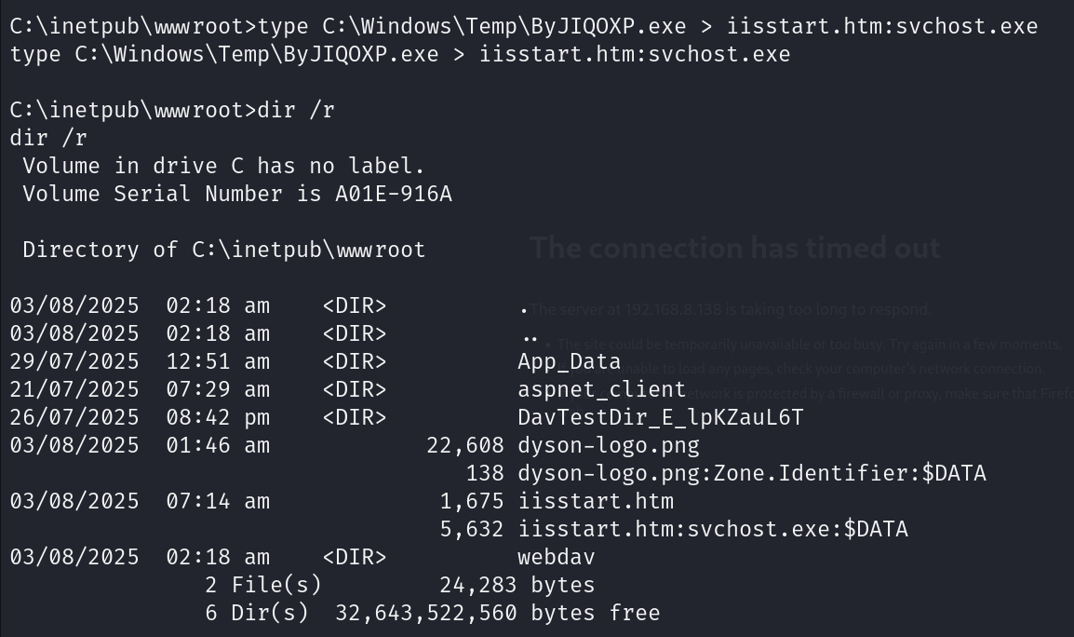

1. I then changed directory into C:\Windows\System32, where I created a symbolic link of a seemingly innocent file named “wupdate.exe” to my malicious iisstart.htm:svchost.exe file.





1. This creates a hidden backdoor to the system that can be executed with the “wupdate” command that will send a meterpreter reverse shell to the attacker.

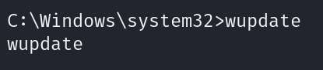

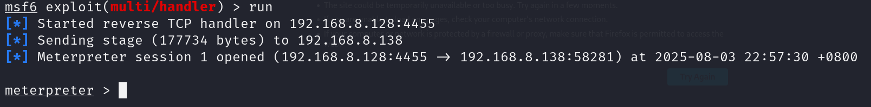

1. Create a scheduled task that runs the command “wupdate” as “SYSTEM” user every minute. I named it “Check for Windows Update” to avoid suspicion.



1. To confirm that my scheduled task is running, I listed all the scheduled tasks and sent the output to a text file.

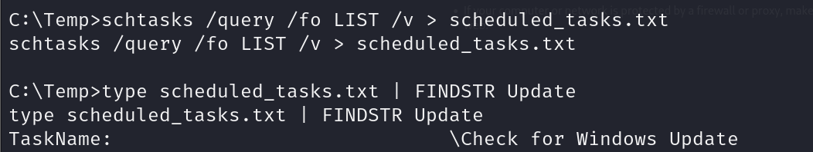

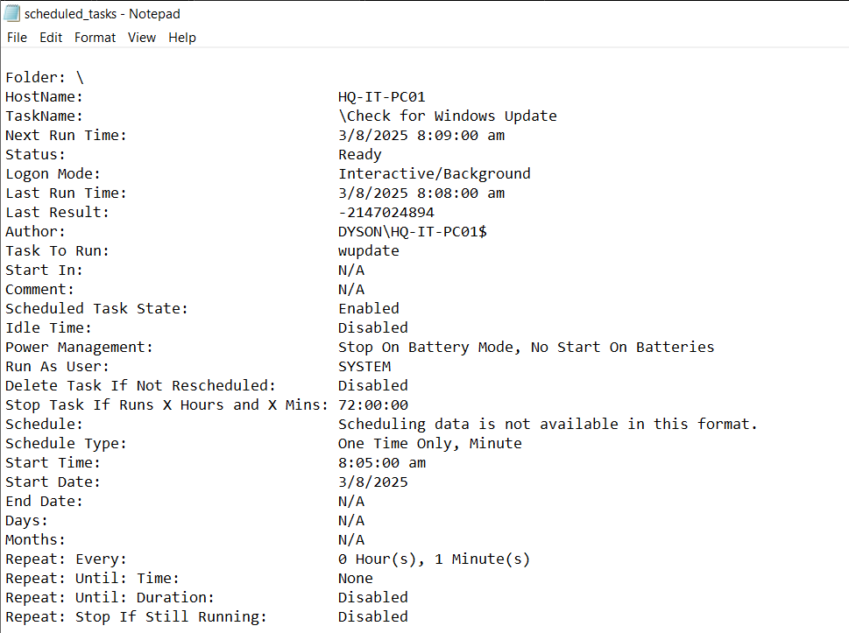

## Task 14 – Hide the Evidence of Comprise

### Clearing logs on Domain Controller

1. Creates a batch file named clears_script.bat on the Desktop.

@echo off inside the batch file ensures that when the script runs, the command prompt does not display each command being executed



1. configures Windows to log both successful and failed account logon events for tracking authentication attempts and system activities, such as login successes or failures.



1. The auditpol /clear clears the audit logs, and the /y flag automatically confirms the action without prompting and this is used to remove traces of malicious activity.



1. auditpol /get /category:* command retrieve the audit policy settings for all categories to check if all audit logs are off.



1. Execute the clears_script.bat file to clear all logs

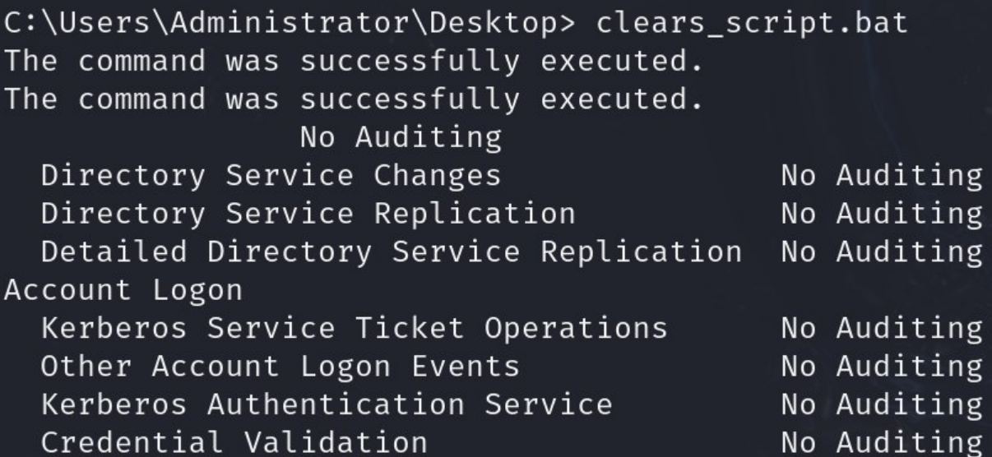

It is important for an attacker to clear all audit logs because these logs serve as a critical record of system activities like logins and file access. If left intact, they can be used to trace the attacker’s actions and identify compromised accounts. In my scenario, after compromising the Domain controller device, I was able to carry out a variety of attacks, including using Mimikatz to extract credentials from memory and generate a Golden Ticket to gain persistent and access across the domain. Without clearing the logs, these high-impact activities would be recorded and could lead to quick detection and containment. Therefore, attackers often prioritize to erase audit logs to maintain stealth and make post exploit investigations more difficult.

### Deleting files in Temp Folder

1. rd /s /q C:\Temp >> clears_script.bat is used to delete the "Temp" directory located at C:\Temp. /s removes all files and subdirectories inside the specified directory, and the /q option runs the command without prompting for confirmation.



1. when executed, the clear_script.bat will perform this deletion silently and all files in temp will be removed.

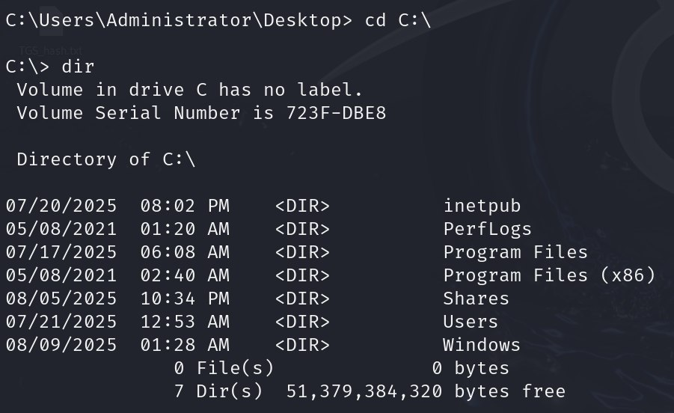

Deleting files in the Temp directory is crucial for hackers to cover their tracks after compromising a machine. In my scenario, I transferred tools like Mimikatz and PsTools to the Temp directory for exploitation purposes. After gaining access, deleting these files helps eliminate forensic evidence of the attack, making it more difficult for investigators to trace the attacker's actions.

# Executive Summary

This report covers the evaluation of Dyson’s internal and external security posture through red teaming. The following sections provide a high-level overview of the tests performed and mitigations for each successful attack.

## Testing Summary

The network assessment evaluated Dyson’s internal and external network security posture. From an external perspective, the employee’s lack of awareness on cybersecurity risks when connected to public Wi-Fi connections leads to wireless attacks such as Evil Twin, which is how the red team gained initial access to the Active Directory network. From an internal perspective, the red team performed Active Directory attacks against all hosts to evaluate the overall security. Such attacks are Kerberoasting, Pass-the-Hash and Golden Ticket Attack. Beyond these attacks, the red team evaluated other potential risks, such as authenticated directory browsing to a publicly accessible IIS WebDav server with file upload and execution enabled as well as privilege escalation with process migration and token impersonation attacks.

## Mitigation

### Evil Twin Attack

* Implement wireless security controls such as WPA3-Enterprise with 802.1X authentication to ensure mutual authentication between clients and access points, preventing rogue AP impersonation.
* Spread awareness on the dangers of public Wi-Fi connections.

### IIS WebDav Exploit

* In IIS Manager, configure the MIME types to restrict file types that can be uploaded to the WebDav server or restrict the execution of the files.
* Check the file contents of the files that are uploaded to ensure that it does not contain any malicious code.

### Privilege Escalation through Process Migration

* Apply the principle of least privilege and enforce strict process isolation to limit inter-process memory access.
* Disable unnecessary debugging and administrative privileges for non-administrative accounts, and implement kernel-level security features such as Windows Defender Exploit Guard to block unauthorized process migration or injection.
* Monitor process behavior with Endpoint Detection and Response (EDR) solutions to detect anomalous process creation or memory manipulation, and ensure all systems are patched to eliminate vulnerabilities that could be exploited for privilege escalation.

### Token Impersonation Privilege Escalation

* Limit access to the SeImpersonatePrivilege. It is a sensitive privilege that allows a user to impersonate others.
* Enable User Account Control (UAC). UAC helps to block applications from performing privileged actions unless explicitly allowed. This makes it harder for attackers to escalate privileges using token impersonation.

### Kerberoasting

* Use strong and complex passwords that are difficult to crack (e.g. passwords that cannot be cracked by common wordlists like rockyou.txt). This can be achieved by enforcing policies that require long, random passwords with a mix of upper and lowercase letters, numbers, and special characters.
* Implement least privilege: Ensure that SPN (Service Principal Name) accounts operate with the minimum required privileges. Service accounts should only have access to resources they absolutely need. This reduces the impact of an attacker who might crack a service account's Kerberos ticket.

### Pass-the-Hash

* Avoid re-using local admin password so that attackers cannot use one hash to log into multiple accounts.
* Use multi-factor authentication (location-based or device-based). Attackers need more than just the hash to log into the account, which makes pass-the-hash significantly harder to perform.

### Golden Ticket Attack

* Reset the KRBTGT Account Password Twice by replacing the old hash with the new one, invalidating all existing forged tickets.
* Enforce Strong Credential Hygiene by using complex, unique passwords for all privileged accounts, especially KRBTGT, domain admin, and service accounts.
* Enforce least privilege by limiting rights to only what is essential for users or systems to perform their role or function. Closely monitor privileged account activities and promptly address any deviations from regular patterns.
* Monitor anomalous Kerberos ticket activity by keeping a vigilant eye on activity surrounding Kerberos tickets within the network. Regularly scrutinize the properties and usage patterns of these tickets. Doing so can help to spot irregularities that might signal a Golden Ticket attack.

# Citations

* nicocha30. (n.d.). *Ligolo-ng* [Computer software]. GitHub. <https://github.com/nicocha30/ligolo-ng>
* Offensive Security. (n.d.). *Ligolo-ng*. Kali Linux Tools. <https://www.kali.org/tools/ligolo-ng/>
* Ligolo-ng. (n.d.). *Quickstart*. <https://docs.ligolo.ng/Quickstart/>
* Lockheed Martin. (n.d.). *Cyber kill chain*. <https://www.lockheedmartin.com/en-us/capabilities/cyber/cyber-kill-chain.html>
* PowerShellMafia. (n.d.). *PowerView.ps1* [Computer software]. GitHub. <https://github.com/PowerShellMafia/PowerSploit/blob/master/Recon/PowerView.ps1>
* borjmz. (n.d.). *ASPX reverse shell* [Computer software]. GitHub. <https://github.com/borjmz/aspx-reverse-shell>